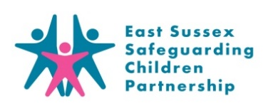

**ICON Fact Sheet**

**for Parents**

**What is ICON?**

Abusive Head Trauma (AHT), previously known as Shaken Baby Syndrome, is a devastating form of child abuse.

The ICON Programme is a preventative programme, based around helping parents cope with a crying baby.  The word ‘ICON’ represents the following message:

**I – Infant crying is normal**

**C – Comforting methods can sometimes soothe the baby**

**O – It’s OK to walk away**

**N – Never, ever shake a baby**

Visit the [**ICON website**](http://iconcope.org/for-professionals/)for more information

**What are the key messages of ICON?**

* Crying is a normal part of child development
* All babies will cry a lot from the ages of 2 weeks to 3-4 months, but this can vary from baby to baby. Show parents the [**Crying Curve**](http://purplecrying.info/sub-pages/crying/why-does-my-baby-cry-so-much.php) to help them understand
* Crying seems to peak in the late afternoon and early evening… but this can vary
* Help parents understand that crying is normal… all parents can feel like this
* Reassure parents that babies are not doing this on purpose

**Where to go for help and support if you are struggling to cope with your baby’s crying**

* Visit the ICON website’s [**page for parents**](http://iconcope.org/parentsadvice/)
* Contact your Health Visitor
* Contact your GP
* Call 111
* NSPCC helpline 0808 800 5000 - **Monday to Friday 8am – 10pm or 9am – 6pm at the weekends.**(It’s free and you don’t have to say who you are)