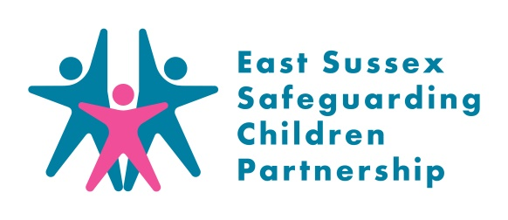
Children with Disabilities Audit: Summary for Practitioners & Managers
September 2020

Background
The East Sussex Safeguarding Children Partnership (ESSCP) Quality Assurance (QA) sub-group is responsible for monitoring and evaluating the effectiveness of the work carried out by partnership agencies to safeguard and promote the welfare of children; and to make recommendations about ways this can be improved. It does this through an annual programme of case file audits.

In December 2019 the QA Subgroup completed an audit of six children with disabilities where there had been a referral and multi-agency involvement. This summary provides a summary of the audit findings.

What is ‘audit topic summary’?
A disabled child, if abused, suffers the same consequences as any other. There are many reasons why disabled children may be more vulnerable to abuse and require additional vigilance

Research indicates that the incidence of Emotional Abuse, Neglect and Sexual Abuse is much higher for disabled children. The level of risk may be raised by:
- A need for practical assistance in daily living, including intimate care from what may be a number of carers;
- Carers and staff lacking the ability to communicate effectively with a child;
- A lack of continuity in care leading to an increased risk that behavioural changes may go unnoticed. Changes in behaviour can also be inappropriately attributed to a child's disability rather than an indicator of abuse;
- Carers may work with the disabled child in isolation;
- Physical dependency with consequent reduction in ability to be able to stop abuse;
- An increased likelihood that a child is socially isolated;
- Lack of access to 'keep safe' strategies available to others;
- Communication or learning difficulties preventing disclosure;
- Parents'/carers' own needs and ways of coping may conflict with the needs of the child;
- Parents/carers' needs dominating professional intervention leading to the needs of a disabled child becoming overlooked;
- Fear of complaining in case services are withdrawn.
Method
Six cases with multi-agency involvement were selected using Children’s Services data. Cases were randomly chosen but reflect a range of disabilities, circumstances, age groups, location and outcome. Each auditor was sent an audit tool based upon the Ofsted framework and populated with the details of each case including family background, relationships, referral date, and assessments.

Auditors examined their agency records and completed a questionnaire to share and discuss findings and to agree the learning, the strengths, the factors that supported good outcomes and the recommendations.
Strengths in Multi-Agency Practice
In the cases audited, there was evidence of:
- Improved outcomes for all 6 children considered.
- Good initial response to the risks the child experienced.
- Professionals understanding and recording the impact of different forms of abuse in the context of the child’s disability.
- A clear outcome focussed plan addressing the risks.
- Robust assessment looking at the impact of the child’s disability, their wider needs and parenting capacity and wider support needs.
- Professional curiosity and challenge of a parent’s version of a child’s disability.
- Good multi agency co-ordination, including effective collaboration between a school, social worker and SWIFT to identify risks posed by a child and to quickly create an effective plan for a child in school.
Improvements in individual cases
While there was evidence of good multi-agency work in all cases, particular improvements in individual cases were identified, including:
- Capturing and recording the child’s voice in Health records.
- Making use of the detail in the EHC Plan of the child’s communication needs and parent’s capacity to care for this child.
- Inviting Health to all strategy discussions, especially when the child has complex health needs.
- Meeting the communication needs of a child being spoken to informally by Police as a child involved and following ABE guidance.
- Considering and recording the impact of homelessness, domestic abuse or any escalation in family difficulties upon a child and the parents’ capacity to care for this child.

Learning Identified
- The ABE guidance does not apply to perpetrators leaving a gap in research informed guidance for interviewing child suspects. (Check?)

- If, following a decision reached at a strategy discussion that a child’s case needs to progress to Initial Child Protection Conference, the situation seems to change positively and Children’s Social Care feel that the decision can be safely changed then that original decision should be reviewed with all members of the original strategy discussion. A unilateral decision should not be made without consultation with all other agencies.

Recommendations for improvement
- Designated Doctor for Safeguarding to raise the need for a system of flagging when a child has CP status on ESHT community paediatric record system.

Learning for Practice
The ESSCP invite you to discuss some of the issues raised in this case audit in your team meetings or during group supervision. We encourage your responses to be included in your team minutes and forwarded to the safeguarding lead within your organisation.

- How would you identify potential additional vulnerabilities due to a disability?
- Where would you get a copy of the child’s Education and Health Care Plan?
- Why is this useful?
- Where could you get advice on interpreting its relevance?
Points for discussion:

Applying learning
- What have you/your team learnt from this audit?
- How might you/your team apply that learning?

Topic Resources
If you are concerned about a child in East Sussex call the Single Point of Advice (SPOA) on:
SPoA (Mon-Friday 8.30am-5pm)
Phone: 01323 464222
Email: 0-19.SPOA@eastsussex.gov.uk
If you think the child is in immediate danger, you should call the police

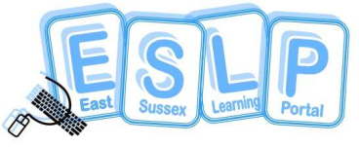
ESSCP Multi-Agency Training:
The ESSCP offers a wide range of training for professionals. Details of future courses can be found on the East Sussex Learning Portal: www.eastsussexlearningportal.org.uk

Pan Sussex Safeguarding and Child Protection Procedures
Details of child protection and safeguarding procedures in relation to X can be found at 8.17 Disabled Children | Sussex Child Protection and Safeguarding Procedures Manual

