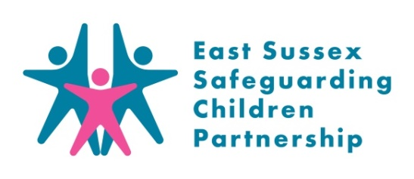
Care Leavers Pre-birth Assessment Audit: Summary for Practitioners & Managers
September 2020

Background
The East Sussex Safeguarding Children Partnership (ESSCP) Quality Assurance (QA) sub-group is responsible for monitoring and evaluating the effectiveness of the work carried out by members of the partnership to safeguard and promote the welfare of children; and to make recommendations about ways this can be improved. It does this through an annual programme of case file audits.

In February 2020 the QA Subgroup, along with 18 front line practitioners and managers, completed a deep dive audit of two cases. This summary provides a briefing on the findings of that audit.

Pre-birth Assessments and Care Leavers
Introductory paragraph on pre-birth assessments for care leavers (not a requirement?)

A pre-birth assessment should be undertaken on all pre-birth referrals as early as possible, preferably before 20 weeks, where:
- a parent or other adult in the household, or regular visitor, has been identified as posing a risk to children
- a sibling in the household is subject of a child protection plan
- a sibling has previously been removed from the household either temporarily or by court order
- the parent is a looked after child
- there are significant domestic violence issues
- the degree of parental substance misuse is likely to impact significantly on the baby's safety or development
- there are significant concerns about parental ability to self-care and/or to care for the child e.g. unsupported, young or learning disabled mother
- any other concern exists that the baby may have suffered, or is likely to suffer, significant harm including a parent previously suspected of fabricating or inducing illness in a child or harming a child
- a child aged under 13 is found to be pregnant

Method
Two cases of care leavers with a pre-birth assessment (within the last 18 months) with multi-agency involvement were selected using Children’s Services data. Auditors were sent the child details and an audit tool based upon the Ofsted Inspection audit tool but highlighting specific key factors that had come out of a recent relevant serious case review. Front line practitioners were sent a questionnaire with open ended questions about what they were trying to achieve at key points, factors that influenced their work, what had worked well, what had not worked so well and their reflections on this.

At the audit meeting auditors and practitioners discussed the case in small groups to identify key factors which had supported good outcomes for the child and factors that had presented challenges or stumbling blocks to good outcomes for the child. Auditors reflected upon the findings from the audit meeting and the submitted evidence to identify key themes and any recommendations.

Strengths in Multi-Agency Practice
In the cases audited both showed positive outcomes for the care leavers and a current good outcome for the babies considered at the time the audit was conducted. The audit highlighted the passion, dedication, skill and tenacity of the professionals working with the families. There was strong evidence of professionals having a consistent and very effective relationship with the care leaver supporting improved emotional stability, more adult and appropriate communication skills and safe parenting. The audit also highlighted the key role of effective and skilled communication with the care leaver in achieving good outcomes and positive change. There was also evidence across agencies that skilled management of difficult discussion and situations which supported effective weekly meetings, maintained calm and engagement of the young parent throughout very difficult periods and ensured that the care leaver’s voice was heard and they felt heard.

Themes supporting good outcomes included: communication with the care leaver; communication between professionals; good planning; experienced professionalism; shared systems; and continuity of care.
Learning Identified
- Colleges are not always receiving safeguarding files for all the students with LAC status. This is a wider problem for Post-16 Colleges and is likely to be especially the case when there are changes to the student’s home address and place of education. There is a ESCC CSD led task and finish group currently charged with improving this information sharing of safeguarding files of vulnerable students entering Post-16 Colleges.
- Brighton and Sussex University Hospital midwifery team and ESHT midwifery team have different practice or threshold for holding a pre discharge planning meeting
- One care leaver felt that they had been denied an opportunity and experienced negative bias when, in response to increase concern for their child, East Sussex County Council issued court proceedings to consider removing the child and did not first go through Meeting Before Action, (MBA) which would be a more usual step.

Recommendations for improvement
- Supervision and level 3 safeguarding training for Midwives to highlight need for midwives to document the detail of discussions between maternity staff and heath visiting team. This is especially important where young parents are presenting differently to different professionals and may seek to disrupt agreed plans.
- Children’s Guardian and professionals around the mother should ensure that the rationale for issuing court proceedings, without going to meeting before action, is properly explained to the care leaver parent.
- Social workers should be realistic with a parent that the duration of stay in the mother and baby placement will be reviewed and may be extended.
- The access to education should be considered as early as possible as part of the pre-birth assessment to support access and engagement.

Learning for Practice
The LSCB invite you to discuss some of the issues raised in this case audit in your team meetings or during group supervision. We encourage your responses to be included in your team minutes and forwarded to the safeguarding lead within your organisation.
Points for discussion:

Applying learning
- What have you/your team learnt from this audit?
- How might you/your team apply that learning?

- What are your agency’s thresholds for discharge planning?
- How do you support children aged 16+ and pass on safeguarding concerns
- Consider how you would support a care leaver who is about to become a parent?

Topic Resources
If you are concerned about a child in East Sussex call the Single Point of Advice (SPOA) on:
SPoA (Mon-Friday 8.30am-5pm)
Phone: 01323 464222
Email: 0-19.SPOA@eastsussex.gov.uk
If you think the child is in immediate danger, you should call the police

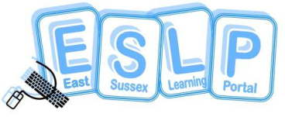
ESSCP Multi-Agency Training:
The ESSCP offers a wide range of training for professionals. Details of future courses can be found on the East Sussex Learning Portal: www.eastsussexlearningportal.org.uk

Pan Sussex Safeguarding and Child Protection Procedures
Details of child protection and safeguarding procedures in relation to pre-birth assessments and child protection conferences can be found at 5.3 Pre-Birth Conference | Sussex Child Protection and Safeguarding Procedures Manual

