Social media posts focused on families with children
January to March 2021

- For use up to 31st March 2021
- Please include the link to the Keep Warm and Well Website (warmeastsussex.org.uk)
- Contact Louise Trenchard – ltrenchard@hastings.gov.uk with any questions or queries.

Post | Picture
Struggling to keep warm at home this winter? Contact us today for advice or to find out if you qualify for a free COVID-secure Warm Home Check. warmeastsussex.org.uk

Is your family struggling to keep warm at home this winter? Contact us today for handy advice and to find out about the support available. You may qualify for a free COVID-secure Warm Home Check and essentials to help your family keep warm and well. warmeastsussex.org.uk

Is it a struggle to keep your family warm at home this winter? The Warm Home Check Service could help!  We offer advice and can help you to access support that’s available. If you’re on a low income you may also be eligible for a free COVID-secure Warm Home Check which includes:  - – advice on getting help with the cost of heating your home  - – an assessment of your home and tips to keep it warm  - – small improvement works or repairs  - – essentials to help your family keep warm and well.  Go to warmeastsussex.org.uk to find out if you are eligible and book your Warm Home Check today. | 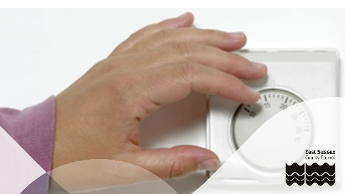
Is your family struggling with fuel bills? Let the Warm Home Check service help you to keep warm and well this winter.

Top tips to stay warm this winter
– keep your home heated to at least 18C (64F)
– draw the curtains at dusk to keep the heat in
– keep bedroom windows closed on winter nights
– make sure your radiators are not blocked
– have at least one hot meal a day and plenty of hot drinks
– don't sit still for more than an hour – get up and stretch your legs

Find out if you're eligible and arrange a free Warm Home Check by enquiring on the Warm East Sussex website, texting WARM to 81400 or calling Citizens Advice on 03444 111 444. Lines are open Monday to Friday from 9am to 5pm.

Alternative pictures
