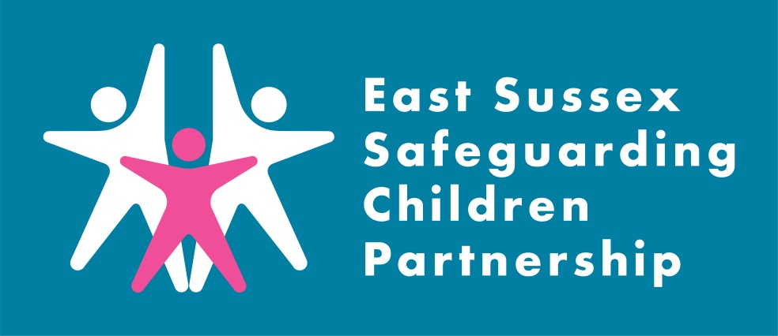
What is a Rapid Review?

Working Together to Safeguard Children 2018 places a duty on local safeguarding partnerships to undertake a rapid review for serious child safeguarding cases where: abuse or neglect of a child is known or suspected; and the child has died or been seriously harmed.

When a serious child safeguarding case is referred to the East Sussex Safeguarding Children Partnership, we have 15 working days to complete a Rapid Review and notify the National Panel of the outcome of the meeting.

The Rapid review does not replace any safeguarding or child protection processes, but identifies where there is any potential for a national or local Child Safeguarding Practice Review (LSCPR)

Infant Injury
Learning Briefing II

March 2021

Introduction:
This is the second Infant Injury Learning Briefing that the East Sussex Safeguarding Children Partnership (ESSCP) has published. The first briefing was published in summer 2020 following two serious case reviews in 2019, which both featured non-accidental injuries in young children.

This second briefing includes learning from three further cases that were reviewed by the ESSCP, but which did not meet the criteria for conducting a local child safeguarding practice review (LSCPR). The briefing also captures emerging learning from a national review on infant injury.

Background:
The impact of COVID-19, and the subsequent national lockdowns, has been significant on child safeguarding. Ofsted were notified of 285 serious incidents (where a child has died or suffered significant harm) during the first half of 2020-21; an increase by 27% on the same period in 2019-20. Of those incidents 36% related to children under the age of one.
The rise in these serious incidents is undoubtedly a result of the ‘pressure cooker’ of the pandemic: a time of enormous additional stresses faced by families coupled with a reduction, or total stop, in contact with families by vital services and wider community support.
During March and May 2020, the East Sussex Safeguarding Children Partnership was notified of three significant incidents involving:
- A two month old baby brought to A&E by their mother with bruises to their forehead, left arm and left leg. Subsequent skeletal survey and Brain imaging identified further evidence of current and old fractures and haemorrhages within the brain.
- An eight week old baby presented at A&E with mother reporting baby was not moving their arm. An x-ray investigation showed it was a fracture. A skeletal survey raised concerns of other fractures.
- A seven-week-old baby was seen in A&E with unexplained swelling of the left lower leg. X-rays of the legs, and subsequent skeletal surveys, identified fractures to both lower legs of a type that is typically seen in non accidental injury .
While abuse and/or neglect and significant harm were all features of these cases, the ESSCP agreed that conducting a Local Safeguarding Children Practice Review (LSCPR) would not be a proportionate response. There was limited involvement by agencies with the families and the rapid reviews did not identify any concerns about multi-agency working. In one case a single-agency review took place, in another a multi-agency reflective learning event was held. In the other, the Rapid Review process identified learning for SECAMB to increase awareness of possible non-accidental injuries and ensure that contacts regarding possible injuries to non-mobile infants are responded to with high priority.

In autumn 2020, the ESSCP was also asked to take part in a national thematic review, by the National Child Safeguarding Practice Review Panel, into non-accidental injury in children under one. The National Panel used learning from our unpublished Serious Case Reviews completed in 2019. Although the National Panel has yet to publish their report (expected summer 2021), we attended a round table discussion where emerging learning was presented.

Key learning
The following learning highlights key themes from our locally reviewed cases, and learning arising from the national thematic review, into non-accidental injuries in children under one:
- Information sharing – information sharing across agencies is not consistent, and IT systems do not support effective information sharing, of risks and issues (for example between midwifery and health visiting); GPs do not always share concerns about parenting capacity with other agencies; information systems do not routinely flag for information about fathers, non-birthing partners, or other significant males.

- ‘Invisibility and non-engagement’ of men – this is a common feature of local case reviews and national learning. The role of fathers is not always fully considered despite them not being ‘invisible’ but often in plain view. More effort should be made to engage fathers, non-birthing partners, or other significant males pre and post-birth. There is also a role for other services, such as housing, to help identify fathers/other significant males that are not living in the same house but have caring responsibilities (that are often not disclosed due to conditions of financial benefits).

- Access to services – current antenatal provision does not always work for engaging fathers (i.e. majority of provision during working hours). The pre-birth Health Visitor visit at home was also seen as a critical touch point in establishing a good relationship with parent/s.

- Domestic abuse – current and historical domestic abuse was a significant factor in the cases reviewed nationally. There was a particular focus on confidence and skills in recognising coercive and controlling behaviour. The national review also flagged the link between MARAC and CP systems were often not strong enough.

- Mental health – Adverse childhood experiences (ACE), anger management, and anxiety were all common features of the national cases reviewed. The national review found there was often an unhelpful focus on presenting issues, rather than addressing underlying causes. Learning also included that GPs often have information on fathers mental health but risk factors are not shared.

- Procedures – within the national cases there were examples of bruising in babies and ‘was not brought’ protocols not being followed. There was also consideration of the benefits of conducting pre-birth assessments for care leavers.

What to do

- Be professionally curious. Bruising in a non-mobile child should never be interpreted in isolation and should always be assessed in relation to the infant's developmental abilities and the likelihood of the occurrence.

- Familiarise yourself with the Pan Sussex Procedure on unexplained injuries to young children and local guidance.

- Familiarise yourself with ICON – our preventative programme designed to support parents to better understand and safely respond to infant crying. The ICON message is:
I – Infant crying is normal
C – Comforting methods can help
O – it’s OK to walk away
N – Never, ever shake a baby.

- Consider if you need additional training or support to be confident having difficult conversations. The ESSCP is running a new multi-agency training course in 2021/22 “Holding Difficult Conversations” – dates tbc in June 2021. Please contact Giovanna Simpson, ESSCP Training Consultant (Giovanna.simpson@eastsussex.gov.uk) for more information.

Questions to consider

We encourage you to discuss this briefing in your team meeting or group supervision. Questions to consider:

ICON
- Do we discuss normal infant crying and management strategies with parents?
- Have we checked the ICON message has been received and understood by all our team members?
- How will we as professionals share the ICON message?

Engaging fathers and other males
- Do we sufficiently engage the father (or non-birthing parent/other significant males) when we work with a new parent?
- How can our services be better designed/delivered to engage fathers, non-birthing parents, and other significant males?
- Do we always ask if there are other adults with caring responsibilities? Do we give enough consideration to fathers that are not in a relationship with the mother, or live in the family home?

Escalating concerns
- What action do you take if you are aware that contact has resumed between a mother and her abusive partner?
- What do you do if you are concerned about the response/advice you have received from SPoA?
- Have you used the Sussex ‘Professional Conflict resolution’ procedure?

Serious incident notifications, Part 1 (April to September) 2020-21 – Explore education statistics – GOV.UK (explore-education-statistics.service.gov.uk)

