East Sussex School Health
Ready, Steady, Go!
Stakeholder Communications Pack

Ready, Steady, Go!
Thank you for enquiring about the children and young people’s healthy weight programme being delivered by the East Sussex School Health Service.
This document contains some background about the programme design and structure for our children’s weight management programme Ready, Steady, Go!
It also includes some suggested posts for your newsletters and emails, informative videos, and JPEG and PDF versions of our programme posters for your use.
Please contact us if you need alternative formats such as bleed and no bleed versions.

What is Ready, Steady, Go?
Ready, Steady, Go! is an eight-week group programme for children aged 4 to 11 and their families. The focus is on helping families achieve and maintain a healthy weight by making small and achievable lifestyle changes with the support of a team of trained staff.
Eight sessions cover a range of lifestyle topics including healthy eating, being active, sleep and screen time. They are delivered in groups in local venues and online. Sessions last up to an hour.
As well as attending the group, families have the opportunity to access one-to-one support throughout the duration of the programme, where they have the chance to discuss individual progress and other queries that they may feel they need some extra support with.

Who is it for?
Ready, Steady, Go! is suitable for East Sussex families who are looking to achieve and maintain a healthy weight. To be eligible for the programme, one child within the family will be above the healthy weight range. If you are unsure, our team can help you work this out or you can use the NHS healthy weight calculator to calculate their BMI.
When and where are the sessions?
Ready, Steady, Go! sessions are offered on a virtual and face-to-face basis. For our fully virtual programme, families can access the one-hour weekly group sessions online via Microsoft Teams. Families will need access to a computer, tablet or mobile phone with internet, camera and microphone access.

Our face-to-face groups are delivered at local community venues, such as schools or community centres, and take place after school. Due to the COVID-19 pandemic, we are currently planning to host a hybrid version of our next face-to-face groups, meaning some weeks will be held at venues in person, and some held virtually.
Parents and carers are asked to attend the group with their child, whether the session is online or in person. Ready, Steady, Go! is a programme that can benefit the whole family and we know that parents and carers play a crucial role in helping their child to make positive lifestyle changes.
From September and October 2021, groups will be running Monday to Thursday after school, with our next cohorts beginning the last week of September.

September and October 2021 GROUPS
- Monday, 27 September 2021
High Cliff Academy, Newhaven
4 to 5pm (hybrid group – half the sessions are face-to-face*)

- Tuesday, 28 September 2021
Virtual group
4 to 5pm (all sessions are online)
- Wednesday, 6 October 2021
The Baird Primary Academy, Hastings
4 to 5pm (hybrid group – half the sessions are face-to-face *)
- Thursday, 7 October 2021
Virtual group, 4 to 5pm (all sessions are online)

*Please note that subject to changing NHS COVID-19 restrictions, hybrid groups may have to be delivered as a fully virtual programme
Families that are unable to join us for the groups starting in September and October can still get in contact with us and join our waiting list so they are ready to join us in the new year.

How to join
Families can refer themselves into our programme using the online referral form or by calling our service and speaking to a member of the team. Schools and other professionals who may be supporting your family can also make a referral on the family’s behalf.
Online referral form: School Health Service (East Sussex) referral form | Kent Community Health NHS Foundation Trust (kentcht.nhs.uk)
Phone: East Sussex School Health Service on 0300 123 4062
How can we help you to refer families?
We know there are many professionals and volunteers working across East Sussex who are making key contacts and having important conversations with families that may benefit from accessing Ready, Steady, Go!
Join us at one of our monthly online MS Teams sessions where we’ll talk you through the programme, how to refer families and some key conversation points when talking about the challenging topic of raising the issue of weight.
- Thursday, 30 September 4-5pm
- Tuesday, 26 October 10.30-11.30am
- Monday, 29 November 4-5pm
- Thursday, 16 December 2-3pm
Email Kim Pocock kimberley.pocock@nhs.net to receive an invite to the session.

Do you need more support about raising the issue of weight with families?
We will also be delivering termly online workshops where we will talk in more detail about how professionals and volunteers can raise the issue of weight with parents and carers. Contact the service on kentchft.esschoolhealthservice@nhs.net or 0300 123 4062 for more information about these workshops.

You can also find information on our service website at: Ready, Steady, Go | East Sussex (eastsussexchildren.nhs.uk)
Here you can find information and videos about the programme, the latest group start dates and FAQs about all different aspects of the programme. You will also find a direct link to our East Sussex School Health referral portal.

Videos
We have produced some short, social media- friendly videos that we’d love you to use on your websites, online newsletters and social media platforms to promote the programme.
Click on the video pictures or titles to be taken to Vimeo where you can download the videos for use.
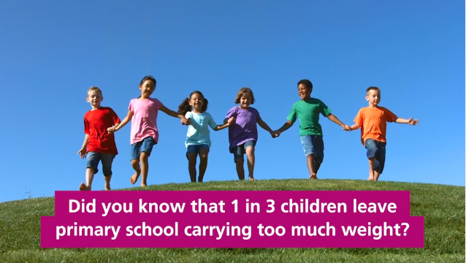
RSG short promotional video
This video is a brief call-to-action to encourage families to visit the East Sussex School Health website for further information about our healthy weights and lifestyle programme Ready, Steady, Go!

Family experience videos
The following videos include content from families about their experience of engaging with the Ready, Steady, Go programme. They are short 30-second videos, perfect for social media or to show clients you may be working with. The longer, full length versions of some of these videos that can be watched on our website at Ready, Steady, Go | East Sussex (eastsussexchildren.nhs.uk)
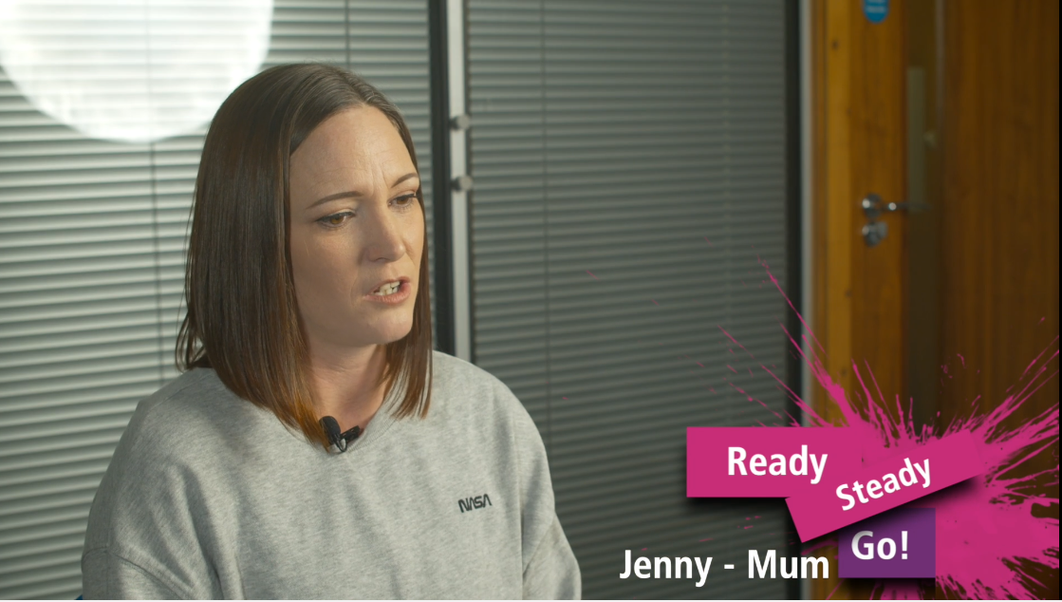
The programme helped all of us short social media clip.

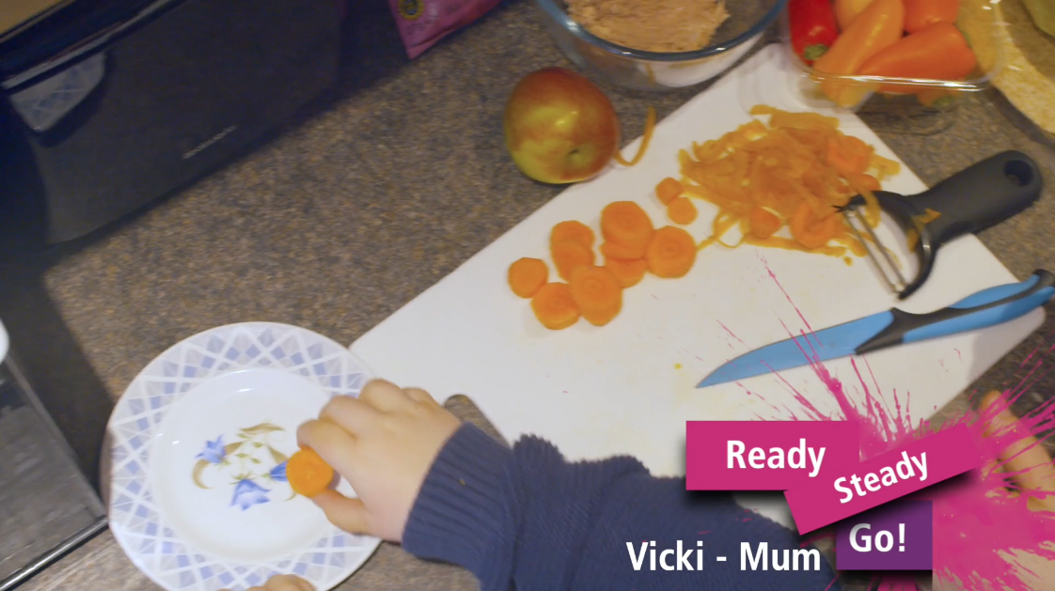
We’ve done it together as a family short social media parent experience clip.

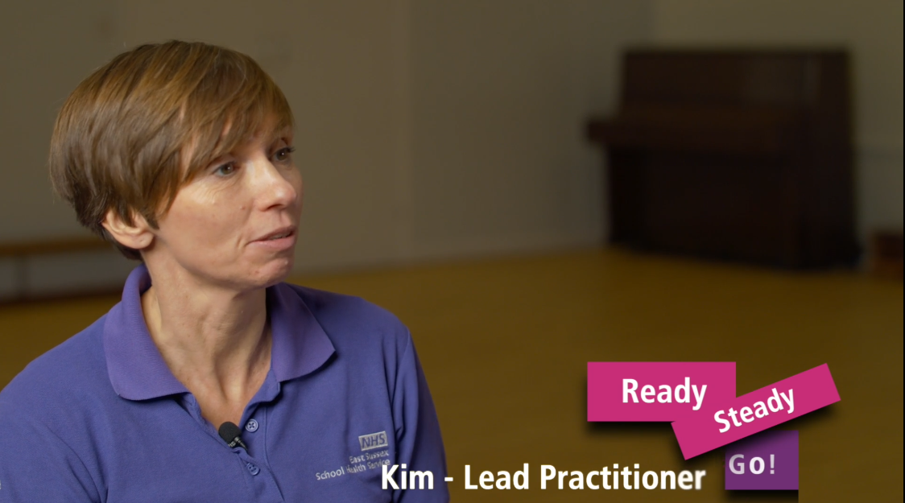
Who is it for? short social media clip.

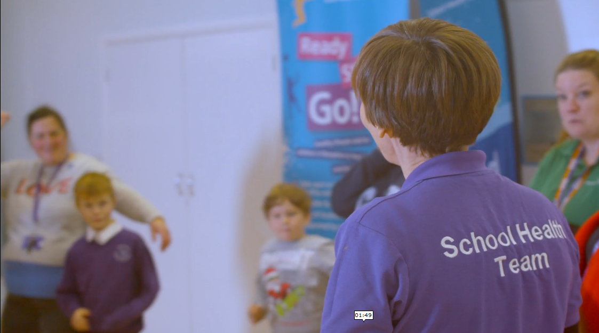
Family video three-minute video.

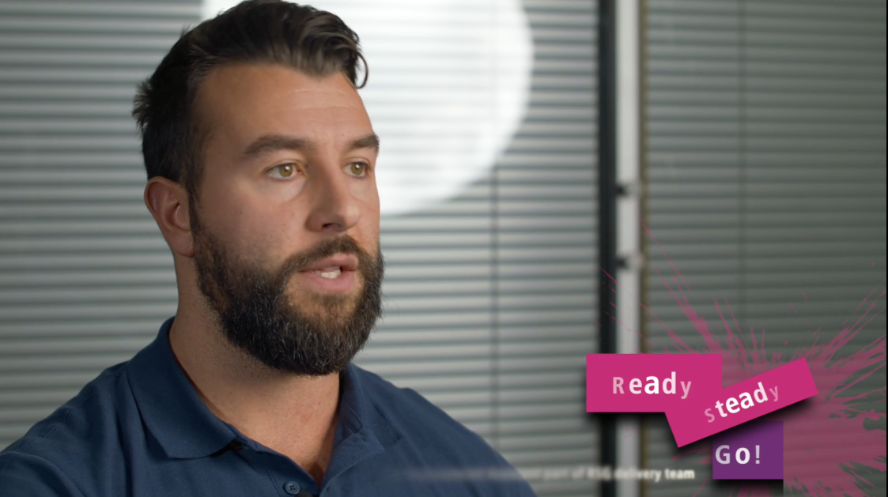
Parent, staff and teacher perspectives five-minute video

Social media
The short video clips above are perfect to accompany your social media posts.
Find more posts and information about Ready, Steady, Go at our East Sussex School Health Service Facebook page. Just search @ESSchoolHealth

Please like and share our Ready, Steady, Go! posts on Facebook to your organisation’s page. Our Instagram account is coming soon.

Schools – live workout with Ready Steady Go!
Meet the Ready, Steady, Go! team, learn about the programme and join us live online for a quick family friendly workout.
Join us on Microsoft Teams for our live stream:
- Tuesday 28 September 9.15am – primary schools, join us during registration or assembly for a great start to your school day! Click here to join the meeting
- Wednesday 15 December 9.15am – primary schools, join us during registration or assembly for some Christmas fitness fun! Click here to join the meeting
- Can’t make it? Watch a recorded version of the session to watch at a convenient time from our website: Ready, Steady, Go | East Sussex (eastsussexchildren.nhs.uk)

Live workouts with Ready Steady Go!
Meet the Ready, Steady, Go! team, learn about the programme and join us live online for a quick family friendly workout!
Join us on Facebook Live for our live stream @ESSchoolHealth:
  - Wednesday, 29 September 4.15pm. Parents and carers, meet the team and finish the school day on a fitness high!
  - Thursday, 16 December 4.15pm. Parents and carers, meet the team and join us for a quick workout!

Not long now until the next Ready, Steady, Go! groups start in September and October 2021
Do you want to help get your family’s healthy lifestyle back on track? Our eight-week family programme covers everything from healthy eating and physical activity, to sleep and screen-time to help your primary school-aged child achieve a healthy weight.
You can join us at one of our face to face groups, or from the comfort of home with our virtual sessions. Join now by contacting East Sussex School Health via our referral portal, email or telephone:
Online referral form School Health Service (East Sussex) referral form | Kent Community Health NHS Foundation Trust (kentcht.nhs.uk)
kentchft.esschoolhealthservice@nhs.net
Telephone 0300 123 4062
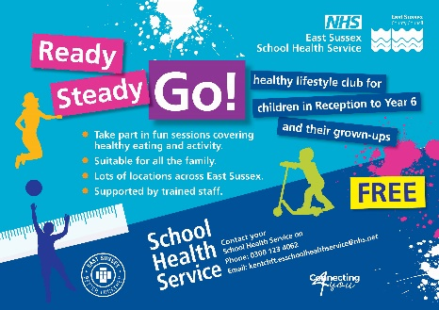

Ready, Steady, Go stock photo library – please feel free to use.

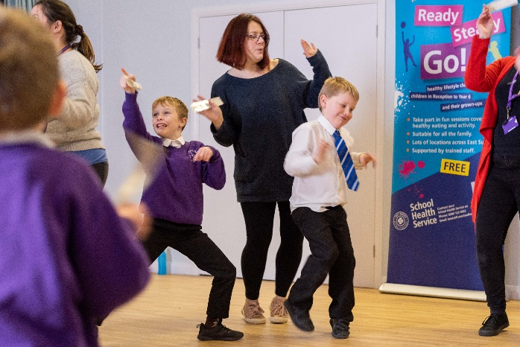

Posters and leaflets
Here you can find digital versions of resources to help promote Ready, Steady, Go!
- RSG landscape JPEG for web/social media/newsletters
- RSG portrait JPEG for web/social media/newsletters

RSG pdf portrait poster with hyperlink RSG JPEG for web/bulletins RSG landscape poster PDF

RSG landscape JPEG for web/bulletins

