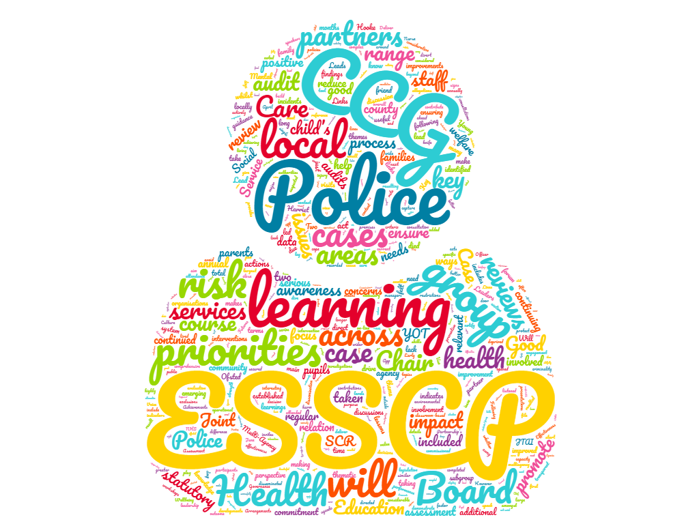

**East Sussex Safeguarding Children Partnership**

**Annual Report 2020/21**

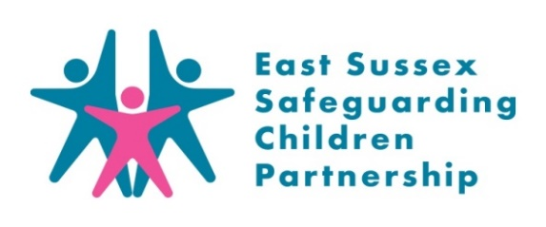

**www.esscp.org.uk**

**Contents**

|  |  |  |
| --- | --- | --- |
|  | **Foreword by East Sussex Safeguarding Children Partnership Independent Chair** |  |
|  |  |  |
| **1.** | **Introduction by strategic safeguarding partners** | **4** |
|  |  |  |
| **2.** | **Key Learning & Achievements 2020/21** | **5** |
|  |  |  |
| **3.** | **Safeguarding Context 2020/21** | **6** |
|  |  |  |
| **4.** | **Partnership Arrangements** | **7** |
| 2.1  2.2  2.3  2.4  2.5  2.6  2.7 | Overview of the Partnership  Board structure and subgroups  Links to other partnerships  Joint Targeted Area Inspection  Pan Sussex working  Review of partnership arrangements and future developments  East Sussex Safeguarding Children Partnership Priorities for 2020-23 |  |
|  |  |  |
| **5.** | **Impact** | **13** |
|  |  |  |
| **6.** | **Evidence** | **23** |
|  |  |  |
| **7.** | **Assurance** | **30** |
|  |  |  |
| **8.** | **Learning** | **34** |
|  |  |  |
|  |  |  |
| **9.** | **Appendices** | **37** |
| 9.A | Board Membership 2020/21 |  |
| 9.B | East Sussex Safeguarding Children Partnership Budget |  |
| 9.C | Links to other documents |  |
| 9.D | Learning Briefings 2020/21 |  |
| 9.E | Acronyms |  |

**Foreword**

It is my privilege to present to you the second annual report of the East Sussex Safeguarding Children Partnership (ESSCP) for the period 2020/21, and my last as the Independent Chair.

It is the statutory responsibility of the local authority, police, and health agencies to jointly oversee multi-agency arrangements to safeguard children in the county. As Independent Chair I assist this by providing independent challenge and scrutiny of those arrangements as well as helping to foment better multi-agency strategic working to protect vulnerable children and young people and ensure positive outcomes for them.

This is the first full year that the statutory agencies have held equal responsibility for the partnership. Each senior lead has committed to this triumvirate arrangement positively, working closely with each other at formal quarterly planning meetings which I Chair, and through their day-to-day leadership. I am confident that the close sharing of responsibility will continue to develop in the coming months and years.

We published one Serious Case Review this year, Child W, which produced significant learning for agencies both locally and nationally. This and other important documentation and reports can be found on our website [www.esscp.org.uk](https://www.esscp.org.uk/)

At the start of the year the totally unanticipated challenges of Covid-19 hit the UK. The impact on children and on the safeguarding system was, and is, substantial, creating additional risk groups and challenges to front line staff and leaders. The local leadership and front-line dedication have shown that the county has a highly adaptive partnership to meet the new challenges. Covid-19 impact is a long term and persistent issue for us, and we are now seeing the negative impact this is having on some children in the cases coming to our attention.

The safeguarding arrangements for the diversity of children in East Sussex are complex. This report has a strong focus on what impact the partnership has had in priority areas and the evidence on which it bases its decisions in a way that, we hope, guides the reader through the complexity. I hope you find the report interesting and informative.





**Reg Hooke**

**Independent Chair of the East Sussex Safeguarding Children Partnership**

1. **Introduction**

We are delighted to present this annual report on behalf of the three statutory partners of the East Sussex Safeguarding Children Partnership. This has been written against the backdrop of the unprecedented global Covid-19 pandemic and it is crucial to acknowledge the impact this has had on our children and families in East Sussex. For every member of the East Sussex Safeguarding Children Partnership, the impact on their service has been significant and unprecedented. Early learning from impact of lockdowns on children and families has been significant and has informed system-wide responses to future lockdowns as partners worked closely to ensure children did not become hidden and that their education, and the social and emotional benefits this brings, was prioritised.

Despite the impact of the pandemic on the operation of services and capacity, the statutory functions of the Partnership have been maintained throughout the course of the year. This has seen an increase in statutory reviews taking place, a continued development of our multi-agency audit processes and the roll out of an extensive virtual learning offer for staff who work with children and families.

Following feedback from the Alan Wood Review and the National Safeguarding Panel’s analysis of SCP’s annual reports, the ESSCP Annual Report for 2020/21 has been restructured so that it is more clearly focused on the impact of partnership working; the evidence used to inform multi-agency working; how the lead safeguarding partners are given assurance of local safeguarding practice; and the learning arising from partnership review activity.

On behalf partnership we hope you find this report to be informative, and open and honest in regards to our achievements and challenges over the last financial year. We would like to sincerely thank all those who have worked tirelessly in East Sussex over the past 12 months to help keep children safe.

|  |  |  |
| --- | --- | --- |
|  |  |  |
| **Naomi Ellis**  **Deputy Director Quality, Safeguarding & Looked After Children, Sussex NHS Commissioners** | **Alison Jeffery**  **Director of Children’s Services, East Sussex County Council** | **Jon Hull**  **Detective Superintendent – Public Protection, Sussex Police** |
|  |  |  |

1. **Key Learning & Achievements 2020/21**

Training

* Roll out of virtual courses from August 2020.
* 545 multi-agency staff attended 42 virtual training courses
* 96% of evaluations rated course as Excellent or Good
* Successful implementation of a local ‘Contextual Safeguarding’ response to children with multiple needs
* Launch of the ICON programme to reduce infant head trauma
* Monitoring and evaluating outcomes of Joint Targeted Area Inspection on mental health
* Task & Finish Groups created to take forward multi-agency activity on Safeguarding Under 5s and A&E and Education Information Sharing
* Two audits held: on intra-familial sexual abuse and domestic abuse. A further MACE audit held on education.
* All cases demonstrated good initial response and an effective response to safeguard the child. No children were found to be unsafe.
* Education Safeguarding
* Child Exploitation
* Embedding a Learning Culture
* Safeguarding under 5s
* Review of partnership arrangements ‘1 year on’
* Learning Strategy launched
* All agencies actively participated in our Section 11 Audit evaluating safeguarding practice
* Development of effective virtual partnership working
* Strengthening of Pan Sussex working and links with the Safeguarding Adult Board
* 5 multi-agency Rapid Reviews conducted to respond to serious incidents
* 1 Serious Case Review published (child W)
* Two learning briefings on infant injuries published
* Engagement in the National Safeguarding Panel review on infant injury
* Three LCSPRs started: Child X, Child Y, and Child Z

**3. Safeguarding Context 2020/21**

**Impact of multi-agency working**

**Children with health related vulnerabilities**

**Children whose actions place them at risk**

**Children supported by statutory services**

**Children with family related vulnerabilities**

1. **Governance Arrangements**

**4.1 Overview of the Partnership**

In 2018/19 there were significant changes to the [Children and Social Work Act 2017](http://www.legislation.gov.uk/ukpga/2017/16/contents/enacted), which created new duties for three key agencies, police, health and the local authority, to lead arrangements locally to safeguard and promote the welfare of children in their area. [Working Together to Safeguard Children 2018](https://www.gov.uk/government/publications/working-together-to-safeguard-children--2) outlined the replacement of Local Safeguarding Children Boards with Local Safeguarding Partnerships, a number of changes to conducting serious case reviews, and significant changes to the child death review process.

The East Sussex Local Safeguarding Children Board formally moved to the East Sussex Safeguarding Children Partnership (ESSCP) on 29 September 2019. The three ESSCP safeguarding partners are:

The ESSCP acts as a forum for safeguarding partners to:

* agree on ways to coordinate safeguarding services in (the geographical local authority borders of) East Sussex.
* act as a strategic leadership group in supporting and engaging other agencies across East Sussex; and
* implement local, regional, and national learning, including from serious child safeguarding incidents.

**4.2 Partnership Structure and Subgroups**

The Board is chaired by an Independent Chair, meets four times a year and is made up of the statutory safeguarding partners and relevant agencies (full list of board members is included in Appendix A). The Independent Chair also chairs the ESSCP Steering Group which meets four times a year. The Independent Chair fulfils the role of the Independent Scrutineer and acts as a constructive critical friend to promote reflection to drive continuous improvement.

The main Board is supported by a range of subgroups that lead on areas of ESSCP business and are crucial in ensuring that the Partnership’s priorities are delivered. These groups ensure that the Partnership really makes a difference to local practice and to the outcomes for children and young people. Each subgroup has a clear remit and a transparent mechanism for reporting to the ESSCP, and each subgroup’s terms of reference and membership are reviewed annually.

The three ESSCP safeguarding partners and the Independent chair form the Planning Group, which also meets quarterly. The Planning Group discusses and agrees the short-term agenda for the work of the partnership and addresses any emerging safeguarding issues requiring strategic input. It also agrees the budget for the ESSCP (see Appendix B).

The Pan-Sussex Strategic Leaders Group membership consists of lead safeguarding partners across East Sussex, West Sussex, and Brighton & Hove. The group’s purpose is to focus on setting the ‘road map’ for future partnership development and identify shared safeguarding priorities and opportunities across the three areas.

Terms of Reference for all the groups are in the process of being refreshed and will be shared on the ESSCP’s website here: [Subgroups - ESSCP](https://www.esscp.org.uk/about-us/subgroups/) when agreed.

**4.3 Links to Other Partnerships**

The Partnership has formal links with other East Sussex and Pan-Sussex strategic partnerships, namely the Health and Wellbeing Board; Pan Sussex Child Death Overview Panel (CDOP), Safeguarding Adults Board (SAB); Safer Communities Partnership; West Sussex and Brighton & Hove Safeguarding Children Partnerships; Children and Young People Trust (CYPT) and Local Head Teacher Forums. Links to other significant partnership documents are highlighted in Appendix C.

The ESSCP Independent Chair also maintains regular liaison with other key strategic leaders, for example, the Police and Crime Commissioner, neighbouring Safeguarding Children and Adult Partnership Chairs and Government inspection bodies.

The ESSCP annual report is presented to the East Sussex County Council People Scrutiny Committee, East Sussex SAB, the Safer Communities Board, the Police and Crime Commissioner and other ESSCP member organisations’ senior management boards.

During 2020/21 the ESSCP has been working with the Safeguarding Adults Board (SAB); Safer Communities Partnership; Children and Young People Trust (CYPT) and the Health and Wellbeing Board to develop a the ‘East Sussex Partnership Protocol’. The protocol sets out the relationships between key partnerships to promote the health and wellbeing of East Sussex’s communities. In relation to safeguarding, the protocol aims to secure coordinated partnership working that avoids duplication and achieves better outcomes for the people of East Sussex. Once agreed, the protocol will be available on the ESSCP website here: [Subgroups - ESSCP](https://www.esscp.org.uk/about-us/subgroups/)

**4.4 East Sussex Joint Targeted Area Inspection**

In February 2020 the East Sussex Joint Targeted Area Inspection (JTAI) took place on the theme of children’s mental health. The inspection was undertaken by Ofsted, the Care Quality Commission (Health), Her Majesty’s Inspectorate of Constabulary (Police) and Fire & Rescue Services and HMI Probation (YOT). The joint inspection included an evaluation of the ‘front door’ and how agencies identify and respond to the inspection theme of children’s mental health. During the JTAI, inspectors found that some areas of multi-agency working could be further strengthened, such as information sharing and that the use of qualitative feedback to demonstrate the impact of agencies could be improved. A multi-agency action plan has been developed to address these areas. This was overseen by the ESSCP Steering Group during 2020/21. Examples of the impact of this action plan can be found in section 5.

**4.5 Pan Sussex Working**

Although the ESSCP’s focus in on safeguarding children in East Sussex, it should be expected that child protection and safeguarding procedure continue to be developed at a Pan Sussex level, and opportunities for joined up working across Sussex will be promoted where appropriate. Examples of Pan Sussex working in 2020/21 include:

* **Learning & Development opportunities** -
  + Existing training: Multi-Agency Public Protection Arrangement (MAPPA), Improving Outcomes for Looked After Children, NSPCC/pan-Sussex SCP ‘It’s your call’ campaign
  + Planned training in development: Harmful Practices; Professional Challenge, Social Graces/Identity, Cultural Competency/Equalities, Suicide Prevention
* **Safeguarding Children Under 5** – East Sussex has facilitated pan-Sussex meetings looking at developing common principles for practitioners regarding the promotion of safer sleeping. This follows on from the publication of the National Safeguarding Panel’s report “Out of Routine: A Review of SUDI in families where the children are considered at risk” in 2020. The group has been ensuring that this work aligns with ICON. The group will also be informing the planning for the proposed pan-Sussex SCP Conference in November 2021, which will focus on a range of issues regarding the safeguarding of infants.
* Between April 2020 to March 2021, the **Pan Sussex Procedures Group** which reviews, updates, and develops pan Sussex safeguarding policies and procedures, supported by several front-line practitioners, reviewed, or created **39** safeguarding policies. The jointly funded Pan Sussex Policy Lead post was embedded in 2020 to co-ordinate a consistent approach to the development and maintenance of the pan Sussex Child Protection and Safeguarding Procedures. This provides an effective and timely response to reflect changes required to procedures from legislation updates or local and national learnings, providing a current tool for professionals working with children and families across Sussex.
* **Suicide Prevention and Emotional Health and Wellbeing** - there is an emerging picture of increased pressure on already pressed CAMHS and acute services across Sussex. Acute hospital settings have seen a rise in self-harm presentations. A Pan Sussex, Public Health led approach to suicide prevention and a working group focussed on improving commissioning of services has been established.

**4.6 Review of Partnership Arrangements: 1 Year On**

* **Lead Safeguarding Partners Self-Assessment**

At the end of 2020/21 the ESSCP lead safeguarding partners undertook a self-assessment as part of the activity to review the effectiveness of our partnership arrangements. The self-assessment tool was developed based on the University of Bedfordshire research *‘six steps for independent scrutiny of safeguarding children partnership arrangements.* Leads separately self-assessed the partnership, followed by a collective discussion at the Planning Group to agree a red, amber, or green rating against specific questions linked to the six statements.

For 2021/22 an action plan has been developed for the partnership to address the areas rated as amber or red. The action plan will include the development areas:

* + Transitional safeguarding arrangements - ensuring close links with adult services.
  + Partnership representation from the private and business sector. Plus, improved representation from schools/colleges.
  + Consideration of appropriate input from children, young people and their families on partnership reviews, meetings, training, audit activity and partnership development.
  + Further exploration of training needs of the children’s safeguarding workforce and the impact of the training programme
* **Review of arrangements with Board Members**

The ESSCP Chair, Business Managers and Lay Members spoke to a total of 14 board members to consider the effectiveness of current partnership arrangements. Specifically, those board members were asked about their role and the support to fulfil the expectations of that role, and the functioning of partnership board meetings.

Generally, the feedback was very positive with all board members interviewed commenting on the effectiveness of the partnership and board meetings in general. A few Pan Sussex agencies commented that the East Sussex SCP feels particularly well-functioning and collaborative, with good attendance by agencies.

Given the diversity of agencies interviewed, it was encouraging that all members understood and valued their membership of the board, and how this supported the safeguarding of children across the whole system.

Several comments were also made about the positive role of the Chair; including how they were approachable and accessible which supported a culture of open and honest challenge and collaboration; how they effectively chaired meetings to ensure that members were encouraged to participate; and the effectiveness of the Chair in holding agencies to account.

Other comments to note:

* All members commented that they found the board meetings useful – in networking with other board members and being able to keep up to date with current work programmes and safeguarding trends.
* Some members noted that the board meetings required lots of time and effort to prepare for when they were able to contribute very little to most main items. The board breakout sessions helped to ensure that all members were able to contribute.
* Communication from the board was clear, timely and well received. In particular, the [one-page summaries from the board](https://www.esscp.org.uk/about-us/subgroups/) were helpful.
* A few members suggested that there could be opportunities to join up communications with Pan Sussex SCPs and/or Safeguarding Adult Boards on a more regular basis – to avoid duplication and strengthen key messaging.
* They would welcome an ‘induction pack’ for new members that sets out subgroups etc and includes what are the expectations and role for board members. Potential that this could be done on a pan Sussex basis.
* Comment from ‘school’ representatives that sometimes schools felt like they were being ‘done to’ rather than informing the debate.
* One member was concerned that the board often discusses an issue when the agency response is already underway, rather than bringing partners together at an earlier, development stage.
* All felt that learning from reviews was very important.
* Members noted that agencies often have well embedded engagement processes with children and young people, but this feedback is not shared at board level. One member noted that the “Partnership relies on board members to bring voice of the child. We must listen as a partnership and not listen in isolation”

**4.7 ESSCP Priorities for** **2020/23**

Following the formation of the ESSCP in September 2019, discussions took place to determine our priority areas of focus for 2020 to 2023. The partnership felt strongly that priorities should relate to key areas of child safeguarding; those identified as of highest risk in the county, where multi-agency working is essential and where significant change and/or commitment is necessary to reduce risk.

Priority development took place at the start of the year, with both the Steering Group and Board, and were agreed by the three safeguarding partners in May 2020. More information on the priorities is contained in the impact and evidence sections of this report. The agreed ESSCP Priorities for 2020-2023 are:

* **Safeguarding in Education**

Lead: Senior Manager, Safeguarding and Assessment, Standards and Learning Effectiveness Service (SLES), Children’s Services

* **Child Exploitation**

Joint Leads: Detective Chief Inspector, Safeguarding Investigation Unit, Sussex Police / Head of Specialist Services, Children's Services

* **Embedding a Learning Culture**

Lead: Manager, East Sussex Safeguarding Children Partnership

* **Safeguarding under 5s**

Joint Leads: Designated Nurse Safeguarding Children, Sussex CCG / Consultant in Public Health, Public Health

It is considered that ensuring the voice of the child is heard, and taking a contextual safeguarding approach, should be cross cutting over all the ESSCP priorities.

Challenges and next steps for 2021/22:

* Clarify how the partnership will work in future using digital tools while ensuring coherent partnership working
* Working group formed to review and align LCSPR processes, with an aspiration for a pan-Sussex procedure to be developed.
* Publish the East Sussex Partnership Protocol between the ESSCP and other East Sussex partnerships.
* SCP Managers to update the New Members’ Induction Guidance and formalise the ESSCP induction process.
* Future Chair arrangements for the ESSCP should be clearly communicated with board members.
* SCP Managers to consider what communication can be joined up with West Sussex and Brighton & Hove SCPs.
* The board should consider, at least on an annual basis, a standing item on the voice of the child – drawing on single agency and multi-agency engagement, and engagement activity by the ESSCP.

**5. Impact of Partnership Activity**

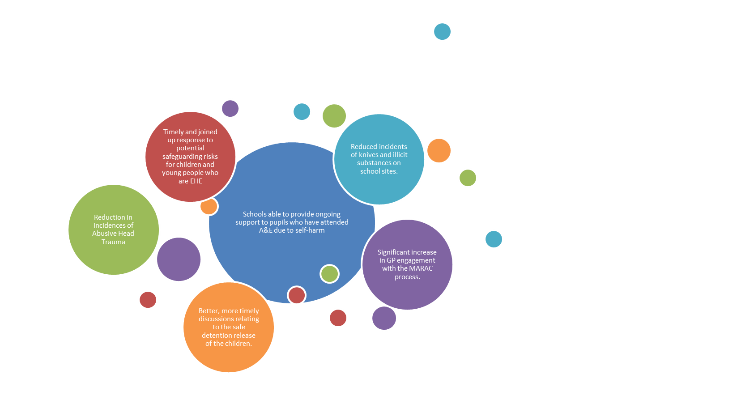

This section aims to convey the impact of multi-agency and partnership activity on outcomes for children and families. The examples of impact are structures around the ESSCP’s four priority areas and action taken following the Joint Targeted Area Inspection on child mental health in February 2020.

**5.1 Safeguarding in Education:**

|  |  |
| --- | --- |
| **Accident & Emergency (A&E) self-harm pathway with schools for children and young people (C&YP)** | |
| *What was the multi-agency area of need identified/responded to?* | C&YP who self-harm, or have significant mental health difficulties, often present to A&E. C&YP need support, help and guidance from specialist services, their families and people that know them best. It is a reasonable assumption that this support would also include their school. Schools are often unaware what challenges children are facing with regards to this issue, and therefore do not know when or how to offer support to help keep them safe. |
| *What action was taken to address that need?* | To help keep children safer and to share their difficulties with their school, a multi-agency task and finish group was formed to develop a pathway for information sharing from A&E to secondary schools, with consent. Next steps would include the consideration of extending the pathway to primary schools and across Sussex. |
| *What was the impact of that action on Children, Young People and Families?* | This pathway is in the early stages of implementation, therefore full impact is unknown. Information is ideally shared with a school because the school may be the only service that is involved with the child and who can support with the Children & Adolescent Mental Health Service (CAMHS) care plan. The schools could help safeguard that young person and identify any wider safeguarding risks that may not be apparent at the CAMHS assessment. Sharing of information is to primarily help the child and the school to be able to work with that child to look at ongoing support at school, and potentially support their family as well. |

|  |  |
| --- | --- |
| **Elective Home Education (EHE) communication and training task & finish group** | |
| *What was the multi-agency area of need identified/responded to?* | Learning from Local Child Safeguarding Practice Reviews (LCSPR) identified an uncoordinated and inconsistent approach to communication with the EHE team regarding potential safeguarding risks. Inconsistent levels of knowledge and understanding were identified across teams within the partnership.   * EHE legislation * The role of the EHE team * The limitations of EHE team’s contact with families * Identified professionals to be approached for case discussions where a concern was raised by another party   The need for communication, guidance, and training to be embedded at a strategic level was identified, to address the above areas of need. |
| *What action was taken to address that need?* | A multi-agency task & finish group was set up to explore embedding of communication pathways and training to all practitioners. Group participants include strategic safeguarding leads across health, social care, police and the EHE team.  One strand of action implemented from this group:   * An identified EHE Lead allocated within Single Point of Advice (SPoA). Training programme delivered by EHE team manager to SPoA EHE Lead, comprising clarification of EHE legislation, the role of the EHE team, the limitations of EHE team’s contact with families and the fragmentary nature of EHE team’s information about families. Pathways agreed for communication, with EHE team manager agreed professional for SPoA-initiated queries, and consultancy offer from SPoA to EHE team agreed.   Complementary to this action, the social care Liquid Logic system has been amended to ensure that the EHE badge is visible on both modules, and a child’s status as EHE is now visible to all social workers and early help keyworkers. |
| *What was the impact of that action on Children, Young People and Families?* | This action has ensured that EHE expertise now sits in SPoA. Contact from SPoA to the EHE team has increased, with discussions taking place when a Statement of Referral (SOR) is submitted by another party, and/or where clarification of a child’s educational setting is required. This improved flow of information ensures potential safeguarding risks for children and young people who are EHE are swiftly responded to and a joined-up approach is taken.  Measurement tools for this action are under development with Teaching & Learning Provision service manager. Further work includes developing a network of EHE Leads (on the same model as SPoA) across other partnership teams. |

**5.2 Child Exploitation**

|  |  |
| --- | --- |
| **Contextual Safeguarding – College Central** | |
| *What was the multi-agency area of need identified/responded to?* | Police and Education colleagues requested a contextual safeguarding response within College Central Eastbourne, which resulted in the first contextual assessment in East Sussex. This assessment provided the opportunity to enhance the contact and support that college central offered their most vulnerable adolescents. |
| *What action was taken to address that need?* | Funding secured via the Pan Sussex Violence Reduction Unit enabled the co-location of Youth Offending Team (YOT) practitioner time across College Central sites. This provides targeted early intervention to vulnerable pupils with the aim of raising awareness of risks such as knife crime and exploitation whilst preventing escalating anti-social behaviour and criminality through a one-to-one engagement offer. Between October 2019 and June 2020, practitioners engaged with 84 pupils and a thousand direct contacts took place. These have taken the form of one to one, group activities, positive activity sessions and family support. |
| *What was the impact of that action on Children, Young People and Families?* | Practitioners provide targeted early intervention to vulnerable pupils with the aim of raising awareness of risks such as knife crime and exploitation, whilst preventing escalating anti-social behaviour and criminality through a one-to-one engagement offer.  Data provided by the school suggests that this intervention has impacted positively on behaviour and exclusions and there have been reduced incidents of knives and illicit substances on school sites. |

|  |  |
| --- | --- |
| **MACE priority – PREVENT Communications** | |
| *What was the multi-agency area of need identified/responded to?* | PREVENT - Raising awareness and delivering targeted responses to Criminal Exploitation. Need identified to develop communications to children, parents and general public to develop a protective, local community. |
| *What action was taken to address that need?* | A variety of communications have been developed, including,   * East Sussex County Council YouTube Channel - [link for parents/carers](https://youtu.be/h5hcTLVtbD0) on county lines and exploitation. This was circulated to schools in the Uckfield Contextual Safeguarding project and Sussex Police Youth Teams * Accompanying leaflets (knife crime and exploitation) for young people and parents available on Safe in East Sussex and Open for Parents websites. * RE-issue of the 2019 Hotel Guidance shared with Eastbourne Hospitality Association to raise awareness within their networks. * [Open for Parents](https://www.openforparents.org.uk/) website – CSE/CCE information added for parents/carers of children aged 11-19. * County Lines Information has also been shared and added into ESCC parenting courses and leaflets for young people and parents. |
| *What was the impact of that action on Children, Young People and Families?* | Contextual Safeguarding responses to both child criminal exploitation and anti-social behaviour continue to be delivered in East Sussex. This work is overseen by the MACE strategic group. Youth Justice Board Pathfinder funding has this year enabled us to strengthen our safeguarding response to exploited children in Hastings and, over the coming months, we will be sharing our learning across the national YOT network |

**5.3 Embedding a Learning Culture**

|  |  |
| --- | --- |
| **ESSCP Learning Strategy** | |
| *What was the multi-agency area of need identified/responded to?* | It was identified that the ESSCP required a learning strategy to ensure the partnership has a clear and shared vision as to the priorities for safeguarding learning and training and to define how this will be achieved. |
| *What action was taken to address that need?* | The multi-agency Learning & Development Subgroup developed the strategy in consultation with the Training Pool practitioners. The ESSCP Learning Strategy was signed off by the Steering Group in December 2020. The Strategy aims to:   * Ensure that safeguarding training/learning activities are based on local necessity and enable practitioners to recognise and respond to need and risk. * Measure the impact of safeguarding training on practice and improving outcomes for children and young people. * Ensure that learning from Local Child Safeguarding Practice Reviews, Audits, the Child Death Overview Process (CDOP) and the Voice of the Child is embedded into practice and ensures continuous learning and improvement. * Ensure key safeguarding messages (local, pan-Sussex and national) are communicated.   These requirements are delegated to the ESSCP Learning & Development Subgroup which produces quarterly training reports, which form the basis of the Annual Learning & Development Report to the ESSCP Steering Group. |
| *What was the impact of that action on Children, Young People and Families?* | The implementation of a strategic learning and training offer that is effective in helping professionals understand their respective roles and responsibilities with regards to safeguarding children and young people. The effective training promotes better outcomes for children and young people by fostering a shared understanding of processes, principles, roles, and responsibilities. It provides opportunities for improved communication and information sharing between professionals, including a common understanding of key terms, definitions, and thresholds for action. |

|  |
| --- |
| **Learning and Communications** |
| **The ESSCP strengthened its links with the Safeguarding Adults Board (SAB)** in responding to the pandemic by producing joint communications for both the public and professionals that related to increased safeguarding risks to children and adults because of the pandemic. |
| The ESSCP and Safeguarding Adults Board (SAB) undertook **joint work in response to Modern Slavery**, which included reviewing and refreshing training to be delivered virtually, supporting training to Local Authority Councillors and the development of a Modern Slavery Single Point of Contact (SPOC) newsletter. |
| In general, partners within the SCP have reported **that engagement with young people has improved during the pandemic**, as staff have moved away from inviting children into offices and more towards meeting with young people in their own community and/or using technology. |
| Since the **introduction of Virtual training courses**, we have added evaluation questions relating to participants experience of this new learning platform. In general, those attending remote training have adapted very well and overall feedback relating to trainer professionalism and adaptability has been extremely positive. The use of break-out rooms to encourage interaction and discussion is regularly cited as adding great value to the virtual sessions. However, a significant proportion of participants stated that they prefer face to face training, the support and networking that it offers and that remote learning for such emotive subjects can be challenging at times. |
| Since the launch of **ICON** by ESSCP the programme has been promoted across Sussex Partnership NHS Foundation Trust via the safeguarding team’s social media channel, a dedicated ICON page on the staff intranet full of ICON guidance and resources, plus circulation of the ICON newsletter across the trust at time of launch. ICON messages have been highlighted and shared during quarterly workshop meetings with safeguarding children link practitioners who take a safeguarding lead role within individual teams. Additional bespoke training on infant head trauma and the ICON message to perinatal services. A 1-page learning briefing on ICON is included in Appendix E. |
| Reflection on learning reviews across the multi-agency arena indicated that there was predominantly a common theme, **an indication of a lack of professional curiosity**. Led by Sussex Police, initially a pilot was run to bring together a cohort of front-line professionals from all agencies to unpick an actual case history. This enabled them to openly discuss good and poor practice, share learning and understand the barriers to advocating professional curiosity. The response to the training was extremely positive and the sessions were shared with partners across Sussex. An interactive 7-minute briefing was developed for frontline professionals unable to attend the sessions and delivered by colleagues that had. |

**5.4 Safeguarding under 5s**

|  |  |
| --- | --- |
| **Safeguarding under 5s pan-Sussex development** | |
| *What was the multi-agency area of need identified/responded to?* | Support in the reduction of incidents of Non accidental injury and Abusive Head Trauma (AHT) in infants.  Serious case reviews across Sussex have highlighted the damage received from AHT is often life-limiting, the aim is that the ICON program will reduce the amount of babies injured or harmed from AHT. |
| *What action was taken to address that need?* | Introduction of the ICON programme Pan Sussex: the ICON preventative programme was established in Hampshire; it is aimed with providing parents with the knowledge/information around coping with a crying baby. It incorporates messages within a series of interventions delivered throughout routine antenatal and post-natal appointments, also through wider professional contacts in pregnancy and postnatally. ICON has been established due to research associated with AHT.  Over 100 staff across Sussex joined the official launch of ICON on the 18 November 2020. Staff heard from the founder of ICON, a mother of a child who lives with life-limiting disabilities caused by AHT and were given ICON resources to share with parents and colleagues. |
| *What was the impact of that action on Children, Young People and Families?* | * Professionals and parents are aware of ICON with this embedded into practice. * ICON is having a much wider reach, sharing the messages across the primary, secondary, and tertiary areas of the providers. |

|  |  |
| --- | --- |
| **Public Health - Reducing childhood unintentional injuries** | |
| *What was the multi-agency area of need identified/responded to?* | To increase awareness of the issue of childhood unintentional injuries with both families and professionals (and key home safety messages). Plus, tailor guidance to address some of the associated increased risks of unintentional injury resulting from COVID. |
| *What action was taken to address that need?* | To address this need, several public health initiatives were developed and delivered in 2020/21:   * **‘Keeping Children Safe’** social media toolkit provided social media content and newsletter text across a range of unintentional injury topics, linking with multi-agency services, to raise awareness with both families and professionals. During 20/21, social media content was tailored to address some of the associated increased risks resulting from COVID. * **The East Sussex Child Home Safety Advice and Equipment Service (ESCHSAES):** Delivered by the East Sussex Fire & Rescue Service (ESFRS) targeted vulnerable families with children under 5 years to be referred by specified staff groups for a home visit to offer evidence-based home safety education and advice, along with the fitting of appropriate home safety equipment. * Public Health worked with Child Accident Prevention Trust (CAPT) and 0-5 Accident Prevention Working Group to develop a **virtual accident prevention training offer,** which started delivery in March 2021. The training is currently targeted at staff delivering the Healthy Child Programme, such as Health Visitors, Community Nursery Nurses and Early Help Keyworkers. * Developed with CAPT, the ‘**Staying Safe with Sam’** resource for infant/primary schools was launched in March 2021 in East Sussex, including the story book, teaching guidance and home-link pack for every reception year child in the county. |
| *What was the impact of that action on Children, Young People and Families?* | Evaluation of the initiatives are scheduled in 2021/22, with the Public Health communications team undertaking an evaluation of engagement with the ‘Keeping Children Safe’ social media toolkit.  An annual evaluation of the ESCHSAES service for 2020/21 is currently being completed by ESFRS.  CAPT are running a survey to gain feedback on the training and to gain feedback from schools on use of the ‘Staying safe with Sam’ resources. |

**5.5 JTAI examples**

|  |  |
| --- | --- |
| **MASH Specialist Nurse Safeguarding Children** | |
| *What was the multi-agency area of need identified/responded to?* | Joint Targeted Area Inspection (JTAI) recommendation was to review the roles of the Specialist Health Visitors within the Multi-Agency Safeguarding Hub (MASH), to strengthen the process of health information gathering around children and young people to inform decision making within the MASH. General Practitioner (GP) contributions to strategy discussions and decision-making processes within the MASH were also identified as underdeveloped. It was also identified that not all GPs were engaging in the local Multi-Agency Risk Assessment Conference (MARAC) process. |
| *What action was taken to address that need?* | Sussex CCG provided funding for a 6-month pilot MASH Specialist Nurse Safeguarding Children (SNSC) and Admin Assistant. Kent Community Health NHS Foundation Trust (KCHFT) were successful in securing the funding and seconding substantive staff members into the posts.  Initial development of the posts included collaborative working across the health economy in East Sussex and surrounds to agree and arrange information sharing processes (including Information Sharing Agreements) and operational function within the MASH, including working alongside the established Specialist Health Visitor team.  The Admin role has an additional purpose of conducting the MARAC process between the MARAC co-ordinators and GP services though liaising MARAC information requests to the victim and any children’s GPs for their direct response to the MARAC service. |
| *What was the impact of that action on Children, Young People and Families?* | The creation of this role (SNSC) means that all elements of a child’s health and wellbeing are being considered through the comprehensive health information gathering that takes place across the health economy in East Sussex. This is then applied to the continuum of need and thresholds document published by ESSCP. This analysis is then presented to the multi-agency partners for assessment within child protection meetings such as strategy discussions. Ensuring that the health of the child/young person is valued and contributes to any risk assessment and decision making undertaken in relation to safeguarding concerns.  Data is being collated and reported monthly to the CCG on the volume of work performed by the SNSC. The view is to audit this in the future to demonstrate the impact of the role once the pilot is complete. Admin support has enabled a significant increase in GP engagement with the MARAC process. Data indicates that for the last quarter of 2020/2021 (Q4) MARAC saw a response rate from GPs of between 41-43%; a significant increase from previous engagement of around 0-5%. |

|  |  |
| --- | --- |
| **‘Golden Hour’** | |
| *What was the multi-agency area of need identified/responded to?* | Previously the police process for processing all children who are in police custody relied on the arresting officer to notify multi-agency partners of the arrest. This process was found to be inconsistent and often took too long meaning that necessary strategy meetings could not take place to plan for the safe release of a child. |
| *What action was taken to address that need?* | The decision was taken to introduce a fast time notification process for all children who are in police custody. In 2020/21 the responsibility for these notifications was changed from the arresting officer to the custody officer who accepts the child into custody. The benefit of this is that the collective partnership is now aware of the detention within 60 mins of it occurring, this is called ‘The Golden Hour’. |
| *What was the impact of that action on Children, Young People and Families?* | The new ‘Golden Hour’ allows for better, more timely discussions relating to the safe detention and then, often, release of the child into the community. All children are also now seen by the Sussex Liaison and Diversion Service to identify any obvious vulnerabilities that the partnership can collectively address. |

|  |  |
| --- | --- |
| **Auditing of repeat contacts to children’s social care** | |
| *What was the multi-agency area of need identified/responded to?* | When there are cumulative concerns about children, including their mental ill health, these concerns are not always being recognised or informing decision-making. There is not currently a system to consider children about whom there are a high number of repeat contacts to children’s social care. This is compounded by limited recording of the rationale for decisions made by managers within the SPOA and the MASH. |
| *What action was taken to address that need?* | Regular auditing of a sample of cases was undertaken by managers to consider all children who receive 5 or more initial contacts in a quarter and where none of those leads to a service at level 3 or 4 on the Continuum of Need. A selection of children who have received 3 or 4 initial contacts per quarter with the same outcome have also been reviewed. Audit of this cohort of children will form a regular part of the audit cycle going forwards. |
| *What was the impact of that action on Children, Young People and Families?* | Review of the cases has not identified any issue that children and families are not receiving a timely or appropriate response. Audit has identified that most repeat contacts stem from a process within the SPOA that stops cases being held open for prolonged periods whilst awaiting information. Ongoing audit will continue to check that this is still the situation. |

**6. Evidence**

This section of the ESSCP Annual Report sets out how the partnership are using evidence to determine its priorities; shape the way multi-agency partners have taken actions or adopted specific practice models; and evaluate the impact of partnership work. Examples of how the partnership have used evidence are also given in section 3 (Impact).

Between September 2019 and March 2020 strategic partners met to agree the priority areas of focus for the next three years. Priorities were chosen because they were identified as of highest risk in the county, where multi-agency working is essential and where significant change and/or commitment is necessary to reduce risk. It is in such areas where the partnership can be most effective in scrutinising and supporting.

The following priorities were agreed for ESSCP focus for 2020-2023:

* **Safeguarding in Education**
* **Child Exploitation**
* **Embedding a Learning Culture**
* **Safeguarding Under 5s**

**6.1 Safeguarding in Education**

***Why is safeguarding in education a priority?***

Everyone who encounters children, and their families, has a role to play in safeguarding children. Early years, school and college staff are particularly important as they see children daily and can identify concerns early and provide help for children, to prevent concerns from escalating. Schools and colleges and their staff form a key part of the wider safeguarding system for children.

Strengthening safeguarding in schools has been a priority for East Sussex Safeguarding partners since 2015. During that time, many developments have been made to ensure that schools are able better to appropriately identify and respond to child protection concerns and effectively safeguarding children in school.

The ESSCP agreed that by making this area a priority for 2020-2023, there will be a continued focus on effective joint working between local agencies and schools, strategically and at a school level. The COVID-19 Pandemic and extended school closures for most children highlighted to many services the critical importance of schools’ role in safeguarding.

***Safeguarding in education in East Sussex***

East Sussex schools responded well to the requirements for remote safeguarding during the three national lockdowns from March 2020. All schools engaged with the LA-wide systems for monitoring and supporting the most vulnerable children during lockdown and encouraging their attendance at school to mitigate risks.

All safeguarding training and networking events for schools have been adapted and delivered virtually and evaluations demonstrate a high level of satisfaction with the quality and content. Engagement levels have been high – for example a “super-network event” in January 2021 was attended by 105 schools and colleges. In some cases, the training programme has been enhanced and improved through the virtual delivery; a set of 2-hour sessions on managing medical issues, safeguarding record keeping and the Single Central Record have been developed to support schools during lockdowns.

The “Everyone’s Invited” national campaign has highlighted the issue of peer-on-peer harmful sexual behaviour in schools and colleges. SLES and key partners such as SWIFT and ISEND have worked together over the last few years to develop a protocol and toolkit for schools and colleges in managing these complex situations.

The protocol includes an LA-based rapid response team which aims to offer timely support, and guidance to school leaders when a situation emerges which threatens the smooth running of a school and creates vulnerabilities within the community.

Since the “Everyone’s Invited” campaign was launched, there has been one significant incident to date in an East Sussex school. On this occasion the East Sussex protocol and rapid response team was deployed to good effect in supporting the school leadership team.

In addition, SLES have commissioned SWIFT to deliver a Sexual Risk Leads Training programme throughout this academic year and to date 40 DSLs have attended. The protocol and toolkit are fundamental elements of DSL and Whole School Safeguarding Training.

Since the full re-opening of schools in March 2021, some school leaders have informally reported that new safeguarding issues for different groups of children have emerged. These include higher incidences of children witnessing domestic abuse, demonstrating harmful sexual behaviour, and experiencing mental health issues.

The number of children open to East Sussex social care has risen significantly over the course of the lockdowns, and there have been several ESSCP Local Safeguarding Children Practice Reviews involving schools. Support for schools over the next academic year will therefore be broadened to include supervision for DSLs and mental health leads in schools, a supportive induction programme for new DSLs, and a programme of further training designed for school safeguarding teams about complex issues such as Domestic Abuse and Child Sexual Abuse.

Multi-agency activity underway includes:

* The ESSCP Task and Finish group focusing on Harmful Sexual Behaviour (HSB) in schools.
* A Police and Public Health funded preventative education project on County Lines and Harmful Sexual Behaviour for all secondary and special schools.
* The development of toolkits for schools such as the Anxiety Toolkit and Self-harm Toolkit.
* The extension of the information sharing protocol between Health and Schools where a CYP has attended A & E for self-harm.

***Evidence to measure success***

* The number of schools where Ofsted has rated ‘safeguarding’ as effective.
* Increase in the proportion of schools who complete their annual s175/157 safeguarding audit.
* The proportion of secondary and special schools that participate in the multi-agency project on County Lines and Harmful Sexual Behaviour and evaluation data on impact.
* The development and implementation of a multi-agency action plan to address HSB in schools arising from the work of the task and finish group.

**6.2 Child Exploitation**

***Why is child exploitation a priority?***

Child Exploitation occurs where an individual or group takes advantage of an imbalance of power to coerce, control, manipulate or deceive a child or young person under the age of 18 into any criminal activity (a) in exchange for something the victim needs or wants, and/or (b) for the financial or other advantage of the perpetrator or facilitator and/or (c) through violence or threat of violence. The victim may have been criminally exploited even if the activity appears consensual.

‘County lines’ is a form of criminal exploitation. It is a police term for urban gangs supplying drugs to suburban areas and market and coastal towns using dedicated mobile phone lines or ‘deal lines’. It involves child criminal exploitation (CCE) as gangs use children and vulnerable people to move drugs and money.

East Sussex Safeguarding Children Partnership has a strategic focus on child exploitation due to the geographical location of East Sussex, its transport links with London and the mix of rural and city conurbations.

***Tackling child exploitation in East Sussex***

The MACE action plan is focused on four areas:

* **PREVENT** - Raising awareness and delivering targeted responses to Criminal Exploitation
* **PREPARE** - Working in partnership, with strong leadership, effective systems, and professional support to tackle CSE
* **PROTECT** - Safeguarding young people
* **PURSUE** - Intelligence gathering, disruption and prosecution

During 2020/21 the MACE subgroup of the ESSCP has focused on four key actions:

Child criminal exploitation (CCE) was the focus of the National Safeguarding Panel’s first national thematic review, published in March 2020. Key learning from the review:

* Known risk factors around adolescent vulnerability do not always act as predictors of risk of criminal exploitation.
* Moving children away from the local area is not an effective long-term solution to protect them from the reach of criminal gangs.
* Exclusion from school can escalate the risk of manipulation by criminal networks.
* Relationship-based practice and making use of the ‘reachable moment’, such as arrest, school exclusion and physical injury, are critical for this group of children.

1. Continue to raise awareness within the community and deliver preventative education to equip children and young people with the skills they need to make safe and healthy choices and avoid situations which put them at risk of Child Exploitation.
2. Deliver a holistic and effective response to children and young people referred to MACE, that reflects learning from previous case audit and service user feedback.
3. Strengthen support and safeguarding arrangements for those young people who are reported Missing or are referred to MACE.
4. Deliver ‘disruption measures’ to divert children and young people away from being exploited and stop those engaging in child exploitation.

***Evidence to measure success***

* Reduction in the number of sexual offences, linked to Child Sexual Exploitation, against children.
* Reduction in the number of victims, linked to Child Criminal Exploitation, of serious violence aged 15-24.
* Reduction in the number of offenders, linked to Child Criminal Exploitation, of serious violence aged 15–24.
* Reduction in the number of incidences of knife carrying.
* Reduction in the number of children’s social care assessments completed where ‘gangs’ is a factor.
* Proportion of children at MACE who are of statutory school age and receiving 25 hours of education.

**6.3 Embedding a learning culture**

***Why is embedding a learning culture a priority?***

The ESSCP is committed to creating and strengthening a learning culture across all agencies in East Sussex who work with children and young people. A culture which is open, and able to challenge all partner agencies, will be able to identify learning, improve, and then evaluate effectiveness. The ESSCP agreed to make ‘embedding a learning culture’ a priority to ensure that the partnership becomes better focused on learning with the following three aims:

* + the learning reaches the right people.
  + we have effective mechanisms for sharing learning.
  + and we test that learning is embedding into practice and outcomes for children.

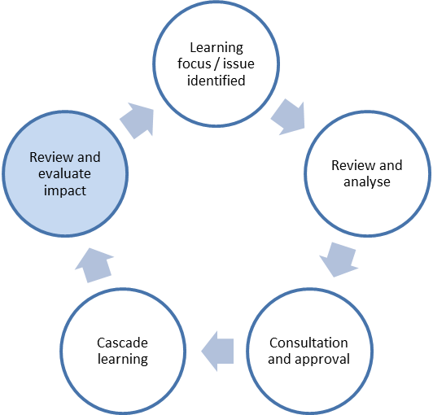

***Embedding a learning culture in East Sussex***

One of the roles of the ESSCP is to ensure the effectiveness of safeguarding practice, which it does through evidence-based auditing, performance management, and self-analysis. The SCP ensures that there is continual evaluation of the quality of services being provided, as well as effective communication and joint working between all SCP partner agencies. The arrangements for assuring the effectiveness of safeguarding practice are set out in the **ESSCP’s Learning & Improvement Framework**.

In addition, the partnership has focused on:

* Supporting the dissemination of multi-agency learning from Rapid Reviews, Local Child Safeguarding Practice Reviews, and audits (multi-agency and single agency) and the multi format ESSCP training offer.
* Linking learning to the other 3 ESSCP Priorities: Child Exploitation, Education Safeguarding and Safeguarding under 5’s.
* Linking learning to wider agencies, such as the Safeguarding Adults Board, the National Safeguarding Children Panel and Child Death Overview Panel.
* Provide a simple ‘one stop shop’ for SCP professionals to access learning resources.

Examples of activity in 2020/21 include:

* Development of a learning strategy for the L&D subgroup.
* Quarterly communication plan for the ESSCP shared with the L&D subgroup.
* Two learning briefings produced on infant injuries arising from SCR and Rapid Review work.
* 1 page learning briefings on key topics such as ICON.
* Stronger links with LA principal social worker for audit and case review learning dissemination.
* ‘Learning from Review’ lunchtime seminar held in May 2021 with further sessions planned in October and November 2021.
* Board briefings from each quarterly board meeting shared with ESSCP network and uploaded on to ESSCP Website.
* Successful development of remote training during Covid-19 pandemic.
* New training areas being developed linked to priorities, including EHE, RPC, Coercion and control, Safeguarding Under 5’s, Improving Outcomes for Children in Care, Professional Curiosity/Challenge.

***Evidence to measure success***

* Front line staff and leaders/managers in every agency to know what the ESSCP is can recall learning themes from recent learning briefings.
* Front line staff to feel confident in how to respond if they have a safeguarding concern.
* Staff to know where to look for more information/resources on safeguarding themes.

**6.4 Safeguarding under 5s**

***Why is safeguarding under 5s a priority?***

Local and national learning tells us that babies and young children are particularly vulnerable to abuse and neglect. Following on from two local serious case reviews involving babies and young children, the ESSCP decided to focus on ‘safeguarding Under 5s, as one of its key priorities, to ensure that action arising from the reviews was coordinated and the profile of safeguarding under 5s was raised across partner agencies.

Nationally, babies under 12 months old continue to be the most prevalent group notified to the national safeguarding panel following serious incidences, with around 40% of serious case reviews involving children aged under 1. There were also a high proportion of cases involving non-accidental injury and sudden unexpected infant death. In these cases, parental and family stressors were the most significant factor in escalating risk.

Learning from the Pan Sussex Child Death Overview Panel also highlighted the need for a multi-agency response to the number of incidences of sudden and unexplained infant deaths where modifiable factors were identified.

***Safeguarding in Under 5s in East Sussex***

The ‘Safeguarding Under 5s’ action plan is jointed owned by the Designated Nurse for Safeguarding in the CCG and the Children’s Lead in East Sussex Public Health. The leads have been supported by a short-life Task and Finish Group to drive ahead action in this area.

Key achievements during 2020/21 include:

* Launch and embedding of ICON across multi-agency network to reduce abusive head trauma.
* Development of an infant bruise leaflet for parents and professionals to increase consistency or response.
* Development of a light-bite training session for multi-agency professionals on key ‘safeguarding U5’ themes, including ICON, safer sleeping, and non-accidental injuries.
* Development of pan-Sussex principles for safer sleeping to ensure that frontline practice is informed by the latest evidence-based guidance.
* Improvement in communication between GPs and health visitors and GPs and midwifery with regards to safeguarding information sharing.
* Successful bid to deliver reducing parental conflict training.

SUDI formed the most common category of fatal cases notified to the National Safeguarding Panel and was the focus of the Panel’s second national thematic review, published in July 2020: **National review of SUDI in families where the children are considered at risk of harm**

Locally, a Pan Sussex working group met to review the publication and agree how agencies could best respond locally. An audit of current measures and existing practice was undertaken with gaps identified.

Key learning included:

• Families living within a context of recognised background risks (such as, deprivation and overcrowding, domestic violence or poor mental health) are at heightened risk of losing a baby to SUDI.

• All those working with families need to recognise this and work together, this is not just an issue for midwives and health visitors.

• We need a flexible and tailored approach to prevention that is responsive to the reality of people’s lives.

• The best local arrangements for promoting safer sleeping involve a range of professionals as part of a relationship-based programme of support, embedded in wider initiatives to promote infant safety, health and well-being.

The review has identified a number of issues that have helped inform the development of a ‘prevent and protect’ practice model. We believe this model, if embedded in practice, has the potential to improve the way safeguarding partners work with families to reduce the risks of SUDI, and beyond that, to address a much wider range of risks to their children’s health, safety and development

***Evidence to measure success***

* Reduction in the number of children who deaths due to SUDI where there are modifiable factors related to safer sleeping.
* Reduction in the number of mothers smoking at time of delivery.
* Reduction in the number of child deaths involving abusive head trauma.
* Reduction in the number of children aged under five on child protection plans with physical abuse as a factor.

|  |
| --- |
| Challenges and actions for 2021/22   * Strengthen the process for evidencing impact from case review work (LCSPRs and rapid reviews) * Update the ESSCP performance dashboard to include ‘success measures’ regarding the four key priorities. * Strengthen the ‘voice of the child’ in the work of the four priorities and across partnership activity. |

**7. Assurance**

One of the roles of the ESSCP is to ensure the effectiveness of safeguarding practice, which it does through evidence-based auditing, performance management, and self-analysis. The SCP ensures that there is continual evaluation of the quality of services being provided, as well as effective communication and joint working between all SCP partner agencies.

The **Quality Assurance (QA) Subgroup** has the lead role, on behalf of the Partnership, for monitoring and evaluating the effectiveness of the work carried out by partners. It does this through regular scrutiny of multi-agency performance data and inspection reports, and through an annual programme of thematic and regular case file audits. This subgroup is chaired by the Detective Chief Inspector of the Safeguarding Investigation Unit in Sussex Police.

Examples of assurance undertaken by the ESSCP during 2020/21 include:

* The **ESSCP has an Independent Chair** whose function is to provide challenge and scrutiny of the effectiveness of the lead partners and other relevant agencies, via the Board and Steering Group meetings, and to also work with the lead partners to ensure the effectiveness of the safeguarding work carried out by partners. Their approach throughout year has been to act as a constructive critical friend to promote reflection and continuous improvement and to provide support to that improvement. Examples include: chairing the Section 11 Challenge Panels for both East Sussex and Pan Sussex agencies; determining the need to conduct Local Child Safeguarding Practice Reviews (LCSPRs) in three cases (Child X, Y and Z); facilitating resolution of agency conflicts (e.g. a school academy and Local authority over the need for a review), championing local issues at national and ministerial level (e.g. in pursuance of recommendations in case Child T and Child W), raising for action and scrutiny by Board of emerging issues (e.g. long term Covid 19 impact on safeguarding, school peer sexual abuse and scrutiny of the JTAI review).
* In addition to the Independent Chair, **two Lay Members** play a critical role in the partnership. The Lay Members act as further independent insight, on behalf of the public, into the work of agencies and of the partnership. As well as acting as critical friends at Board meetings, providing additional challenge and scrutiny, the Lay Members have undertaken a number of key tasks including taking a lead role in the development of a Children’s Pledge through a series of art workshops, participation in multi-agency workshops examining how agencies can respond to the problem of Modern Slavery and county lines activity, involvement in the ‘challenge panel’ in the section 11 audit process, and being a standing member of the SCP Case Review Group (CRG). Their role has been critical at CRG – via the rapid review process and subsequent LCSPR process - in advocating the voice of the child.
* The Partnership has a key role in **evaluating the effectiveness of support for looked after children and care leavers** – it does this via the annual scrutiny of the ESCC Annual Looked After Child & Care Leaver Report, regular monitoring of key performance information in the ESSCPs quarterly dashboard, and via the Section 11 process. In 2020/21 the Section 11 audit tool was strengthened to include a range of new indicators regarding how agencies fulfil their responsibilities towards looked after children. Three of these indicators were in the top 8 of the lowest rated areas in the audit. Subsequently, the ESSCP is now delivering training for multi-agency partners on ‘improving outcomes for looked after children’. One key action to be taken forward in 2020/21 was learning from the Child W serious case review regarding the development of the council’s, and other agencies’, Corporate Grandparenting Role. As a result:
  + The safeguarding policy and procedure has been reviewed to include comprehensive contributions from the ESSC Through Care Team (TCT) in relation to prebirth assessments, prebirth case conferences and care planning.  This has been successfully implemented.
  + The TCT Participation Worker is re-establishing face to face groups for care experienced parents, or care leaver parents to be – this will include midwifery input.  In addition, a self-selecting group of young adults/parents will participate in the buddying scheme which is taking shape.  Many of these young parents experience isolation in their living circumstances, therefore greater links with universal services, community support and local resources are being set up via the PA’s.
  + The local offer now includes a one-off payment of £100 for care leaver parents on the birth of their baby, gifts are given for birthdays and key celebrations, and where necessary assistance is given relating to the higher cost items such as buggies.
* The QA Subgroup reviews the ‘**ESSCP Performance Dashboard’** on a quarterly basis. The dashboard includes 60 performance indicators which are presented by: impact of multi-agency practice; children supported by statutory services; children with family related vulnerabilities; children with health-related vulnerabilities; and children whose actions place them at risk. Indicators are reviewed by the QA subgroup and escalated to the Steering Group if required. During 2020/21, performance indicators escalated by QA include the increase in numbers of electively home educated children (EHE); fluctuations in the numbers of children with child protection plans; significant decrease in private fostering; increase in numbers of unaccompanied asylum-seeking children; rise in recorded sexual offences against children; reduction in cases reviewed by MACE; and indicators to monitor CAMHS performance. The typical action is illustrated below:
  + **Action** EHE was escalated as a specific item for focus at the Steering Group. It was then agreed that a breakout session at the next Board should be held on exploring more fully how multi-agency partners can support the safeguarding of EHE.
  + **As a result**, a short-life multi-agency working group has been set up to take forward several recommendations made at the Board.
* The QA subgroup held only **two audits** during 2020/21 as two audit meetings were cancelled due to COVID-19 lockdown and pressures on local health services to engage with the process. The two audits completed were on Intra-familial Child Sexual Abuse and Domestic Abuse. A further audit was held in April 2021 (delayed from February due to COVID pressures) on non-accidental injuries in under 1s. The audits highlighted:
  + The importance of a successful working relationship between a social worker and school and the impact this can have on the outcome of the child and family.
  + The importance of always covering identity related issues in accompanying Family Assessments, to explore what the impact is on the child and family of these factors in context of the risks identified and generally. This will ensure we have a full understanding of the child and families lived experience around identity.
  + The need for Children’s Services to be clear about sources of therapeutic support for the child victim after Police proceedings have taken place. This will ensure that the child is able to receive the appropriate support.
  + When a child makes a disclosure about sexual abuse professionals involved should appropriately safeguard and respond to the allegation seriously, even when there is no substantive evidence to support this allegation.
* In 2020 the ESSCP held its sixth bi-annual ‘**section 11’ audit**. All organisations represented on the ESSCP are asked to complete a self-assessment and provide evidence of how they comply with s11 when carrying out their day-to-day business. The audit provides an indication of how well organisations are working to keep children safe. All 27 agencies (40 including individual ESCC teams) represented on the Board returned the Section 11 audit tool for ESSCP. Of the 2778 responses to the 93 standards included in the audit tool, 86% were rated Green ‘standard met’. Local Peer Review and Pan Sussex Challenge Events – including representatives from the three lead partners, Lay Members, and young people - provided additional scrutiny, highlighting areas of best practice and areas for ESSCP focus. The local peer review event also led to additional follow up work with an individual agency where there were concerns over the quality and robustness of their section 11 return. The standards with the most amber/red response included standards relating to ICON, care experienced children/adults involved in recruitment, trauma informed practice, and understanding the difference between voluntary accommodated and care order children. This was escalated to the ESSCP Learning & Development Subgroup for action.
* The Annual **Schools Safeguarding Audit Report (s175)** was presented to the ESSCP Steering Group for scrutiny and challenge in September 2019. All schools (including maintained, independent, academies, free schools, and colleges) in East Sussex are requested to complete the safeguarding audit toolkit on an annual basis – assessing their practice in line with statutory guidance and local good practice. Engagement with the process is strong with 97% of state funded schools returning their audit, despite the added pressure of COVID-19. The level of self-challenge within the audits suggests that schools are in general accurately reflecting on their practice. Additional quality assurance is also provided by SLES, a recently formed DSL Strategy Group, which is formed of DSLs and headteachers from 18 different schools, and the ESSCP.
  + The audit did not identify any widespread areas of common deficit but did highlight the need for continued focus upon online safety, especially at home, and within the context of additional time spent online through lockdown. This was escalated to the ESSCP Learning & Development Subgroup and as a result, work was undertaken to expand on the range of online safety resources offered to schools via the East Sussex Stay Safe Directory for schools.
  + Following the publication of the Child T SCR in 2019 there was significant focus upon health at the January 2020 Schools Safeguarding Conference, which was supported with some excellent and tailored input from a number of Health professionals, from a variety of specialisms within the sector.
* Other examples of assurance work undertaken include:
  + Scrutiny at Board of the report from the Manager at Lansdown Secure Children’s Home, highlighting safeguarding and behaviour management practice at the unit over the past year. Annual presentation of this report to the ESSCP is a regulatory requirement given the significant vulnerability of young people in secure establishments. The Board noted how the unit uses and monitors techniques such as enforced separation and restraint; and how a more values-based style at the unit had impacted on the continued reduced use of these techniques. The Partnership agreed to support further scrutiny of the use of these techniques through a quarterly review by representatives of the Partnership.
  + Scrutiny at Board of the annual report for the Sussex [Child Sexual Abuse Referral Centre (SARC).](https://www.sussexcommunity.nhs.uk/services/servicedetails.htm?directoryID=22678) Children aged up to 14 years, or up to 19 with a severe learning disability, who have experienced sexual abuse or assault, are seen at the centre for holistic health assessments following a referral by police or children’s services. Board members noted that 35% of SARC referrals came from East Sussex compared to 43% in 2018/19. The board noted SARC is working in partnership with local agencies to improve access to the service for children in care – as attendance is lower in this group – and to ensure that all children who would benefit from a health assessment receive one.

|  |
| --- |
| **Challenges & next steps for 2021/22:**   * Recruitment of a new Independent Chair * Recruitment of new Lay Members * Develop the section 11 tool to ensure it is more proportionate for agencies to complete and provides stronger assurance for safeguarding partners of the quality and effectiveness of safeguarding in individual agencies. * Developing a partnership protocol, across the partnerships in East Sussex, to ensure that opportunities for joint working and sharing learning are maximised. * Strengthening the information presented in the ESSCP dashboard regarding equalities information, so that the ESCCP can more efficiently understand the equalities implications for safeguarding locally. * Introduce a robust system to evaluate the impact of learning arising from LCSPRs and rapid reviews. |

8. Learning

The ESSCP is committed to creating and strengthening a learning culture across all agencies in East Sussex who work with children and young people. A culture which is open, and able to challenge all partner agencies, will be able to identify learning, improve, and then evaluate effectiveness.

Below are examples of ‘learning’ within and across the ESSCP in 2020/21.

8.1 ESSCP Learning Strategy

The ESSCP Learning Strategy was developed through the summer and signed off by the Steering Group in December 2020. The Strategy aims to:

* + Ensure that safeguarding training/learning activities are based on local necessity and enable practitioners to recognise and respond to need and risk.
  + Measure the impact of safeguarding training on practice and improving outcomes for children and young people.
  + Ensure that learning from Local Child Safeguarding Practice Reviews, Audits, the Child Death Overview Process (CDOP) and the Voice of the Child is embedded into practice and ensures continuous learning and improvement.
  + Ensure key safeguarding messages (local, pan-Sussex and national) are communicated.

These requirements are delegated to the ESSCP Learning & Development Subgroup which produces quarterly training reports, which form the basis of the Annual Learning & Development Report to the ESSCP Steering Group.

8.2 ESSCP Training Programme

Throughout 2020/21 the ESSCP Learning, and Development (L&D) Subgroup responded proactively and effectively to the challenges faced during the Covid-19 Pandemic. All planned classroom-based courses were cancelled from April 2020. No ESSCP courses ran during the first quarter of 2020/21 to allow time for the training pool practitioners to develop approaches and materials suitable for virtual delivery. Contingency planning had been underway since April 2020 and an initial pilot selection of virtual courses were chosen to run between August and September. Due to the ongoing risks brought by Covid-19, we continued to use MS Teams as the format for most of the training delivery for the remainder of 2020/21.

Between 1st August 2020 and 31st March 2021, 42 virtual training courses ran with an attendance rate of 77%. This compares with 80% attendance at classroom-based courses during 2019/20 which is a positive endorsement of the virtual training offer and evidence that investment in CPD to support the multi-agency workforce continued during very difficult circumstances. A large majority of participants continue to rate courses as either Excellent (43%) or Good (53%). Since the introduction of virtual training courses, participants are asked additional evaluation questions relating to participants experience of this new learning platform. In general, those attending remote training have adapted very well and overall feedback relating to trainer professionalism and adaptability has been extremely positive. The use of break-out rooms to encourage interaction and discussion is regularly cited as adding great value to the virtual sessions. However, a significant proportion of participants stated that they prefer face to face training, the support and networking that it offers and that remote learning for such emotive subjects can be challenging at times.

8.3 Quality Assurance Audits

The QA subgroup held **two audits** during 2020/21 on Intra-familial Child Sexual Abuse and Domestic Abuse. Learning from the audits is shared at the ESSP Steering Group and one page learning briefings are shared with the wider ESSCP network and on the ESSCP website here: [Quality Assurance Group - ESSCP](https://www.esscp.org.uk/about-us/subgroups/quality-assurance-group/). In 2020/21 the QA audit reports are now shared at the Learning & Development Subgroup to ensure that learning arising from audit activity is more efficiently and effectively embedded into local training and learning activity.

Two examples of action taken following learning arising from QA audits in 2020/21 includes:

* + The importance of always covering identity related issues in accompanying Family Assessments, to explore what the impact is on the child and family of these factors in context of the risks identified and generally. This will ensure we have a full understanding of the child and families lived experience around identity. As a result, L&D Managers across Sussex are exploring the potential of a Pan Sussex course on equalities and identity in Safeguarding.
  + When a child makes a disclosure about sexual abuse professionals involved should appropriately safeguard and respond to the allegation seriously, even when there is no substantive evidence to support this allegation. As a result, local training and support for professionals when responding to child sexual abuse has been reviewed and strengthened.

8.5 Learning from Child Death Overview Panel

The Chair of the Sussex Child Death Overview Panel (CDOP) attended the ESSCP Board in November 2020 to present the CDOP Annual Report. Key headlines from the work of the panel included:

* The total numbers of deaths recorded during 2019/20 was the second lowest during the 10-year period that CDOP’s have been in operation.
* The Mortality rate for children aged under 18 in Brighton & Hove and East Sussex combined is significantly higher in the most deprived 40% of areas compared to the least deprived areas – this is in line with the national picture.
* At both a national and Sussex level the largest cause of death is a perinatal/neonatal event (37% for Sussex[1], 33% for England).
* Cancers are the largest cause of death in children aged 1-17 years ranging from 24% of deaths in East Sussex to 33% in Brighton and Hove.
* Sudden unexpected death in infancy remains one of the leading causes of infant death in the community and in all the cases reviewed by the panel, modifiable factors were identified regarding the infants sleeping environment.

The ESSCP was asked to consider how it plans to take forward the multi-agency response to safe sleep learning, particularly considering the recommendations of the National Child Safeguarding Practice Review Panel report ‘Out of Routine’ – July 2020. Subsequently, East Sussex facilitated pan-Sussex meetings looking at developing common principles for practitioners regarding the promotion of safer sleeping. The group has been ensuring that this work aligns with the ICON initiative. The group has also be informing the planning for the proposed Pan Sussex SCP Conference in November 2021, which will focus on a range of issues regarding the safeguarding of infants. The aim of this work is to ensure robust and consistent messages are understood by practitioners and shared with parents by universal and targeted services across the partnership workforce.

The ESSCP were also informed that Abusive Head Trauma (AHT) was the leading cause of fatal head injury in children under 2. Members of the ESSCP were aware of the launch of the ICON programme across Sussex in relation to these infant deaths. More details on ICON can be found on pages 17-18 of this report.

8.6 Learning from Rapid Reviews and Serious Case Reviews

The Case Review Group (CRG) developed two briefings for the East Sussex workforce on learning arising from two serious case reviews – which at the time were unpublished due to criminal proceedings – and three rapid reviews which were undertaken in the early part of the COVID-19 lockdown in March-May 2020. Both briefings related to learning around non-accidental infant injuries. These briefings are included in Appendix E.

The learning briefings were shared directly with ESSCP Board Members, members of each ESSCP Subgroups, and presented at the East and West Local Safeguarding Children Liaison Groups, with the expectation that they are shared among team and service networks. They are also published on the ESSCP website and shared with partner SCPs in Brighton & Hove and West Sussex. The learning briefings include discussion points for team meetings and group supervision to help ensure that learning becomes embedded into practice.

The learning was also shared in a ‘learning from reviews’ lunchtime seminar, held by members of CRG, in which over 60 staff from across the children’s workforce attended.

**9. Appendices**

**9.A Board Membership**

|  |  |
| --- | --- |
| **NAME** | **TITLE, ORGANISATION** |
| **Reg Hooke (Chair)** | Independent East Sussex SCP Chair |
| **Louise MacQuire-Plows** | Manager, East Sussex SCP |
| **Victoria Jones** | Manager, East Sussex SCP |
| **Graham Cook** | Lay Member, East Sussex SCP |
| **Harriet Martin** | Lay Member, East Sussex SCP |
| **Maxine Nankervis** | Admin Support Officer, East Sussex SCP |

|  |  |
| --- | --- |
| **Gareth Knowles** | SECAmb Trust Safeguarding Lead, Clinical Supervisor |
| **Louise Jackson** | Designated Nurse Safeguarding Children |
| **Domenica Basini** | Assistant Director for Safeguarding and Quality, Nursing and Quality Directorate NHS England |
| **Jayne Bruce** | Deputy Chief Nurse, Sussex Partnership Foundation Trust (SPFT) |
| **Jo Tomlinson** | Brighton + Hove Designated Nurse |
| **Judith Sakala** | Named GP for Child Safeguarding |
| **Martin Ryan** | Acute Service Manager Coastal / AMHP Sussex Partnership |
| **Michael Brown** | Head of Safeguarding and Looked After Children  Sussex NHS Commissioners |
| **Naomi Ellis** | Deputy Director Quality, Safeguarding & Looked After Children  Sussex NHS Commissioners |
| **Tracey Ward (Deputy. Chair)** | Designated Doctor Safeguarding Children, East Sussex |
| **Vikki Carruth** | Director of Nursing, ESHT |
| **Sue Curties to Nov.20** | Head of Safeguarding, (Adults and Children) ESHT |

|  |  |
| --- | --- |
| **Andrea Holtham** | Service Manager, Sussex CAFCASS |
| **David Kemp** | Head of Community Safety, East Sussex Fire & Rescue Service |
| **David Satchell** | Snr Probation Officer, National Probation Service, Sussex |
| **Jon Hull** | D/Sup Sussex Police |
| **Siamack Danesteh-Pour**  **to Nov.20**  **Joanne Wood to Jan.21**  **Jason Halliwell from Feb.21** | KSS, Assistant Chief Probation Officer |

|  |  |
| --- | --- |
| **Annabel Hodge** | Dir. Of Safeguarding, Bede’s Senior School |
| **Kate Bishop** | Head Teacher, Rotherfield Primary School |
| **Richard Green** | Deputy Head Teacher, Chailey Heritage School |
| **Richard Preece** | Executive Head teacher, Torfield & Saxon Mount Federation |

|  |  |
| --- | --- |
| **Ben Brown** | Consultant, Public Health, ESCC |
| **Catherine Dooley** | Senior Manager, Standards and Learning Effectiveness (5-19), Children’s Services |
| **Douglas Sinclair** | Head of Safeguarding and Quality Assurance, Children’s Services |
| **George Kouridis** | Head of Service Adult Safeguarding |
| **Justine Armstrong** | Safer Communities Manager |
| **Liz Rugg** | Assistant Director (Early Help & Social Care), Children’s Services |
| **Rachel Doran** | Legal and Coroner Services Manager |
| **Stuart Gallimore** | Director of Children’s Services |
| **Sylvia Tidy** | Lead Member for Children and Families |
| **Vicky Finnemore** | Head of Specialist Services, Children’s Services |

|  |  |
| --- | --- |
| **Jeremy Leach** | Principal Policy Adviser, Wealden District Council |
| **Malcolm Johnston** | Executive Director for Resources, Rother District Council |
| **Oliver Jones** | Lewes DC + Eastbourne BC, Strategy and Partnerships Lead |
| **Seanne Sweaney** | Strategy and Corporate Projects Officer, Lewes DC and Eastbourne BC |
| **Verna Connolly** | Head of Personnel and Organisational Development, Hastings Borough Council |

|  |  |
| --- | --- |
| **Kate Lawrence** | Chief Executive Home-Start East Sussex |

**9.B ESSCP Budget**

**ESSCP – Actual Income and Expenditure 2020/21:**

|  |  |  |  |
| --- | --- | --- | --- |
| **Actual Income 2020/21** | | **Actual Expenditure 2020/21** | |
| Sussex Police | £35,000 | Independent Chair | £28,852 |
| Sussex CCG | £53,400 | Business Manager(s) 1.4 FTE & Administrator | £100,298 |
| East Sussex County Council (ESCC) | £112,900 | Administration | £1,606 |
| Training Income | £5,423 | Trainer | £53,449 |
| National Probation Service | £1,434 | Training Programme and Conferences | £2,035 |
| LSCB brought forward from 19/20 | £58,510 | Projects | £15,850 |
|  |  | Pan Sussex Procedures | £6,123 |
|  |  | IT Software & Hardware | £1,600 |
|  |  | Safeguarding Practice Reviews | £1,301 |
|  |  | cfwd (balancing fig) | £55,553 |
|  |  |  |  |
| **Total** | **£266,667** |  | **£266,667** |

**Projected Income and Expenditure 2021/22:**

|  |  |  |  |
| --- | --- | --- | --- |
| **Projected Income 2021/22** | | **Projected Expenditure 2021/22** | |
| Sussex Police | £35,000 | Independent Chair | £24,500 |
| Sussex CCG | £53,400 | Business Manager(s) 1.4 FTE & Administrator | £107,500 |
| East Sussex County Council (ESCC) | £112,900 | Administration | £1,500 |
| Training Income | £7,500 | Trainer | £56,000 |
| National Probation Service | £1,434 | Training Programme and Conferences | £10,000 |
| ESSCP brought forward from 2020/21 | £55,553 | Projects | £15,000 |
|  |  | Pan Sussex Procedures | £6,500 |
|  |  | IT Software & Hardware | £1,500 |
|  |  | Safeguarding Practice Reviews | £26,000 |
|  |  | cfwd (balancing fig) | £17,287 |
|  |  |  |  |
| **Total** | **£265,787** |  | **£265,787** |

**9.C Links to other documents**

[**East Sussex Health and Wellbeing Strategy (2016-19)**](https://www.essp.org.uk/wp-content/uploads/2019/11/Health-and-Wellbeing-Strategy-201619v3.pdf)

This strategy is a framework for the commissioning of health and wellbeing services in the County. The Health and Wellbeing Board will consider relevant commissioning strategies to ensure that they have considered the priorities and approaches set out in the Health and Wellbeing Strategy. The main priority is to protect and improve health and wellbeing and reduce health inequalities in East Sussex, the strategy focuses on: Accountable care; Improving access to services; Bringing together health and social care; Improving emergency and urgent care; Improving health and wellbeing; Improving mental health care; Improving primary care; Better use of medicines; Better community services.

[**Sussex Police and Crime Commissioner – Police and Crime Plan 2021-2**](https://www.sussex-pcc.gov.uk/our-priorities/police-crime-plan/)**4**

The Commissioner has identified the following four policing and crime objectives:

* Strengthen local policing
* Work with local communities and partners to keep Sussex safe
* Protect our vulnerable and help victims cope and recover from crime and abuse
* Improve access to justice for victims and witnesses

[**East Sussex Safer Communities Partnerships’ Business Plan (2017-2020)**](http://www.safeineastsussex.org.uk/content/Business%20Plan%202017-18_FINAL(1)(2).pdf)

The East Sussex Safer Communities Partnership undertakes a strategic assessment of community safety every three years with an annual refresh to select work streams and plan activity for the year ahead.

Colleagues from the ESSCP and ESCC Children’s Services work closely with the Safer Communities Partnership to respond to the broader threat of exploitation. Sustaining existing work within the partnership and developing new and existing relationships with partners is of particular importance to ensure that we are supporting vulnerable individuals within the community and helping them feel safe and confident in their everyday lives.

[**East Sussex Safeguarding Adults Board Annual Report 2020-21**](https://www.eastsussexsab.org.uk/wp-content/uploads/2020/07/ESSAB-Annual-Report-2020-21-FINAL.pdf)

The ESSCP works closely with the SAB on the overlapping themes of Modern Slavery, Domestic Abuse, transition, and Cuckooing.

**DfE Keeping Children Safe in Education 2021.pdf**

Updated statutory guidance from the Department for Education issued under Section 175 of the Education Act 2002, the Education (Independent School Standards) Regulations 2014, and the Non-Maintained Special Schools (England) Regulations 2015. Schools and colleges in England must have regard to it when carrying out their duties to safeguard and promote the welfare of children.

**9.D Learning Briefings**

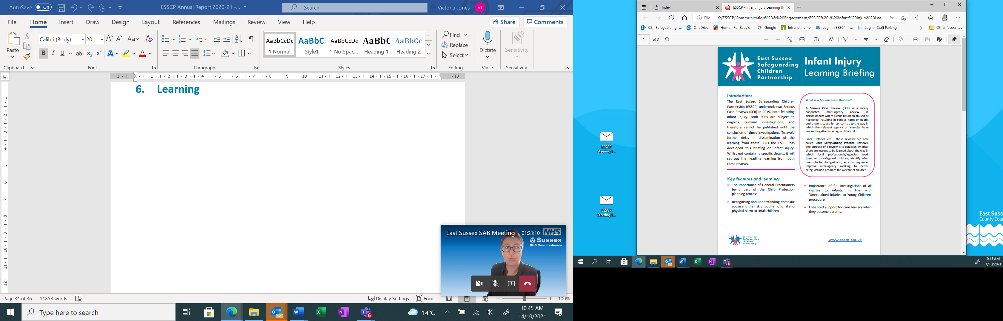

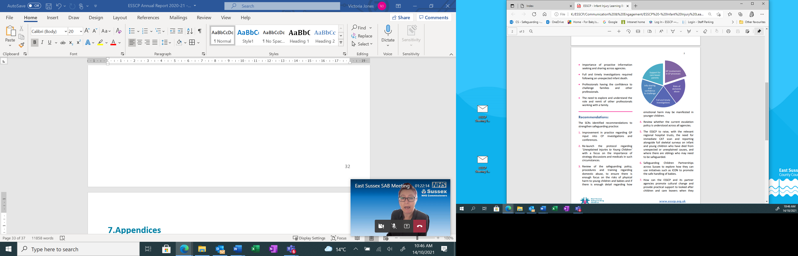

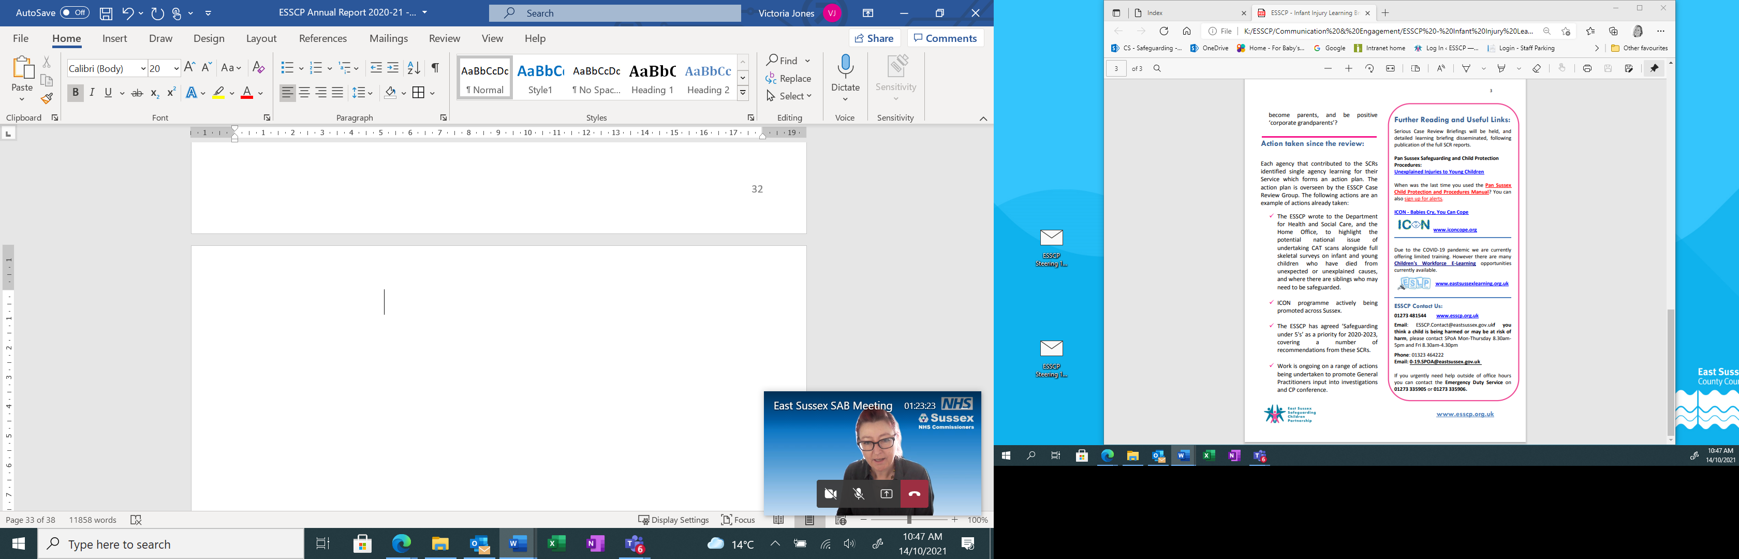

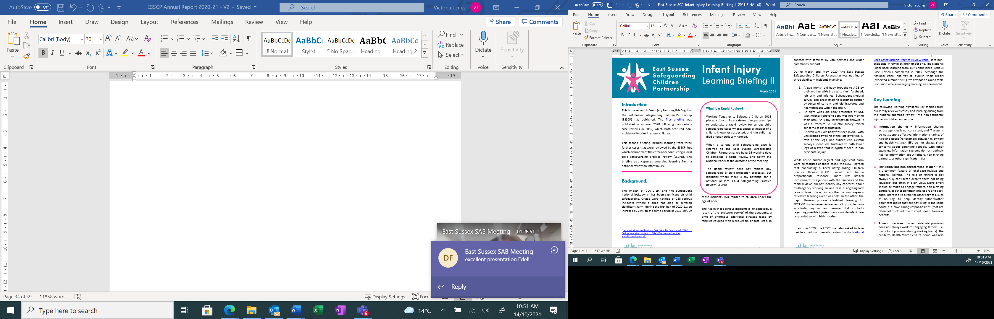

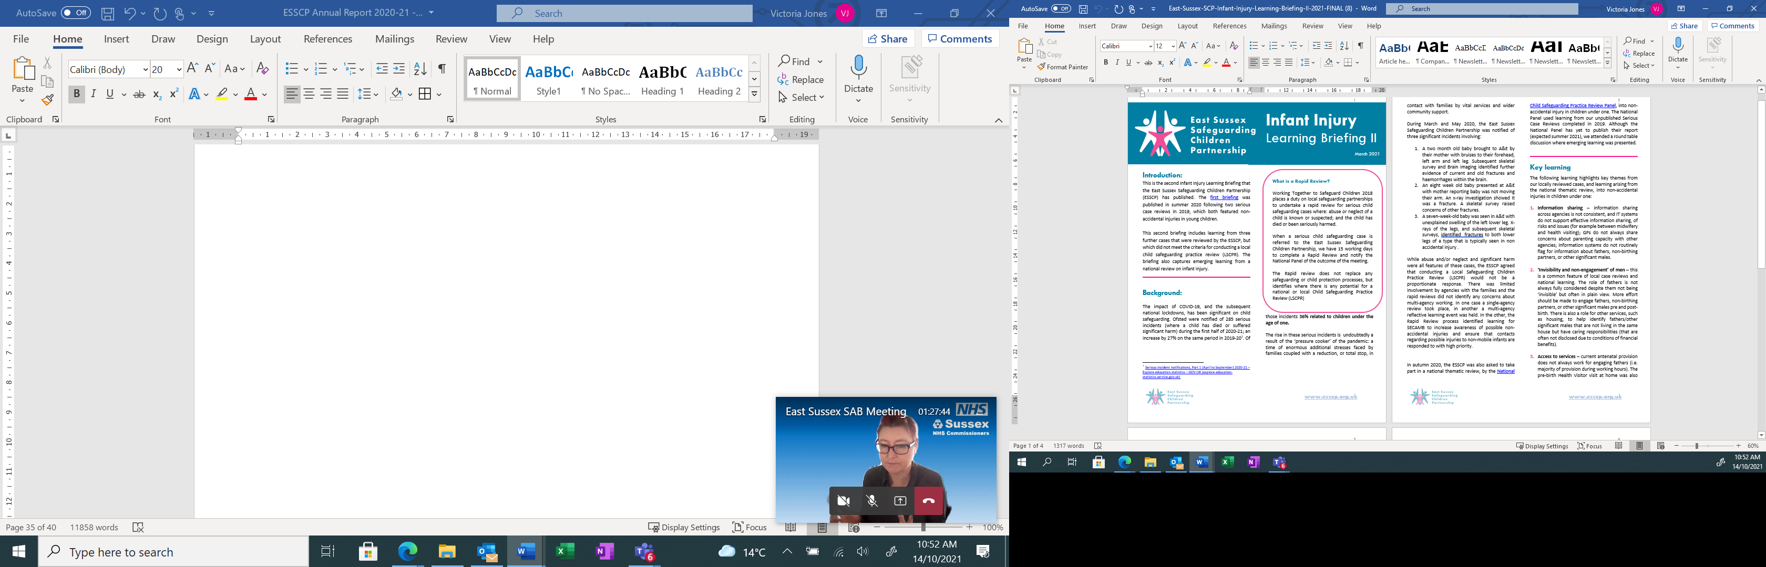

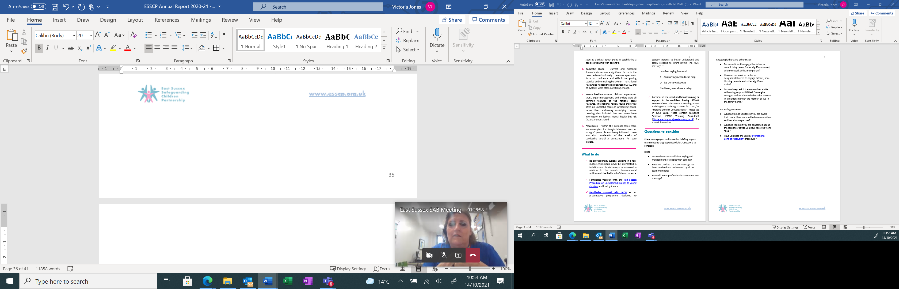

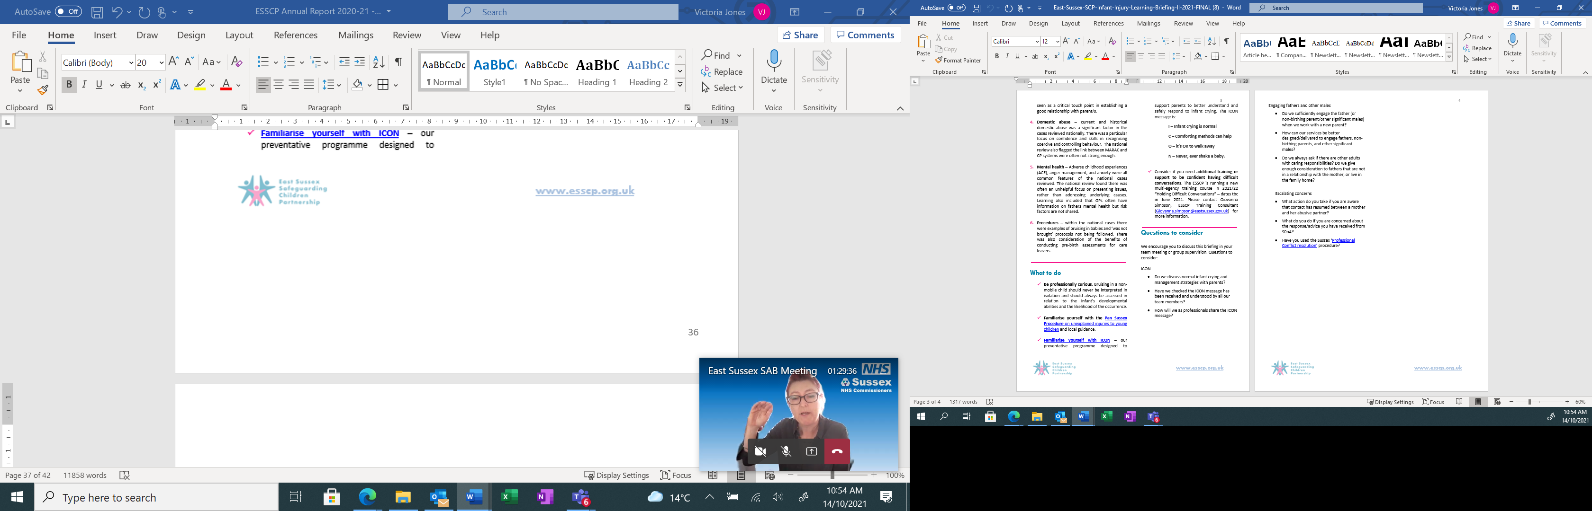

**ICON 1 page learning briefing**

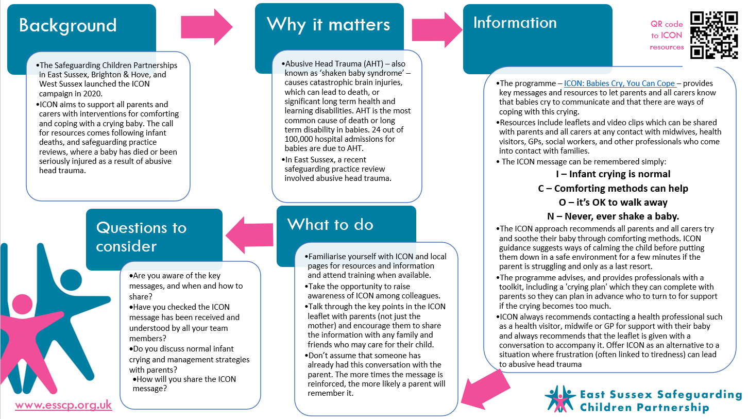

**9.E Acronyms**

|  |  |
| --- | --- |
| **ABE** | Achieving Best Evidence |
| **AMH** | Adult Mental Health |
| **B&H** | Brighton & Hove |
| **BC** | Borough Council |
| **CAFCASS** | Children and Family Court Advisory and Support Service |
| **CAMHS** | Child and Adolescent Mental Health Service |
| **CC** | County Council |
| **CCG** | Clinical Commissioning Groups |
| **CDOP** | Child Death Overview Panel |
| **CQC** | Care Quality Commission |
| **CRG** | Case Review Subgroup |
| **CSARC** | Children’s Sexual Assault Referral Centre |
| **CSP** | Community Safety Partnership |
| **CYPT** | Children and Young People Trust |
| **DC** | District Council |
| **DfE** | Department for Education |
| **EET** | Education, Employment, or Training |
| **EHE** | Electively Home Educated |
| **ESCC** | East Sussex County Council |
| **ESFRS** | East Sussex Fire & Rescue Service |
| **ESHT** | East Sussex Health Trust |
| **ESSCP** | East Sussex Safeguarding Children Partnership |
| **GP** | General Practitioner |
| **JTAI** | Joint Targeted Area Inspection |
| **L&D** | Learning & Development |
| **LAC** | Looked After Children |
| **LADO** | Local Authority Designated Officer |
| **LCSPR** | Local Child Safeguarding Practice Review |
| **LSCLG** | Local Safeguarding Children Liaison Groups |
| **MACE** | Multi-Agency Child Exploitation Group |
| **MASH** | Multi-Agency Safeguarding Hub |
| **NHS** | National Health Service |
| **NPS** | National Probation Service |
| **QA** | Quality Assurance |
| **SAB** | Safeguarding Adults Board |
| **SCARF** | Single Combined Agency Report Form |
| **SCP** | Safeguarding Children Partnership |
| **SCR** | Serious Case Reviews |
| **SECAmb** | South East Coast Ambulance |
| **SLES** | Standards and Learning Effectiveness Service |
| **SPFT** | Sussex Partnership Foundation Trust |
| **SPOA** | Single Point of Advice |
| **STP** | Sustainability and Transformation Plan |
| **SUDI** | Sudden Unexpected Death in Infancy |
| **SWIFT** | Specialist Family Services |
| **YOT** | Youth Offending Team |

1. Sussex CDOP will review all neonatal deaths where there is a death certificate regardless of the gestation of the baby.