NEW DIGITAL HEALTHY START SCHEME – APPLY FOR YOUR PREPAID CARD TODAY!

The NHS Healthy Start Scheme provides pregnant women and parents/carers of children up to 4 years on a low-income access to free fruit, vegetables, pulses, milk, and vitamins.

Do you currently receive Healthy Start vouchers?

If you’re currently in receipt of Healthy Start vouchers, you will have already received a letter or email from NHS Healthy Start, inviting you to apply online for your new Healthy Start prepaid card. Instead of receiving paper vouchers in the post each month (to help purchase healthy foods), families will receive a prepaid card which is topped up once a month with their Healthy Start allowance and can be used in any shops/markets/ food outlets accepting Mastercard.

There are many benefits to the new prepaid card. For example, your payments will be automatically added to your card (so you no longer need to wait for your vouchers to arrive in the post) and you can check your balance (which can help with money management). The card is discreet, and any money you do not spend will remain on your card and can be put towards healthy food and milk in the future (unlike the current voucher scheme where you must spend £4.25 or over in one transaction). The prepaid card can also be used to prove entitlement for free Healthy Start vitamins.

Apply for your prepaid card now to avoid a gap in Healthy Start payments

The NHS Business Services Authority (NHS BSA) were due to send out the last Healthy Start paper vouchers to existing beneficiaries the week commencing 7th March 2022. It is therefore important that if you are in receipt of Healthy Start vouchers that you apply online to avoid a gap in payment of your Healthy Start benefit. Please note: any paper vouchers you still have can be used up until the expiry date shown on voucher. Once you submit your online application, you will stop receiving paper vouchers and will be sent a new prepaid card within approximately 5-10 working days with your first payment on it (and instructions on how to activate your card before use). It has been reported nationally that some individuals have experienced problems with applying online (including being rejected as part of application process). The NHS BSA has reported that it has now ‘fixed problems with the online application service that should help to resolve some of the issues people have faced and encourages anyone who believes that they are eligible and has had an online application rejected to try again now that the fix is in place’.

Could you be eligible for Healthy Start?

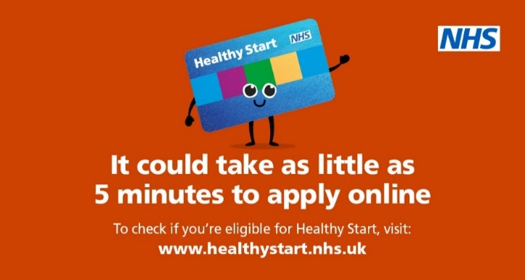
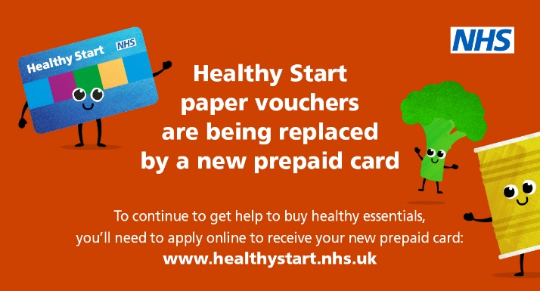
Despite the positive impact that the Healthy Start scheme can have on a household’s budget and access to a healthy diet; during 2021, over 40% of eligible families in East Sussex were not benefitting from the scheme - a huge loss to families struggling to cover the rising cost of living. If you’re receiving a qualifying benefit and are pregnant or have parental responsibility for at least one child under the age of 4 years, you could receive £4.25 a week (or over £220 a year). To find out more about NHS Healthy Start, including eligibility and how to apply, visit the Healthy Start website or follow Healthy Start on Facebook or Twitter.

