SOCIAL MEDIA CONTENT

HEALTHY START
The NHS Healthy Start digital scheme is open to accept applications from those who currently receive paper vouchers. To get your prepaid card, make sure to keep an eye out for your letter in the post to let you know when you can apply online.  www.healthystart.nhs.uk  #HealthyStartEastSussex | 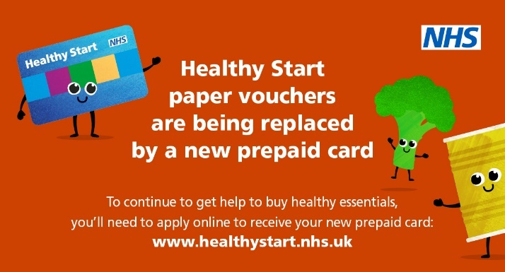
The digital #NHSHealthyStart scheme has now replaced the paper voucher scheme! If you are eligible to apply you will receive your prepaid card. You could get £4.25 per week to help you buy healthy food and milk for your child. Check if you’re eligible at: www.healthystart.nhs.uk  #HealthyStartEastSussex | 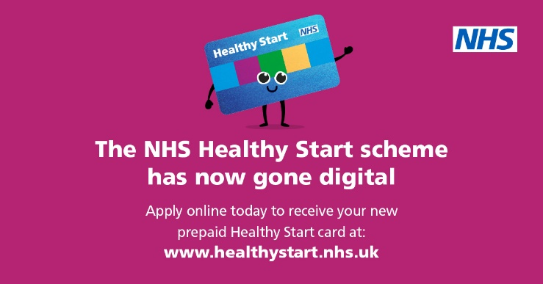
#HealthyStart is now going paperless. If you’re eligible for the Healthy Start Scheme, you will no longer receive paper vouchers each week. Instead, you will receive a prepaid card entitling you to healthy food, milk, and vitamins. Apply now: www.healthystart.nhs.uk/how-to-apply/  #HealthyStartEastSussex | 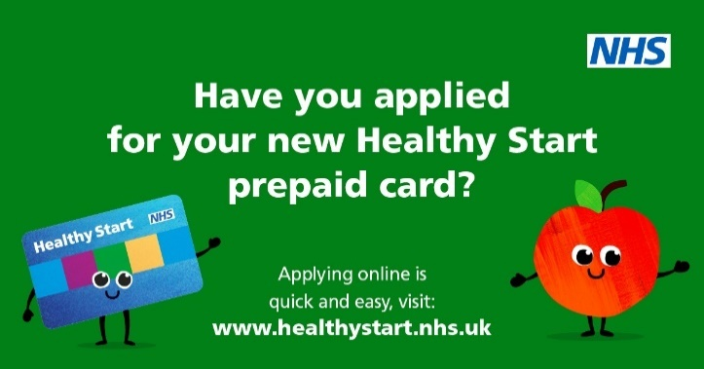
It's time to apply online for your Healthy Start prepaid card. Your prepaid card can be used in most shops that sell eligible Healthy Start items and accept Mastercard payments. Apply now:  www.healthystart.nhs.uk/how-to-apply/  #HealthyStartEastSussex | 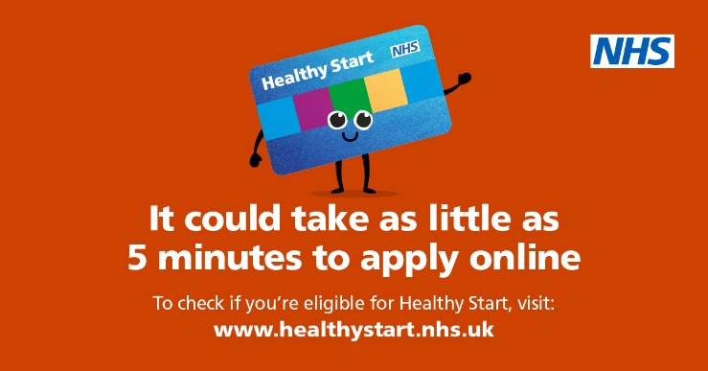
With the #NHSHealthyStart scheme, you’ll get a prepaid card to help you buy healthy food and milk. No more waiting for your vouchers to arrive! For more information visit: www.healthystart.nhs.uk  #HealthyStartEastSussex | 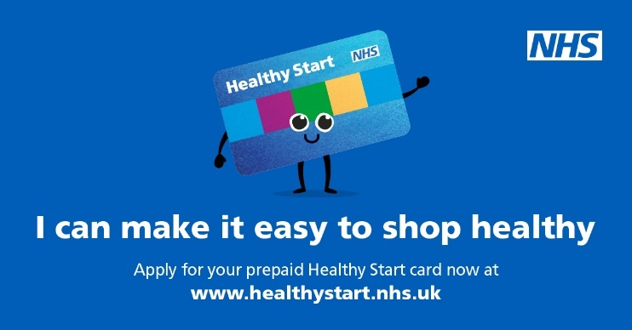
Your Healthy Start prepaid card gets topped up every 4 weeks and you can check your card balance at any cash machine. Have you applied for your new prepaid card yet?  www.healthystart.nhs.uk #HealthyStartEastSussex | 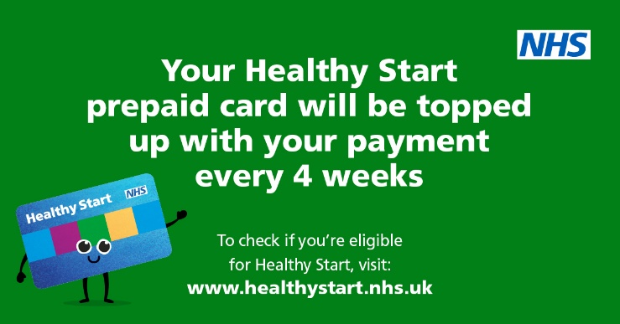
Reminder! If you've received your Healthy Start prepaid card, you'll need to activate it first before use. Call the 24/7 automated service on 0300 330 2090 and select option 1  www.healthystart.nhs.uk  #HealthyStartEastSussex | 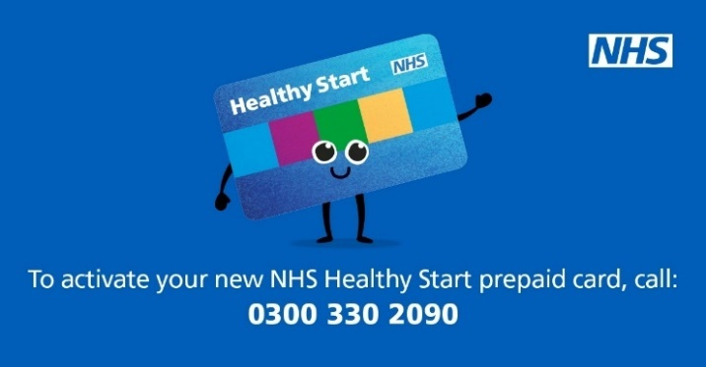
There are many benefits to joining the @NHSHealthyStart scheme. It could take as little 5 minutes to complete the online application form. See if you’re eligible to apply: www.healthystart.nhs.uk  #HealthyStartEastSussex | 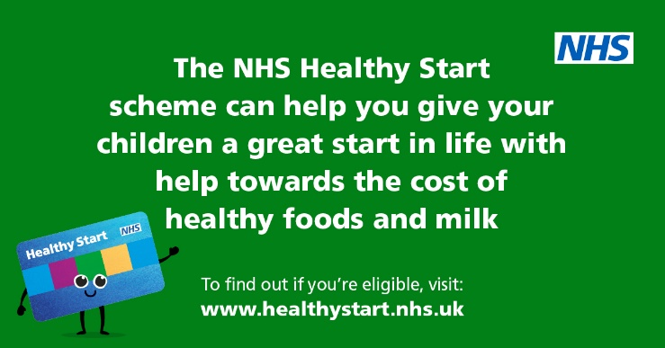
Fruit and vegetables are part of a healthy, balanced diet and can help your family stay healthy. If you're pregnant, or have a child under the age of 4, you could be eligible to help towards the cost of healthy essentials.  Find out more by visiting: www.healthystart.nhs.uk  #HealthyStartEastSussex | 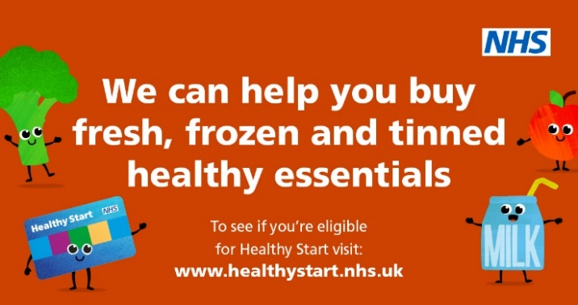
Healthy Start helps your children have a great start in life, with help towards the cost of fresh fruit, vegetables, and milk. Make it easy to shop healthy, with our new prepaid Healthy Start card. Apply online today:  www.healthystart.nhs.uk #HealthyStartEastSussex | 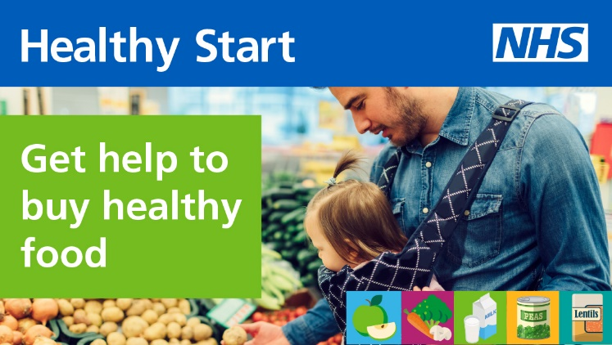
You’ll qualify for the #NHSHealthyStartScheme if you’re at least 10 weeks pregnant or you have at least one child under 4. You must also be receiving at least one of the benefits listed on the NHS Healthy Start website. Find out more: www.healthystart.nhs.uk #HealthyStartEastSussex | 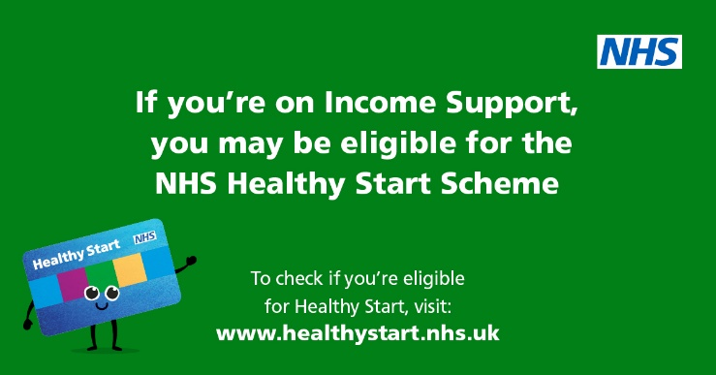
Healthy Start helps give your children the very best start in life. If you’re eligible, you could receive up to £4.25 a week towards the cost of healthy fruit, vegetables, pulses, and milk.  Find out more about the scheme and what you could be entitled to:  www.healthystart.nhs.uk #HealthyStartEastSussex | 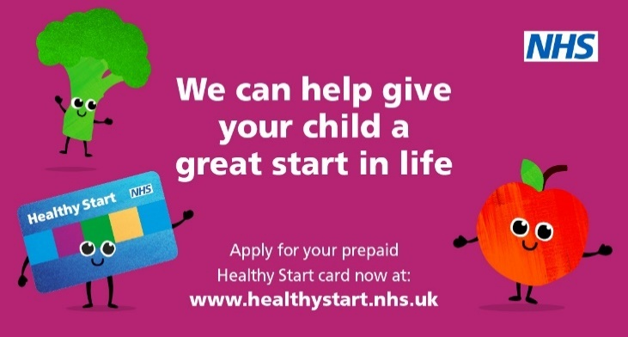
Could you be eligible for support in providing a Healthy Start for your family? If you’re pregnant or have a child under the age of 4, you could be entitled to receive a prepaid card to support the cost of healthy essentials. Find out more: www.healthystart.nhs.uk #HealthyStartEastSussex | 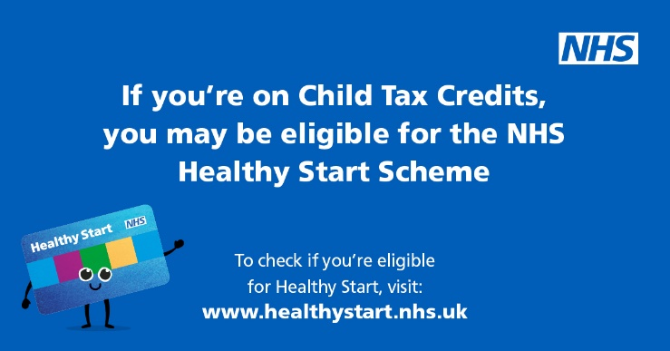
Did you know you can find out in as little as 5 minutes whether you could be eligible for Healthy Start? The online eligibility checker is a quick and easy way to find out whether you could be entitled. Click here  https://endchildfoodpoverty.org/healthy-start  www.healthystart.nhs.uk  #HealthyStartEastSussex | 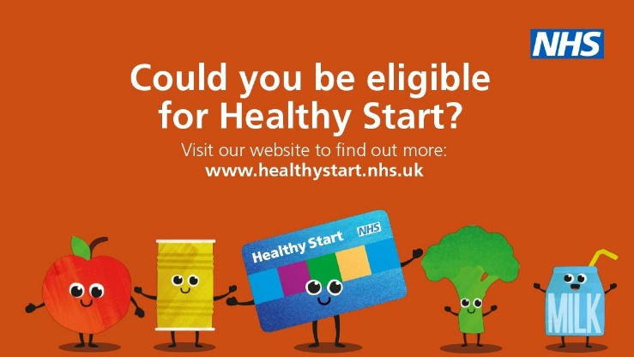
Did you know you can get free Healthy Start vitamins when you join the @NHSHealthyStart scheme? All you need to do is show your card when you collect your vitamins! Find your nearest provider here:  www.healthystart.nhs.uk/getting-vitamins  #HealthyStartEastSussex | 