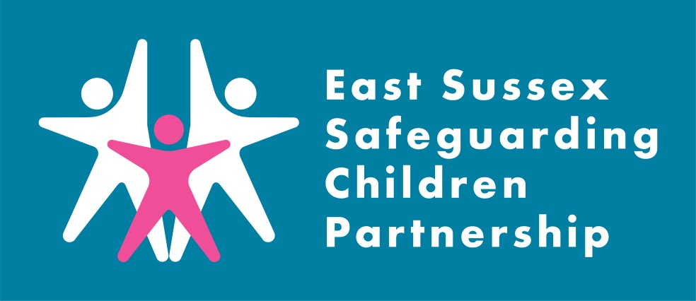
Child X LCSPR
Learning Briefing

Introduction:
The East Sussex Safeguarding Children Partnership (ESSCP) undertook a Local Child Safeguarding Practice Reviews (LCSPR) in 2021 regarding Child X. The review involved the tragic death of a child, referred to as Child X in this report.

The tertiary hospital, where the child had been treated and subsequently died, had concerns about abuse and neglect. However, during the review process the ESSCP and Independent Reviewer did not find evidence to support these concerns.
What is a Local Child Safeguarding Practice Review?

A Local Child Safeguarding Practice Review (LCSPR) is a locally conducted multi-agency review in circumstances where a child has been abused or neglected, resulting in serious harm or death, and/or there is cause for concern as to the way in which agencies have worked together to safeguard the child.

The purpose of a review is to establish whether there are lessons to be learned about the way in which local professionals and agencies work together to safeguard children; identify what needs to be changed and, as a consequence, improve inter-agency working to better safeguard and promote the welfare of children.

The ESSCP agreed though, that continuing this review offered an opportunity to consider any local or national learning around safeguarding for children electively home educated and from minority faith groups.

To protect the wellbeing of child X’s sibling/s, the ESSCP will be publishing the report anonymously on the NSPCC’s website. Whilst not containing specific details of the case, this briefing will set out the headline learning from this review.

Key learning:
The following learning points were identified in the Partnership Review process.

Learning point 1: Elective Home Education
Child X was electively home educated (EHE) from the end of Year 5 (10 years old). The family had ‘routine’ contact with the Local Authority which comprised of - in line with statutory requirements - an annual phone call to discuss and agree if education provision was suitable, the offer of attendance at a Drop-In, and a home visit if requested by the family.
A home visit was not requested, and the education of the children was deemed suitable. Therefore, the contact with this family didn’t include face to face contact or home visits.
During the Review process, working groups were established to consider how to enhance safeguarding for EHE children. As a result:

- An action plan was agreed to raise awareness with schools/agencies, and the Local Authority EHE Policy was updated to ensure clear multi-agency pathways to raise concerns and consider better ways to engage and hear the child’s voice.
- A multi-agency working group involving education, health, police and children’s social care developed clear pathways of communication to support identification of EHE children.

Learning point 2: Jehovah’s Witness Faith
There were no safeguarding concerns in relation to Child X, however it was agreed that the review would consider how agencies respond to safeguarding concerns for children from the Jehovah’s Witness community. In addition, the review considered the Jehovah’s Witness safeguarding arrangements to inform local and national learning.

A commissioned expert on the Jehovah’s Witness faith reviewed their current (December 2020) Safeguarding Policy and liaised with the Charity Commission. The review did not provide assurance on the current safeguarding policies around safe recruitment, management of allegations of abuse and safeguarding training in the Jehovah’s Witness faith.

The ICCSA Inquiry interim report makes a specific recommendation for religious organisations to address these issues.

Learning point 3: Information Sharing
The process of this review highlighted some inconsistencies and inaccuracies in information provided by the tertiary hospital, to the various statutory processes involved following a child death, which had a significant impact on the safeguarding concerns about Child X.

The ESSCP has raised the concerns with the hospital and their local Safeguarding Partnership and suggested that the resulting Action Plan is monitored to provide assurance to the Partnership.

Learning point 4: Access to Health resources
Feedback from Child X’s mother identified two areas of consideration for the ESSCP:

- The initial triage assessment by the Child and Adolescent Mental Health Service (CAMHs) for Child X sibling was undertaken by phone. Sibling had clear suicidal ideation but felt unable to disclose over the phone. A review of these arrangements may be helpful.
- Services/counselling to support bereaved parents appear locally to be restricted to provision by charities and commissioning needs to be considered by the local Clinical Commissioning Group (CCG)/National Health Service England.

Recommendations:
The LCSPR identified eight recommendations to strengthen safeguarding practice:

- The Safeguarding Children Partnership consider how they can engage local faith communities to undertake a proportionate Section 11 self-evaluation process to provide assurance to the Partnership on the effectiveness of those arrangements.
- The Local Authority Elective Home Education team continue to lead the work on improving the identification and assessment of children who are electively home educated and ensure the voice of the child is included.
- The Safeguarding Children Partnership engage with the DfE in the development of local guidance for schools on children electively home educated.
- The Safeguarding Children Partnership to request the National Safeguarding Practice Review Panel considers the recommendations from the IICSA report and its final report on the safeguarding arrangements within religious faiths to ensure they are addressed and implemented at a national level.
- The CCG Designated Nurse and Designated Doctor support the tertiary hospital to consider the learning and review their arrangements to share information with other agencies.
- The Safeguarding Children Partnership seeks assurance from CAMHs regarding the robustness of the triage of CAMHs referrals.
- The CCG consider the current commissioning of bereavement services to parents following the death of a child to enable a consistent and appropriate response to the need.
- The Safeguarding Children Partnership should alert the National Child Safeguarding Practice Review Panel and contact all Child Death Review Leads to raise awareness of the need to ensure that all Child Death Review processes require referrals into the Coronial process to be explicit about any potential safeguarding concerns.

Action taken since the review:

To be updated following action plan update (?)
Since work on the LCSPR as started, the following has been completed:
- The tertiary hospital safeguarding team now links with the designated teams to ensure an internal professional meeting takes place prior to any external sharing of information from the trust.
- Schools exploring areas where they can be overt and explicit in the way they embrace alternative religions and faiths. Such as changing ‘Chapel’ to a ‘prayer room,’ to ensure all faiths feel supported and able to access a safe space during the school day.
- Exploring feedback methods for students who are taken off roll to become electively Home educated so their views are sought and shared as appropriate.
- Ongoing conversations with the National Safeguarding Practice Review Panel and Child Death Overview Panel regarding the learning of national importance.

Useful Links:

Pan Sussex Procedures
When was the last time you used the Pan Sussex Safeguarding and Child Protection Procedures? Did you know you can sign up to alerts for when the manual is updated.

ESSCP Multi-agency Training
Currently all ESSCP training courses are running virtually, and we will update you on the East Sussex Learning Portal when these courses become available.

Contacting the Single Point of Advice (SPoA)
Details on contacting SPoA can be found here: Contacting the Single Point of Advice (SPoA) | East Sussex County Council

ESSCP Contact
Details about the Partnership and its work can be found at www.esscp.org.uk. Follow the ESSCP on twitter for the latest safeguarding news in East Sussex @EastSussexLCSB

The ESSCP can be contacted on ESSCP.Contact@eastsussex.gov.uk or 01273 481544

Learning for practice:
The ESSCP invite you to discuss the issues raised in this LCSPR in your team meetings or during group supervision. We encourage your responses to be included in your team minutes and forwarded to the safeguarding lead within your organisation.

Points for discussion:
- How do you ensure that the voice of the child is heard in the work you do with families?
- How do you consider a child/family’s religion, and the impact on your relationship with them, in your work with children?
- If you come in to contact with a child who does not have a named school, do you know who to contact? Watch this video about EHE and the Local Authority EHE Team: https://web.microsoftstream.com/video/309be393-7271-46a2-90b3-6b1886a15b5d
- When was the last time you used the Pan Sussex Child Protection and Procedures Manual?

