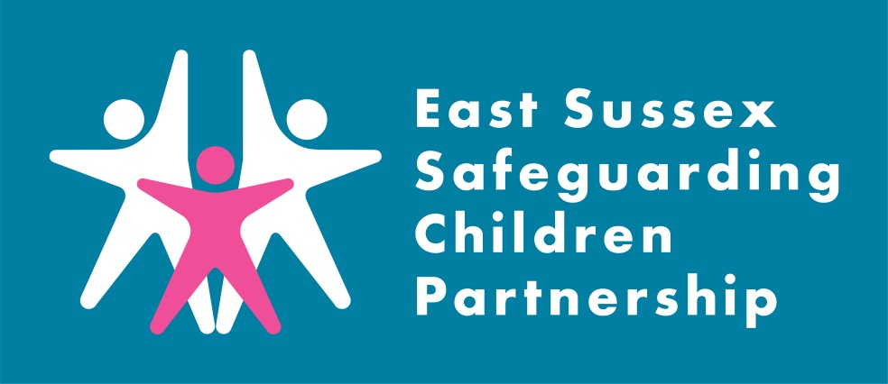

What is a Local Child Safeguarding Practice Review?

A Local Child Safeguarding Practice Review (LCSPR) is a locally conducted multi-agency review in circumstances where a child has been abused or neglected, resulting in serious harm or death, and/or there is cause for concern as to the way in which agencies have worked together to safeguard the child.

The purpose of a review is to establish whether there are lessons to be learned about the way in which local professionals and agencies work together to safeguard children; identify what needs to be changed and, as a consequence, improve inter-agency working to better safeguard and promote the welfare of children.

Child Z LCSPR
Learning Briefing

Introduction:
The East Sussex Safeguarding Children Partnership (ESSCP) undertook a Local Child Safeguarding Practice Reviews (LCSPR) in 2021 regarding Child Z. Child Z was 18 months old when he died of a non-accidental head injury.

Child Z and his family were known to multi-agency services amid previous concerns about domestic abuse in the parents’ relationship. The alleged perpetrator (referred to as Adult A) was also known to local services, most recently resulting in the removal of their child following significant safeguarding concerns.

The publication of the Child Z report is delayed due to criminal procedures. To ensure that learning is shared as soon as possible this briefing will set out the headline learning from this review.

Key learning:
The following learning points were identified in the Partnership Review process.

- The legacy of relationships characterised by domestic abuse
Domestic abuse between partners who have separated but where there is ongoing contact because of children is complex. The power imbalance is likely to still be present and practitioners need to consider how this should be assessed. Research tells us that parental separation does not guarantee an end to domestic abuse and that for many women who separate from violent partners, the domestic abuse continues beyond this. Separated women are at particularly high risk and so therefore are their children. For many families, contact between fathers and their children provides a context for domestic abuse to continue.

- Information sharing
it was established during the review that the information about Adult A and their background was not shared with either parent. Consequently, they were unaware of the extent of Adult A’s background and potential risk. Poor information sharing is a recurrent theme from multiagency case reviews, normally in the context of how information is shared (or not) between professionals. In this case, the dilemma was about information sharing with other parents and the review has highlighted different perceptions in agencies about how and when information can be shared with parents.

Government guidance and legislation is clear about information sharing with other professionals, but there is less clarity about information sharing with parents as was the case here. The review has found that there was an opportunity for the police and Children’s Social Care to do a joint disclosure to both parents but there is currently no clear process to do this.

- The importance of assessing background information
The review has highlighted the importance of researching background information and the challenge of fully understanding that within a very tight timescale. Best practice would have been to have a three-way conversation between staff in SPOA, Legal Services and the social worker but as previously noted there was no established process for this.

- Assessing risk to children from risky adults outside of the family home
Within the multi-agency networks in East Sussex there is strong practice in identifying and assessing risk to children in their own families. This includes a range of scenarios where children may be at risk. In other situations, however, where there is information available to suggest that a person is risky in terms of being aggressive and violent, but the behaviour is not aimed specifically at children, the practice may not be so well developed.

It is important that all practitioners have a broad understanding of the risks posed by adults who are violent and that they assess risk based on the level, frequency, and history of violence in its many forms. Frameworks exist to assess this risk via formal assessment and/or s47 enquiries, but practitioners need to be supported by clear guidance from senior managers about when this is appropriate.

Recommendations:

The LCSPR identified three recommendations to strengthen safeguarding practice:

Recommendation One
Clarity is needed for practitioners about information sharing with parents. The East Sussex Safeguarding Children Partnership should commission a multi-agency task and finish group to develop a framework and chain of command about how and in what circumstances details of individuals and the risk they may pose, can be shared with parents.

Recommendation Two
East Sussex Safeguarding Children Partnership to review their training strategy to ensure that all partners equip their practitioners to be confident when dealing with families where domestic abuse is (or has been) a factor. This should include;
  - the increased risk to women and children when parents separate and the need for ongoing contact arrangements to be kept under review
  - the importance of not solely relying on victims of DA to put measures in place to protect children against their DA perpetrators

Recommendation Three
East Sussex Safeguarding Children Partnership to be assured that practice is in place whereby fathers are engaged in any risk assessment of their children to protect them from adults who pose a risk.
Useful Links:

Pan Sussex Procedures
When was the last time you used the Pan Sussex Safeguarding and Child Protection Procedures? Did you know you can sign up to alerts for when the manual is updated.

ESSCP Multi-agency Training
Currently all ESSCP training courses are running virtually, and we will update you on the East Sussex Learning Portal when these courses become available.

Contacting the Single Point of Advice (SPoA)
Details on contacting SPoA can be found here: Contacting the Single Point of Advice (SPoA) | East Sussex County Council

ESSCP Contact
Details about the Partnership and its work can be found at www.esscp.org.uk. Follow the ESSCP on twitter for the latest safeguarding news in East Sussex @EastSussexLCSB

Action taken since the review:

Since work on the LCSPR as started, the following has been completed:
A pan-Sussex working group developed a procedure for sharing information with parents around safeguarding risks posed by an adult who is in contact with their children. The approved guidance is available here: 2.3 Sharing information with family members about other adults and the risk they may pose | Sussex Child Protection and Safeguarding Procedures Manual

Learning for practice:

The ESSCP invite you to discuss the issues raised in this LCSPR in your team meetings or during group supervision. We encourage your responses to be included in your team minutes and forwarded to the safeguarding lead within your organisation.
Points for discussion:
- How do you manage situations where there are potential risks posed by other adults involved with the child/family?
- How do you consider the legacy of domestic abuse in your work with families?
- How do you consider fathers, partners and other significant adults in assessments addressing the needs and welfare of children?
- When was the last time you used the Pan Sussex Child Protection and Procedures Manual?

