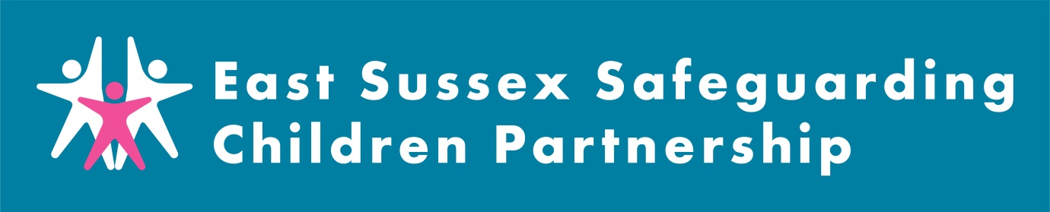

East Sussex Safeguarding Children Partnership Monthly Digest – March 2023

This latest roundup of ESSCP news includes highlights from recent publications, information about forthcoming events and training, and other snippets of useful information from across the ESSCP and partner agencies. If you have anything that you would like included in next month's ESSCP digest please email esscp.contact@eastsussex.gov.uk.

ESSCP Learning Briefing: Evidencing Impact Child T

ESSCP training and learning opportunities

The new platform for learning and training in East Sussex is now live! Courses may be delivered face to face or virtually so make sure you check the course details when booking. Information on all courses available can be found on the East Sussex County Council Learning Portal. There is still time to book on the ESSCP ‘Harmful traditional practices’, ‘Participating in the Child Protection Conference’, and ‘Professional curiosity and professional challenge’ course. More information can be found in the first attachment to this email.

East Sussex County Council have secured Home Office funding to offer 3 sessions during March 2023 across the county ( in Eastbourne, Newhaven and Hastings) on Media literacy to prevent radicalisation and extremism’, to help you mitigate and combat the risks relating to online radicalisation and extremism. To find out more details, and to sign up, go to the ESSCP website: Preventing radicalisation (focus on online) March 2023 FREE TRAINING OFFER - ESSCP

The Safeguarding Adult Board are running two action learning events on SAR Anna. Although there are no specific reocmmendations for children’s services, there is relevant learning for agencies regarding the Importance of Multi-Agency Meetings; the relevance and importance of working closely with the whole family; and dealing with hostility and aggression shown by family members. For more information and to sign up to the events please go to: SAR Anna Action Learning Events - 27th and 28th March 2023 Tickets, Multiple Dates | Eventbrite

Local briefings and newsletters
- East Sussex Children’s Services has published their February 2023 edition of the Cost of Living Newsletter for staff working with families (attached to this email). This newsletter is a resource for practitioners to use to support families. It is not something to send direct to families/residents. The content informs work with families during casework, when signposting or referring onwards. Cost of living information for residents: Support with the cost of living | East Sussex County Council
- The East Sussex Domestic Abuse, Sexual Violence/Abuse and Violence Against Women and Girls Team have produced their February information round up, attached to this email. This contains latest news from the sector, events, policy and legislative updates, funding opportunities, research and resources, local service information and job opportunities.
- NHS Sussex produce a monthly ‘Safeguarding and Looked-After Children Newsletter’. All newsletter articles are accessible on the NHS Sussex intranet and all Sussex professionals can request access. If you have not already registered, the please use the following link: Safeguarding and looked-after children Newsletter September 2022 - NHS Sussex (ics.nhs.uk). February’s newsletter includes information on training opportunities within Sussex, transitional safeguarding, MCA video clip, and much more.
National Updates

Children’s Social Care Reform: Stable Homes, Built on Love: Strategy and Consultation.
The Government’s new strategy to reform children’s social care responds to three independent reviews published last year: The National Safeguarding Panel’s national review the murders of Arthur Labinjo-Hughes and Star Hobson (Child Protection in England), the Independent Review of Children’s Social Care 2022, and the Competition and Markets Authority’s Children’s Social Care Market Study 2022. The strategy sets out proposals for action across six ‘pillars’. The strategy emphasises the need for a The strategy emphasises the need for a whole system approach to reforming children’s social care, requiring input from health, police, schools, family courts, youth justice, business and civil society alongside central government, local authorities and the workforce. All safeguarding partners and partner agencies involved in supporting and protecting children will want to familiarise themselves with the proposed strategy and give feedback through the consultation process about its ambitions and proposed actions to achieve whole system reform that will benefit children and families.
The NSPCC have also produced a briefing of the strategy: The independent review of children’s social care: final report | NSPCC Learning

The Centre of Expertise on Child Sexual Abuse (CSA Centre) has published a report compiling recent studies on children and young people who display harmful sexual behaviour. Findings include: during 2021/22 in England harmful sexual behaviour accounted for 40% of referrals to local authority children's services involving sexual abuse; and some forms of harmful sexual behaviour are so common in education settings that they have become ‘normalised’ to young people. Recommendations include: assessments should be holistic and should view harmful sexual behaviour through the lens of trauma; and the role of patriarchal values and attitudes in the development of harmful sexual behaviours needs to be considered. Key messages from research on children and young people who display harmful sexual behaviour - CSA Centre
The Children’s Commissioner for England has published a report into persistent absence which summarises research from previous attendance audit reports. The research identified groups of children who are at more risk of persistent absence from school, including: children with special educational needs and/or disabilities (SEND); children with mental health needs; and children with a history of exclusion and absence. The Commissioner recommends additional training for teachers to support pupils; and multi-agency working to deliver joined up support for children and families. Attendance is everyone's business | Children's Commissioner for England (childrenscommissioner.gov.uk)

The Department of Health and Social Care (DHSC) have commissioned NHS England to carry out a review of the Female Genital Mutilation (FGM) Enhanced Dataset. This dataset is a valuable information source to support the identification, commissioning and management of FGM services both nationally and locally. To help improve the quality and completeness of the dataset we are reviewing its content and the processes surrounding it. The first stage of the review is to get initial views from key stakeholders about which information contained in the FGM dataset is useful, how it is used and identify any information that may be missing. To support this work please see the link below to a short questionnaire that will take about 5-10 minutes to complete:
https://forms.office.com/Pages/ResponsePage.aspx?id=Hwf2UP67GkCIA2c3SOYp4j79uwVdgthOm3Yi6__JZtdUMjNCTFQxVkJBNTZWM0c4S1lKRlhSUThYTi4u

