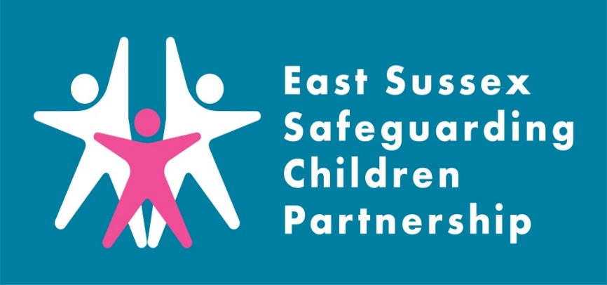
SAR Charlie
Learning Briefing
What is a Safeguarding Adult Review?

A Safeguarding Adult Review (SAR) is a locally conducted multi-agency review in circumstances where an adult has been abused or neglected, resulting in serious harm or death, and/or there is cause for concern as to the way in which agencies have worked together to protect the adult.

The purpose of the SAR is to establish whether there are lessons to be learned about the way in which local professionals and agencies work together to safeguard adults; and, as a consequence, improve inter-agency working to better safeguard vulnerable adults.

Introduction:

The East Sussex Safeguarding Adult Board commissioned a Safeguarding Adult Review (SAR) to explore the circumstances that led to the death of an 18-year-old, who is referred to in this review as ‘Charlie’. While the SAB led the review, given Charlie’s age and significant involvement with a range of children’s services prior to their death, the ESSCP felt it was important to highlight the learning from the SAR in this briefing, as much is relevant for services working with children and families.
An executive summary of the report can be found on the East Sussex SAB website here: Safeguarding Adults Reviews - East Sussex SAB
The SAR identified important learning for agencies, particularly in relation to transitions to adult services, risk management and planning, self-harm, gender identify, trauma informed practice, mental health and professional challenge.

Background to case:
Sadly, Charlie had a short and complex life. Charlie had suicidal thoughts in adolescence and significantly self-harmed on many occasions and regularly refused hospital treatment. Charlie went missing regularly and was temporarily excluded from school.
Charlie was born female and transitioned to a male when aged 17. He had a long history with Children’s Social Care having lived in a traumatic home environment as a child. They experienced several care placements as a looked after child from the age of 15 and was the subject of a child protection plan.
Charlie was the subject of two periods in Hospital under Section 2 of the Mental Health Act (1983) due to their repeated self-harm. Following his second period in hospital, Charlie was discharged to temporary accommodation where he continued to self-harm and drink significant amounts of alcohol. A short while after he moved into temporary accommodation Charlie died of suicide.

Key learning:
The following learning points were identified in the Safeguarding Adult Review process.
- Risk Management and Planning
Sadly, Charlie’s experiences are similar to many other national SARs regarding young adults. Differing attitudes to risk, and no shared understanding or accountability for that risk, leaves one or two professionals holding that risk and making decisions based on sole observations and presentations. SAR Charlie identified learning regarding:
- Supported accommodation providers are not always set up to manage and support individuals who have complex needs and/or at high risk of harming themselves or others. The placing of young people in semi-supported accommodation at a young age with limited or no experiences of living alone or semi-independently needs to be carefully risk assessed especially if there are no support mechanisms including visiting patterns in place.
- The management of harm and risk of young people, including for Looked After Children, needs to be shared across the multi-agency partnership. The appropriate use of the child safeguarding system to assess risks and needs for young people post 16 needs to be considered, particularly where self-harm is evident.
- The awareness and use of the recent Multi-Agency Risk Management (MARM) protocol and guidance needs to be encouraged and also better understood by child safeguarding professionals.
- Self-harm
Charlie had suicidal thoughts and significantly self-harmed on many occasions and regularly refused hospital treatment. The SAR identified learning regarding:
- Practitioners who work with young people who significantly self-harm need ongoing support from their line managers, alongside opportunities to reflect on their practice with other professionals.
- Assessments of capacity under the Mental Capacity Act 2005 should be considered when young people who are significantly self-harming are unable to make effective decisions for themselves whilst under the influence of drugs or alcohol. Opportunities or a necessity to undertake an assessment under the Mental Capacity Act and needs to be included in forward care planning.
- Up to date awareness sessions are needed for professionals about the use of social media platforms and the role they play in young people’s lives. Non suicidal self-injury and suicidal ideation in adolescents with mental health problems and their sharing on social media platforms are an indicator for suicide.
- Young people’s use of alcohol should be risk assessed, particularly if this is a trigger for self-harming behaviours. Alcohol use is as significant as self-harming behaviours and needs to be given equal weight in terms of risk to health.
- Transitional Safeguarding
Unchallenged perceptions of child and adult vulnerability and capacity can lead to young people falling through the ‘safeguarding net’. The safeguarding systems for children and adults are based on different legal and procedural frameworks and this has the potential to create gaps in operational practice. Basing safeguarding decisions on chronological age is fraught with challenges, ignoring the developmental and behavioural challenges of becoming an adult. The model of transitional safeguarding requires whole system change and a shared accountability by children’s safeguarding partners and strategic leads in adults’ services.
- Trauma informed practice and non-engagement
Due to Charlie’s life experiences, they struggled with relationships and trust. Charlie’s presentation and behaviour at times was very challenging and aggressive. Professionals’ ability to get alongside them was difficult. Charlie’s story reflects how childhood experiences and trauma can significantly impact on adolescence and early adulthood. The Review identified learning regarding how the inability of young people to access services should result in further enquiry or assessment. Agencies need to ensure a more person centred, flexible and relationship-based approach to support and services. The non-engagement of young people and adults should encourage professionals to work harder in meeting their specific needs rather than withdrawing support. Independent advocacy and assertive outreach, needs to be encouraged where agencies struggle to engage with professionals.

Recommendations:
SAR Charlie identified six recommendations for the ESSCP to strengthen safeguarding practice:
Recommendation 2: ESSAB and East Sussex Safeguarding Children Partnership (ESSCP) should encourage a partnership wide approach to trauma informed practice, which should be supported by training.
Recommendation 3: The ESSCP Quality Assurance Subgroup should consider how best to undertake a multi-agency audit of selected young people aged between 16 and 18 subject to child protection plans in the last two years to assure themselves that effective safeguarding arrangements were in place.
Recommendation 5: ESSAB and ESSCP should work with partners to ensure practitioners are able to access awareness training on the use of social media and its significance in the safeguarding of children and adults.

Recommendation 13: ESSAB and ESSCP are encouraged to undertake some joint learning events to assist children’s services to better understand adult safeguarding principles, processes, and lawful differences.

Recommendation 16: The ESSAB and ESCCP should update and assure partners that the current work being undertaken between both Boards to develop a Transitions Protocol for East Sussex reflects the needs of vulnerable young people reaching 18. Assurance should be provided that the Transitions Protocol will be shared with practitioners to inform and promote the current pathways and arrangements in place locally.

Action taken since the review:

Since the review was completed, the SAB and ESSCP has set up a ‘Transitions’ Task and Finish Group, which is made up from a range of representatives from multi-agency partners. It will be the responsibility of the Task and Finish Group to:
- Agree what a ‘good transition’ looks like for a vulnerable young person
- Identify existing transitional pathways, including identifying and sharing best practice.
- Identify what information and guidance needs to be shared with frontline professionals.
Learning for practice:
Useful Links:

Pan Sussex Procedures
When was the last time you used the Pan Sussex Safeguarding and Child Protection Procedures? Did you know you can sign up to alerts for when the manual is updated.

The Multi-Agency Risk Management (MARM) Protocol has been designed to provide guidance for practitioners on working adults with multiple complex needs and managing cases in which there is a high level of risk, but the circumstances may sit outside the statutory safeguarding framework

Allsorts Youth Project listens to, connects & supports children & young people under 26 who are lesbian, gay, bisexual, trans or exploring their sexual orientation and/or gender identity (LGBT+) and their families: Allsorts Youth Project

Multi-agency training
Our new platform for learning and training in East Sussex is now live! Courses may be delivered face to face or virtually so make sure you check the course details when booking. Information on all courses available can be found on the East Sussex County Council Learning Portal

The Safeguarding Adult Board run multi-agency training: SAB Learning and Development Opportunities - East Sussex SAB
The ESSCP invite you to discuss the issues raised in this briefing in your team meetings or during group supervision. We encourage your responses to be included in your team minutes and forwarded to the safeguarding lead within your organisation.

Points for discussion:
- What learning did you expect, or what surprised you about learning from this review?
- How does ‘trauma informed practice’ shape the work you do with young people?
- How do you consider the impact of social media when you have concerns about a child who is self-harming?
- What do you know about the use of Deprivation of Liberty Safeguards (DOLs) and forthcoming changes to legislation, including the implications for 16- and 17-year-olds regarding the introduction of Liberty Protection Safeguards (LPS)?
- Do you know how to signpost for support where young people have gender identity needs?

