East Sussex Safeguarding Children Partnership

Annual Report 2022/23

www.esscp.org.uk

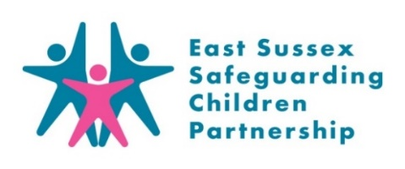
Contents

Foreword by East Sussex Safeguarding Children Partnership Independent Chair |  | 3
1. | Introduction by Strategic Safeguarding Partners | 4
2. | Key Learning & Achievements 2022/23 | 5
3. | Safeguarding Context 2022/23 | 6
4. | Partnership Arrangements | 7
4.1  4.2  4.3  4.4  4.5  4.6 | Overview of the Partnership  Partnership Structure and Subgroups  Links to Other Partnerships  Pan Sussex Working  Ongoing review of Partnership Arrangements  East Sussex Safeguarding Children Partnership Priorities
5. | Evidence | 13
6. | Learning | 20
7. | Impact | 29
8. | Assurance | 33
9. | Appendices | 40
9.A  9.B | Safeguarding Context  Board Membership 2022/23
9.C | East Sussex Safeguarding Children Partnership Budget
9.D | Links to other documents
9.E | Acronyms

Foreword
Thank you for taking the time to read the East Sussex Safeguarding Childrens Partnership (ESSCP) Annual Report. This document should give you an open, honest view of how the Partnership works to safeguard our children and young people. As the Independent Chair and Scrutineer of the ESSCP I have the responsibility for scrutinising this report and making sure it is accurate and provides the information you, the reader, requires. I hope that it meets your expectations and above all gives you complete confidence in the way the Partnership strives to safeguard children in East Sussex.
I wanted to start by offering some reassurance regarding the strength of the Partnership. During the reporting period covered by this document I have observed some truly outstanding partnership work. The safeguarding culture in East Sussex affords everyone the opportunity to be confident that they will be supported as they strive to improve outcomes for our children and families. That culture permeates from the very top of the organisations through to the practitioners whom we so heavily rely on. I meet with those at executive level, and I am consistently impressed with their commitment to safeguarding, personal investment and leadership. Representation at Partnership meetings is excellent and there is a culture of support and challenge as we strive to reach our joint objectives. Perhaps of greatest importance is the fact that East Sussex is blessed with a professional, caring and incredibly hard-working community of individuals who work and volunteer in the safeguarding arena. On behalf of the Partnership, I would like to offer each of them our sincere thanks for all they do.
This report sets out our achievements, concentrating in part, on the areas we have prioritised. Whilst it is right that we celebrate success it is also important that we recognise that we should always seek to improve. I have seen a real will to seek continuous improvement in East Sussex, the training offer is excellent, supported by effective trainers from a wide range of backgrounds. The response to learning reviews is effective and all partners are alive to disseminating lessons learned at the earliest opportunity. Please spend some time reading the sections of this report that details some of these reviews. They touch on some of the most distressing cases our practitioners, communities and families are involved in. They also offer some of the best opportunities for us to learn and improve outcomes for children.
I would also like to take a moment to acknowledge the fantastic work of the ESSCP business support team. They work tirelessly behind the scenes to make sure that our business runs smoothly, and I would like to thank them on behalf of all the partners.
Finally, when you read this report, I would ask that you consider the impact you can have. Safeguarding children is the responsibility of all of us, professionals, volunteers, families, friends, and communities. Please don’t be afraid to raise concerns, seek advice or offer to help.

Chris Robson
Independent Chair of the East Sussex Safeguarding Children Partnership

- Introduction
Welcome to the 2023 annual report, on behalf of the three statutory partners, thank you for taking the time to read this and for your support in our continuing progress to improve how we work together to deliver the best possible services to our communities.

We hope you find the report useful in understanding the partnership’s work and celebrating some of the successes. These successes are only possible through the dedication and diligence of the many people working with children, young people and families across a range of agencies.

We continue to keep children at the centre of our thinking and delivery at all levels, as well as encouraging professional curiosity across the multi-agency workforce, ensuring the lived experience of the child is recognised.

We are continuously learning with over 500 staff trained across the learning programme and many more accessing learning through briefings, online learning and multi-agency meetings. We know from our quality assurance that our services make a positive difference to the lives of many children, young people and families every day. We do not always get everything right. Serious incidents when they occur are, of course, the subject of Rapid Reviews and Local Child Safeguarding Practice Reviews. We are pleased to see the high quality of those reviews and the partnership embracing any learning in a timely way. Our learning doesn't stop there, from the task and finish groups to the case file audits to lively discussion, the culture is of working together, learning together and delivering together which is a positive indicator for the partnership potential for the coming years.

Thank you again for your ongoing support, your hard work and commitment to this vital area of work to improve the lives of our children and their families in East Sussex.

Naomi Ellis  Director of Safeguarding & Clinical Standards, NHS Sussex | Alison Jeffery  Director of Children’s Services, East Sussex County Council | James Collis  Chief Superintendent, Head of Public Protection, Sussex Police

- Key Learning & Achievements 2022/23
- Three multi-agency Rapid Reviews conducted to respond to serious incidents; one progressed to an LCSPR, learning from the other two shared via learning briefings and action plans developed.
- Two LCSPRs published.
- Two LCSPRs and one legacy SCR awaiting publication due to criminal proceedings and pending family input.
- Two new Lay Members recruited.
- Two ‘evidencing impact’ events held on Child T and infant injury learning.
- Launch of partnership promotional video.
- Pan Sussex: agreed process for development of Pan Sussex training and events; completion of Pan Sussex serious incident referral and rapid review procedure.
- Development of a Scrutiny Plan to track how the partnership is responding to national and local learning.

- 552 multi-agency staff attended 42 training courses.
- 99% of evaluations rated course as Excellent or Good.
- Four new courses introduced into the training offer.

- Task & Finish Groups:
- Harmful Sexual Behaviour (HSB) in Schools and Colleges
- Neglect and Poverty
- Transitions
- Information sharing with third parties
- Education Safeguarding
- Child Exploitation
- Embedding a Learning Culture
- Safeguarding under fives
Training
- Four multi-agency audits held:
  - Pan Sussex audit on safeguarding children who are electively home educated.
  - Deep Dive audit on harmful sexual behaviours.
  - Audit of initial assessment of risk (front door).
  - Appreciative style audit on theme of ‘Unseen Men’.
3. Safeguarding Context 2022/23
Impact of multi-agency working

East Sussex child population
Children with family related vulnerabilities
17,798 family contacts (to SPOA and other excluding MASH)
21,181 information gatherings by the Multi-agency Safeguarding Hub (MASH)
4018 referrals to statutory social care
35 Privately Fostered children
See Appendix A for more detailed information.
Children with health related vulnerabilities
Children whose actions place them at risk

2083 missing episodes
11 births to under-18 year olds
62 young people entered the youth justice system
11 occasions of young people held overnight in Police custody

22 children with disabilities with a Child Protection Plan
692 children attending A&E due to self-harm
3607 referrals to child mental health services
Children supported by statutory services
691 children with a child protection plan
664 Looked After Children
73 unaccompanied asylum-seeking children
12 young people at high risk of child exploitation
570 sexual offences against children

106,575 children aged 0-17 years
19,183 children aged 0-17 live in low income families
1835 children living with domestic violence (MARAC)
328 vulnerable young carers
1514 children educated at home
- Partnership Arrangements

4.1 Overview of the Partnership
The East Sussex Safeguarding Children Partnership acts as a forum for the lead safeguarding partners (Sussex Police, East Sussex County Council, and the NHS Sussex) to:
- agree on ways to coordinate safeguarding services in (the geographical local authority borders of) East Sussex.
- act as a strategic leadership group in supporting and engaging other agencies across East Sussex; and
- implement local, regional, and national learning, including from serious child safeguarding incidents.

4.2 Partnership Structure and Subgroups
The Board is chaired by an Independent Chair, meets four times a year and is made up of the statutory safeguarding partners and relevant agencies (full list of board members is included in Appendix B). The Independent Chair also chairs the ESSCP Steering Group which meets four times a year. The Independent Chair fulfils the role of the Independent Scrutineer and acts as a constructive critical friend to promote reflection to drive continuous improvement.
The main Board is supported by a range of subgroups that lead on areas of ESSCP business and are crucial in ensuring that the Partnership’s priorities are delivered. These groups ensure that the Partnership really makes a difference to local practice and to the outcomes for children and young people. Each subgroup has a clear remit and a transparent mechanism for reporting to the ESSCP, and each subgroup’s terms of reference and membership are reviewed annually.
The three ESSCP safeguarding leads and the Independent Chair form the Planning Group, which also meets quarterly. The Planning Group discusses and agrees the short-term agenda for the work of the partnership and addresses any emerging safeguarding issues requiring strategic input. It also agrees the budget for the ESSCP (see Appendix C).
The Pan-Sussex Strategic Leaders Group membership consists of lead safeguarding partners across East Sussex, West Sussex, and Brighton & Hove. The group’s purpose is to focus on setting the ‘road map’ for future partnership development and identify shared safeguarding priorities and opportunities across the three areas.

Terms of Reference for the Board and Steering Group are available on the ESSCP’s website here: Subgroups - ESSCP

4.3 Links to Other Partnerships
The Partnership has formal links with other East Sussex and Pan-Sussex strategic partnerships, namely the Health and Wellbeing Board; Pan Sussex Child Death Overview Panel (CDOP), Safeguarding Adults Board (SAB); Safer Communities Partnership; West Sussex and Brighton & Hove Safeguarding Children Partnerships; the Sussex Integrated Care System Children and Young People’s Board, Children and Young People Trust (CYPT) and Local Head Teacher Forums. Links to other significant partnership documents are highlighted in Appendix D.
The ESSCP Independent Chair is also the Independent Scrutineer for the West Sussex and Brighton & Hove Safeguarding Children Boards which will enable and facilitate greater joint working between the three areas. The Chair also maintains regular liaison with other key strategic leaders, for example, the Police and Crime Commissioner, Adult Partnership Chairs and Government inspection bodies. The ESSCP annual report is presented to the East Sussex County Council People Scrutiny Committee and Health and Wellbeing Board, and the East Sussex SAB. The report is also shared with the Safer Communities Board, the Police and Crime Commissioner and other ESSCP member organisations’ senior management boards.
At the end of March 2023, the ESSCP had the opportunity to undertake an exciting and effective piece of joint working with the Safer East Sussex Team, who had secured Home Office funding for Shout Out UK to deliver 3 large scale events on ‘Preventing online Radicalisation’. The East Sussex Prevent Board was responding to an increasing in casework that involves extremism with an online element, such as accessing extremist material on websites and forums, and making contact with others on encrypted and gaming platforms. These events, that complemented the ESSCP training programme, took place in venues across East Sussex and were well attended. An evaluation report for these events will be available during either Quarter 1 or Quarter 2 of the 2023/24 reporting period.
Joint training on Coercion and Control is now embedded in the ESSCP Training Programme and a multi-agency Domestic Abuse Task and Finish Group continues to update the existing Domestic Abuse (DA) Training Pathway. This is in recognition of the Domestic Abuse Act 2021 and because partnerships continue to see similar DA conclusions and recommendations from Safeguarding Adult and Children Reviews, Domestic Homicide Reviews, and referrals to the LADO. The refreshed pathway is designed to reflect key emerging issues. From April 2022 the DA Training offer has expanded due to increased involvement from the Domestic Abuse, Sexual Violence and Abuse & Violence against Women & Girls (VAWG) Joint Unit, Brighton & Hove and East Sussex.

4.4 Pan Sussex Working
Although the ESSCP’s focus is on safeguarding children in East Sussex, it should be expected that child protection and safeguarding procedure continue to be developed at a Pan Sussex level, and opportunities for joined up working across Sussex will be promoted where appropriate. Examples of Pan Sussex working in 2022/23 include:
- Pan-Sussex Learning & Development opportunities:
- Considerable work has been undertaken to develop learning at a Pan Sussex level, and opportunities for joined up working across Sussex are promoted where appropriate. During 2022/23 Pan Sussex training continued with: Multi-Agency Public Protection Arrangement (MAPPA), Improving Outcomes for Looked After Children and Harmful Practices. New Suicide Prevention courses ran as a Pan Sussex offer via Grassroots, an external provider.
- Through continuing collaborative working with training counterparts in Brighton and Hove and West Sussex the SCPs are now offering new training on ‘Adultification’. The in-house training on Working with LGBTQ Children and Young People is now offered pan-Sussex. The three SCP’s continue to review further opportunities for joint delivery of courses where practical and beneficial for all 3 Safeguarding Children Partnerships.
- The Pan-Sussex procedures working group reviews, updates and develops over 100 safeguarding and child protection policies and procedures in response to local and national issues, changes in legislation, practice developments and learning from LCSPRs and quality assurance activities. There is excellent attendance and buy in from all lead agencies and Pan-Sussex Local Authorities. Since March 2022 a number of new policies have been published. These include:
- A procedure to describe the sharing of information between Police and the LADO
- A statement about Professional Difference has been added to a number of relevant policies
- A procedure on how to respond to a suspected suicide
- A Sussex Safeguarding Children Partnership Anti Racist Statement
- A procedure on sharing information with family members about other adults and the risks they may pose
There has also been some significant re-drafting of existing policies and procedures. This includes:
- A review of Allegations against people who Work/Volunteer with Children, which was updated to align with Keeping Children Safe in Education 2021 updates
- A review of the Online Safety Policy to include the Dark Web, safeguarding children with SEND online, online bullying and the impacts of harmful content in relation to self-harm, suicide and eating disorders
- The inclusion of virginity testing and hymenoplasty to the Honour base abuse policy
- An extensive review and re-draft of the policy regarding parent carer involvement in sex work
After each meeting, a short briefing is disseminated to the Group for onward cascading across their agencies to front line professionals and these can be read online Welcome to your Pan Sussex Child Protection and Safeguarding Procedures Manual | Sussex Child Protection and Safeguarding Procedures Manual. Going forward, the aim is to improve the intuitive user experience of searching for Policies on the website and further work to understand website use and how people engage with the policies.
- Pan-Sussex Child Safeguarding Practice Reviews Procedure – in March 2023 the new Pan-Sussex procedure for referring a serious incident to Case Review Group and the process for undertaking a Rapid Review and Local Child Safeguarding Practice Review was published. This joint procedure allows the three partnerships to have the same templates and approach which is beneficial to agencies working across the Pan-Sussex area. It also incorporates best practice from the National Panel with regards to undertaking effective reviews.

4.5 Ongoing review of Partnership Arrangements
Lead Safeguarding Partners Self-Assessment
Every other year, lead safeguarding partners undertake a self-assessment as part of the activity to review the effectiveness of local partnership arrangements. At the end of 2020/21 the lead partners used the ‘six steps for independent scrutiny of safeguarding children partnership arrangements’ developed by the University of Bedfordshire. For 2021/22 a Partnership Development Action Plan was created to address the areas rated as red/amber, in particular regarding ‘involving children, young people and families in plans for safeguarding children’. Progress on this action plan was reported on in last year’s Annual Report.
During the first half of 2023/24 lead partners will be using the National Safeguarding Panel’s ‘reflective questions for safeguarding partners’, as set out in their 2021 Annual Report, to assess the effectiveness of local partnership arrangements. The reflective questions draw on what the National Panel has identified are factors behind effective and strong child protection practice. The questions are framed around 4 areas: wider service context; practice and practice knowledge; systems and processes; and leadership and culture.
Areas for improvement will be highlighted in the Partnership’s development action plan, with progress reported on in next year’s Annual Report.

Review of arrangements with Board and Partnership Members
At the end of 2022/23 the ESSCP Business Unit sent a questionnaire to all board and subgroup members to consider the effectiveness of current partnership arrangements.
In total, 17 partnership members responded. Feedback was largely positive with reassuring responses to the quality of the administration, and the communication of the partnership. The majority of partnership members were clear about their role and the support they received to fulfil their role. Nearly all partnership members were confident about communicating what the partnership does and what the priorities of the ESSCP were.
Most encouraging was the reported impact of the partnership on safeguarding and child protection practice. Over 80% of partners responded that partnership learning impacts on the work they do; nearly two-thirds had discussed one of the ESSCP learning briefings in their team meetings, and a similar proportion agreed that ESSCP learning had changed the way their team works.
The survey has been useful to the ESSCP business unit to identify future improvements and planning of meetings. Suggestions include:
- Updating the Induction Pack and sending out to all members on an annual basis.
- Considering how to incorporate a stronger focus on ‘holding up a mirror’ to local practice and the experience of children and families.
- Following up on past board agenda items, including links to published documents (post discussion of draft versions at board meetings).
- Better sharing of actions and information across the partnership groups.
- Considering the implementation of an ‘education’ subgroup to ensure appropriate engagement of schools and other education providers.

4.6 ESSCP Priorities
Following the formation of the ESSCP in September 2019, discussions took place to determine our priority areas of focus for 2020 to 2023. The partnership felt strongly that priorities should relate to key areas of child safeguarding; those identified as of highest risk in the county, where multi-agency working is essential and where significant change and/or commitment is necessary to reduce risk. Priority development took place with both the Steering Group and Board and were agreed by the three safeguarding partners in May 2020. More information on the priorities is contained in the impact and evidence sections of this report. The agreed ESSCP Priorities for 2020-2023 were:
- Safeguarding in Education
- Child Exploitation
- Embedding a Learning Culture
- Safeguarding under 5s
It was considered that ensuring the voice of the child, and taking a contextual safeguarding approach, would be cross cutting over all the ESSCP priorities.
In March 2023 the ESSCP held an extraordinary Board meeting to discuss local evidence – including learning from case reviews, quality assurance activity, and the voice of children – and propose future priorities for the partnership. Proposed priorities were scoped which clearly identified the evidence to choosing as a priority, the intended impact on practice and outcomes for children, and how success would be evidenced. From the priorities proposed, the safeguarding leads agreed on the following priorities for 2023 onwards:
- Safeguarding children in schools including safeguarding children who are electively home educated, excluded from school, and missing education.
- Safeguarding adolescents including adolescents who are criminally exploited, self-harm and/or express suicidal thoughts, child to parent abuse, and transitional safeguarding.
- Embedding learning and evidencing impact from case review and audit work, including ensuring that learning from the 2020-23 priority on safeguarding infants was embedded.

5. Evidence

This section of the ESSCP Annual Report sets out how the partnership is using evidence to determine its priorities; shape the way multi-agency partners have taken actions or adopted specific practice models; and evaluate the impact of partnership work. Examples of how the partnership are evidencing the impact of its work are also given in section 3 (Impact).
ESSCP priorities for 2020-23 were chosen because they were identified as of highest risk in the county, where multi-agency working is essential and where significant change and/or commitment was necessary to reduce risk. It is in such areas where the partnership can be most effective in scrutinising and supporting practice.

5.1 Safeguarding in Education
Why is safeguarding in education a priority?
Everyone who encounters children, and their families, has a role to play in safeguarding children. Early years, school and college staff are particularly important as they see children daily and can identify concerns early and provide help for children, to prevent concerns from escalating. Education settings, and their staff, form a key part of the wider safeguarding system for children.
The ESSCP agreed that by making this area a priority for 2020-2023, there would be a continued focus on effective joint working between local agencies and education settings, strategically and at a setting level. The COVID-19 pandemic and extended school closures for most children highlighted to many services the critical importance of education settings’ role in safeguarding. Given the ongoing impact of the pandemic on safeguarding issues, and wellbeing of children, in March 2023 the ESSCP agreed that ‘safeguarding in education’ would continue to be a priority for the partnership going forward.

Using evidence to deliver safeguarding in education
The Education Safeguarding agenda has significantly altered as a result of COVID-19 national lockdowns with safeguarding, alongside emotional wellbeing, now a higher priority within all local education settings. Most education settings report that new safeguarding issues for different groups of children have emerged; these include higher incidences of children witnessing domestic abuse, demonstrating harmful sexual behaviour, and experiencing mental health issues. Improving school attendance in order to safeguard children is a priority both nationally and locally. Examples of using local and national evidence in 2022/23 has included:
- The revised Harmful Sexual Behaviours Protocol for schools was launched in January 2023. The protocol provides detailed local guidance on how schools should respond to incidents of child on child sexual harassment, sexual violence, or harmful sexual behaviour (HSB). The protocol was updated in collaboration with a range of multi-agency partners via the ESSCP HSB Task & Finish Group. The revised protocol also includes a new East Sussex screening tool. The HSB data was collected for the first time in 2022, which was used to reinforce targeted work with primary schools and to develop an intervention programme for children who have displayed HSB.
- The revised Vulnerable Learners Protocol was finalised and shared with schools and colleges in May 2022. The revisions were made in response to learning from the Thematic Local Child Safeguarding Practice Review.
- A new 2-year cycle of safeguarding reviews has been established with all maintained schools in East Sussex. A new QA review process has also been established with Independent non-maintained special schools and a commissioning process are in place to conduct reviews of Multi-Academy Trusts. More comprehensive monitoring of standards of safeguarding in all schools and colleges, via these new processes, will allow the education safeguarding team to tailor training according to needs, and to provide support to improve practice where safeguarding requires improvement.
- The Mental Health Support Teams in schools supported 800 children last academic year with 1:1 and small group interventions. Outcomes are broadly positive, and the data collected is now being used to inform county wide ‘whole school approach’ work to support children’s wellbeing.

Evidence to measure success (2022-23)
- The proportion of schools who complete their annual s175/157 safeguarding audit.
100% of state funded schools completed the annual section 175 audit this year.
- The proportion of secondary and special schools that participate in the multi-agency project on County Lines and Harmful Sexual Behaviour and evaluation data on impact.
23 secondary schools and 4 special schools received the performance ‘Safe and Sound’ a preventative approach to tackling violence against women and girls. 5100 students participated and all student evaluations were positive and felt the package increased their knowledge and understanding of healthy and unhealthy relationships.

5.2 Child Exploitation
Why is child exploitation a priority?
Child Exploitation occurs where an individual or group takes advantage of an imbalance of power to coerce, control, manipulate or deceive a child or young person under the age of 18 into any criminal activity (a) in exchange for something the victim needs or wants, and/or (b) for the financial or other advantage of the perpetrator or facilitator and/or (c) through violence or threat of violence. The victim may have been criminally exploited even if the activity appears consensual.
‘County lines’ is a form of criminal exploitation. It is a police term for urban gangs supplying drugs to suburban areas, and market and coastal towns, using dedicated mobile phone lines or ‘deal lines’. It involves child criminal exploitation (CCE) as gangs use children and vulnerable people to move drugs and money.
East Sussex Safeguarding Children Partnership has a strategic focus on child exploitation due to the geographical location of East Sussex, its transport links with London and the mix of rural and city conurbations.

Using evidence to tackle child exploitation in East Sussex
The Multi-Agency Child Exploitation Group (MACE) action plan is annually refreshed and focuses on four areas:
- PREVENT – delivering evidenced based preventative interventions within schools and communities to equip children and families with the skills they need to make safe and healthy choices and avoid situations which put them at risk of child exploitation.
- PREPARE – deliver a holistic and effective response to children and young people referred to the Safeguarding Adolescents From Exploitation and Risk (SAFER) panel, that reflects learning from previous LCSPRs, case audits, and user feedback.
- PROTECT – strengthen support and safeguarding arrangements for those young people who are reported missing or are referred to SAFER.
- PURSUE – deliver ‘disruption measures’ to divert children and young people away from being exploited and stop those engaging in child exploitation.
Examples of using local and national evidence in 2022/23 has included:
- Delivery of a whole school programme, funded by drug prevention monies and delivered in partnership with schools by the education safeguarding team, Public Health and CSD. A comprehensive evaluation of the project is available to the Partnership including the request to consider sources of future funding.
- Implementing changes to practice following the Child AA LCSPR including sharing of disruption activity from the Serious Organised Crime Unit, development of new Inclusion Partnerships to discuss vulnerable children, and new head of service appointed for LD and Transitions.
- Evolution of MACE to SAFER Panels, which has incorporated MACE and VARP (vulnerable adolescent risk panel) into a combined meeting. The introduction of these operational changes has enabled improved referral quality and meeting capacity as well as improvements to agency interface.
- Contextual safeguarding responses have focussed upon Eastbourne Train Station in 22/23 and risks specific to County Lines.
- The area of performance which remains concerning to the MACE strategic group is that of missing children. Episodes of reported missing has significantly increased in 22/23 and remains an area of improvement for those agencies involved in the delivery of responses. An improvement plan has been developed by social care and performance is being closely monitored by the group.
- A Sussex force wide intelligence policy has recently been launched and that combines the ES Intel protocol with a Pan Sussex operating framework. NHS and Police strategic leads are working together to ensure effective embed of the intel sharing practice into the NHS critical care setting.
- The intended review of disruption tactics and application of legal measures is still pending although an increase in the disruption measures deployed at a MACE operational level continues to increase (60% at January 2023).

Evidence to measure success
- At the end of March 2023 there were 22 children, at risk of exploitation, who were held within the ‘SAFER’ process. Over the course of 2022/23, on average, MACE/SAFER has had an active case load of 24, with highs of 27-29 in November, December and January.
- Over the course of the 2022/23, 11 children have had their concern rating increase from amber to red, and 21 children have had their concern rating decrease. However, this often demonstrates an increase in the information available regarding a child which then enables professionals to have a more informed picture of their exploitation.
- Nearly half (45%) of the current cohort of children held by SAFER is six months or less. Of the current cohort, 8 children have been with SAFER for a year or more. Of those who are no longer held by SAFER, the average time for a child to be assessed as at lower risk, following intervention, was 5.3 months.
- In 2022/23 there were 11 incidences of young people held overnight in police custody. This is much lower compared to 26 incidences in 2020/21. The reduction in incidences of young people held overnight in police custody is due to the robust approach taken by Police across custody centres and the Force to drive down to an absolute minimum the number of children who need to remain in custody overnight. Police are achieving this through prioritising investigations involving children, working closely with partners to secure accommodation where required and using bail with conditions more effectively.

5.3 Embedding a learning culture
Why is embedding a learning culture a priority?
The ESSCP is committed to creating and strengthening a learning culture across all agencies in East Sussex who work with children and young people. A culture which is open, and able to challenge all partner agencies, will be able to identify learning, improve, and then evaluate effectiveness. The ESSCP agreed to make ‘embedding a learning culture’ a priority to ensure that the partnership becomes better focused on learning with the following three aims:
- the learning reaches the right people.
- we have effective mechanisms for sharing learning.
- and we test that learning is embedding into practice and outcomes for children.

Using evidence to embed a learning culture in East Sussex
The arrangements for assuring the effectiveness of safeguarding practice are set out in the ESSCP’s Learning & Improvement Framework. Examples of using local and national evidence in 2022/23 has included:
- Holding two ‘evidencing impact’ events – with one event focusing on the impact of learning arising from the Child T Serious Case Review (published in 2019) and a themed event on ‘infant injuries’, which considered the impact of learning arising from the Child V and Child W Serious Case Reviews (conducted in 2019) and three rapid reviews, which were conducted in 2020 following serious incidents involving non-accidental injuries to babies, occurring in the first national COVID-19 lockdown. The impact of the events on practice and outcomes for children and families is shown in report section 7.
- Delivering four ‘learning from Review’ briefing sessions for staff in July 2022, December 2022, and January 2023. In total, over 200 staff attended these four separate events.
- In March 2023 the Partnership Board held a ‘priority setting’ workshop to review local evidence. Evidence included data and learning from recent LCSPRs and rapid reviews, learning from recent case audits, results of the 2022 section 11 self-assessment, safeguarding performance data, and the voice of children and young people. Future priorities were developed based on available evidence.
- The QA subgroup held an ‘appreciative style’ audit on the engagement of fathers and other male carers in safeguarding work. Eight cases were selected where either the father/male posed a risk to the child and successful engagement by services reduced that risk and/or they were successfully engaged to ensure the child was protected/nurtured. Key learning from the audit will be shared via a learning briefing and series of lunchtime training sessions in autumn 2023.
- The ESSCP published a three-minute video explaining the purpose of partnership and its work. The aim of the video is if everyone who works with children and families knows about the Partnership, this will increase the likelihood of them reading one of the ESSCP’s learning publications and keep up to date with local learning and practice developments. The video will be embedded into induction processes for new staff and initial safeguarding training across the children’s workforce.
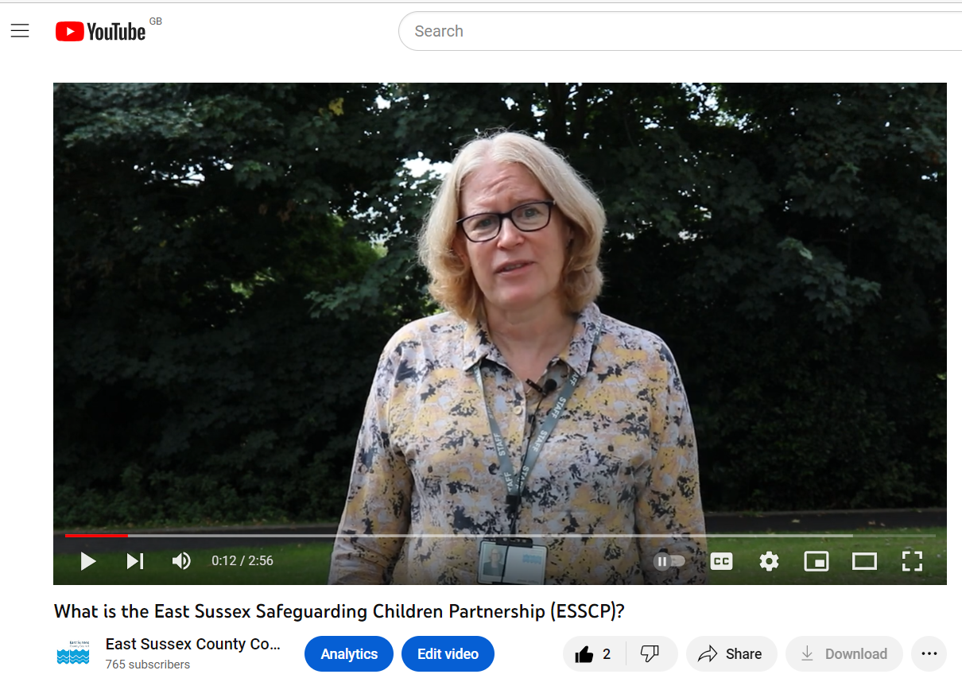

Evidence to measure success
- Front line staff and leaders/managers in every agency to know what the ESSCP is and can recall learning themes from recent learning briefings.
- Front line staff to feel confident in how to respond if they have a safeguarding concern.
- Staff to know where to look for more information/resources on safeguarding themes.

5.4 Safeguarding under 5s
Why is safeguarding under 5s a priority?
Local and national learning tells us that babies and young children are particularly vulnerable to abuse and neglect. Following on from two local serious case reviews involving babies and young children, the ESSCP decided to focus on ‘safeguarding Under 5s, as one of its key priorities, to ensure that action arising from the reviews was coordinated and the profile of safeguarding under 5s was raised across partner agencies.
Nationally, babies under 12 months old continue to be the most prevalent group notified to the national safeguarding panel following serious incidences, with around 40% of serious case reviews involving children aged under 1. There were also a high proportion of cases involving non-accidental injury and sudden unexpected infant death. In these cases, parental and family stressors were the most significant factor in escalating risk. In the first few months of the 2020 Covid lockdown the ESSCP also completed three rapid reviews following serious safeguarding incidents involving non-accidental injuries involving children under the age of one. Learning arising from these reviews was compiled in a learning briefing for professionals and a combined action plan produced, which has informed ongoing work in this priority area, and is monitored regularly by the ESSCP Case Review Group and Steering Group.
Learning from the Pan Sussex Child Death Overview Panel has also highlighted the need for a multi-agency response to the number of incidences of sudden and unexplained infant deaths where modifiable factors were identified.

Using evidence to safeguard children under 5 in East Sussex
The ‘Safeguarding Under 5s’ action plan is jointly owned by the Designated Nurse for Safeguarding in NHS Sussex and the Children’s Lead in East Sussex Public Health. The leads were supported by a short-life Task and Finish Group to drive ahead action in this area, which ended in 2022. During 2022/23 examples of using local and national evidence has included:
- Embedding of ICON (infant crying is normal) across multi-agency partners to prevent abusive head trauma. Direct training sessions have been delivered to different groups of professionals, including GPs, midwifery, Sussex Police, health visitors, early help, and children’s social care.
- Launch of a social media toolkit to raise awareness amongst professionals, and the general public, to reduce and prevent childhood unintentional injuries, highlighting how many accidents can be prevented with the right knowledge. The Child Accident Prevention Trust (CAPT) training for professionals that ended in 2022 was evaluated, showing an increase in knowledge, understanding and skills across all elements of the training. This included understanding of hazards, raising issues with parents/carers, and knowledge of resources and equipment available.
- East Sussex County Council Public Health has commissioned University College London (UCL) Centre for Behaviour Change to support our local knowledge, skills, and confidence in applying behavioural science using the Behaviour Change Wheel (BCW) to preventing unintentional childhood injuries. The BCW can be used to help to develop behaviour change interventions from scratch, build on or modify existing interventions or choose from existing or planned interventions. A Task & Finish group has been established to develop this project during the next 2023-24 financial year.
- During 2022-23 the SCP Partnership has focused on refreshing professionals’ advice (including Sussex wide webinars) on evidence-based scientific recommendations to be followed for all the baby’s sleep periods (not just at night). Recent SUID deaths before Christmas, however, highlight the need to continue work in this area, embedding good practice and the recommendations from the National Safeguarding Panel’s Out of Routine report.
- Although the ESSCP has not made ‘safeguarding under 5s’ a priority for 2023, ensuring that learning from this priority, and learning from national reports such as Out of Routine and Myth of Invisible Men, will be included in the ‘embedding learning’ priority.

Evidence to measure success
- There have been no child deaths across Sussex involving abusive head trauma (AHT), over the past three years. This follows three suspected AHT in 2019/20.
- The number of children aged 0-4 attending East Sussex hospital A&Es due to accidents has decreased from 2,803 in 2021/22 to 2752 in 2022/23. Poisonings accounted for 127 of those attendances; falls from furniture accounted for 471 attendances.
- Learning

The ESSCP is committed to creating and strengthening a learning culture across all agencies in East Sussex who work with children and young people. A culture which is open, and able to challenge all partner agencies, will be able to identify learning, improve, and then evaluate effectiveness.
Below are examples of ‘learning’ within and across the ESSCP in 2022/23.

6.1 Learning from Rapid Reviews and Serious Case Reviews
Case Review Activity 2022/23
In 2022/23 the ESSCP undertook three Rapid Reviews following serious safeguarding incidents, where a child had died or been seriously injured, and where abuse or neglect is known or suspected. Of the three rapid reviews undertaken:
- One progressed to a joint LCSPR and Domestic Homicide Review (DHR) (Family D);
- Two did not lead to a LCSPR. In these cases learning was shared via learning briefings and individual agency actions from rapid reviews monitored by CRG
One outstanding SCR – Child V (Infant injuries) is due to be published following completion of criminal procedures and once parent input into the review has been gained (expected June 2023).
During 2022/23 the ESSCP published two LCSPRs:
Child AA – published September 2022  Child AA Learning Briefing 2022 (esscp.org.uk)  Child AA LCSPR Sept 22  Child AA Partnership Response Sept 22  Key learning:  - Multi-agency activity to disrupt criminal exploitation  - The impact of missing education - poor attendance as a risk factor to criminal exploitation  - Transition between educational establishments for children who are excluded from school  - Information sharing between educational establishments, and between schools and other agencies  - Understanding that behaviour is communication - using a ‘therapeutic thinking’ approach to address trauma-based behaviours | Thematic Review – published September 2022  Thematic Review Learning Briefing 2022  Thematic Review Sept 22  Thematic Review Partnership Response Sept 22  Key learning:  - Knowing and considering a parent’s history and vulnerabilities  - Working with hard to engage families who refuse to cooperate with child protection planning  - Recognising where there is no further police investigation of an issue, this does not mean that a child is not at risk.  - The impact on children of reoccurring domestic abuse and parental mental health issues  - Vulnerable children approaching adulthood and the impact of COVID-19

Two LCSPRs are awaiting publication:
Child Z (delay in publication due to ongoing criminal proceedings – Trial expected December 2023)  Child Z Learning Briefing 2022 (esscp.org.uk)  Key learning:  - The legacy of relationships characterised by domestic abuse  - Information sharing about adults who may pose risks to children  - The importance of assessing background information  - Assessing risk to children from risky adults who are not household members, but part of the child’s wider network | Family CC (due to be published shortly once family have had the opportunity to contribute)  Family CC and Neglect Learning Briefing (esscp.org.uk) This briefing also reflects on learning from rapid reviews, featuring significant neglect  Key learning:  - Working with ‘highly resistant’ parents  - Safeguarding children who are EHE in the context of neglectful parenting  - Relevance of neglect and/or abuse of animals when assessing risks to children  - Relevance of history when screening for service delivery  - Role of voluntary sector agencies in providing support to vulnerable families  - The cumulative risk of harm when risk factors are present in combination or over time

Rapid Review learning
Child 1  Key learning:  - Suitable access by children aged 14-16 who are being electively home educated to education at institutions whose primary purpose is post 16 education and training.  - Support offered by services to children and families following unsuccessful suicide attempts by children.  - The need for agencies to make timely referrals for substance misuse support for young people.  - Access to specialist support to address issues relating to gender dysphoria in young people. | Child 2  Key learning:  - Consideration of parents mental and physical health needs and the impact this has on the ability to effectively parent.  - Early closure of CIN plans in the context of neglectful parenting.  - Working with resistant/avoidant parents.  - Impact of children missing education and poor elective home education.  - Professional curiosity with regards to consideration of domestic abuse

Analysis of Case Review Activity
Since the Safeguarding Children Partnership arrangements began in East Sussex in October 2019, the partnership Case Review Group (CRG) has undertaken 17 Rapid Reviews, resulting in 7 Local Child Safeguarding Practice Reviews (figures up to March 23). A total of 30 children are the subjects of the 17 Rapid Reviews; 57% male, 43% female. This is in line with national figures, where males are the most common gender at 55%.
When under 1s and 1 year olds are combined they represent 30% of all children considered within rapid reviews in East Sussex. This age group featured predominately due to experiencing non-accidental injuries, such as fractures and abusive head trauma. This is in keeping with the national picture which also shows a predominance of infants under 1 amongst children involved in serious incidents notified to the National Child Safeguarding Practice Review Panel (35% of 456 children notified 2022/23)

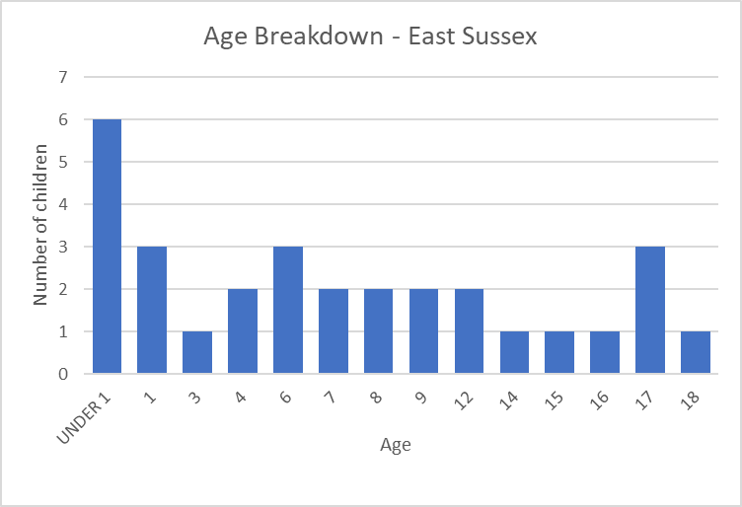

The Child Safeguarding Practice Review Panel Serious Incident Notification Statistics (May 2023) breaks age down into five categories. Over the same time period, the highest age category for England is under 1’s (36%), whereas in East Sussex it is age 6-10 year olds (30%). This is due to three Rapid Reviews in 2021/22 in East Sussex that involved the neglect of three large sibling groups.
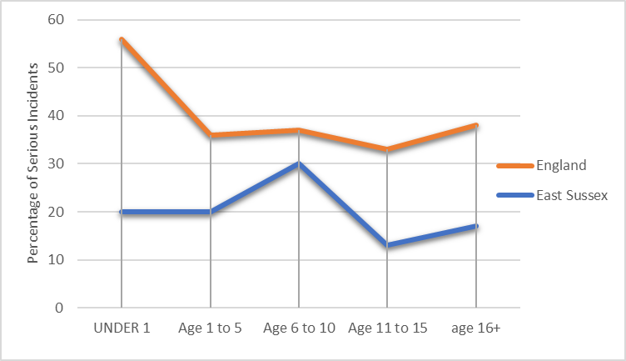
When the East Sussex rapid reviews are analysed by the primary types of abuse and/or neglect known in the family at the point of notification of the serious incident, non-accidental infant injuries (fractures and/or head trauma) featured in 6 of the cases; followed by neglect (3) and domestic violence (3). However, most cases involved complex families with multiple factors contributing to the safeguarding risk to the child/children.
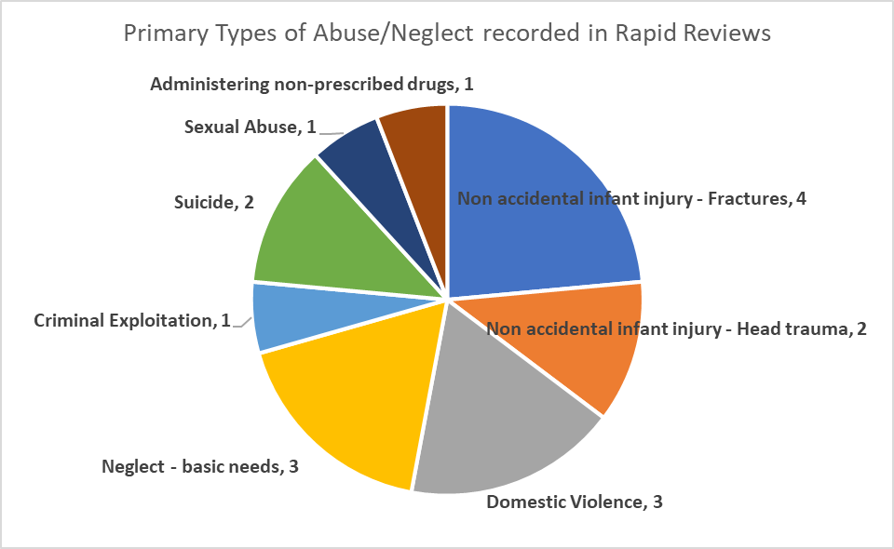
Each Rapid Review and Local Child Safeguarding Practice Review can result in a number of key themes for learning. The tables below show the breadth of learning themes captured across the reviews undertaken since October 2019:

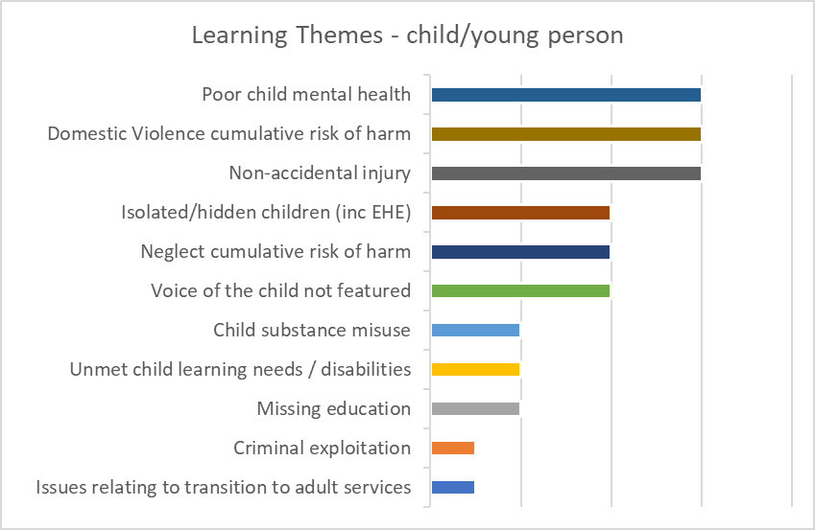
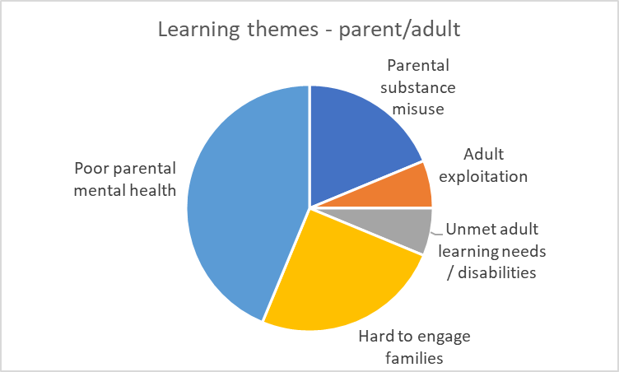
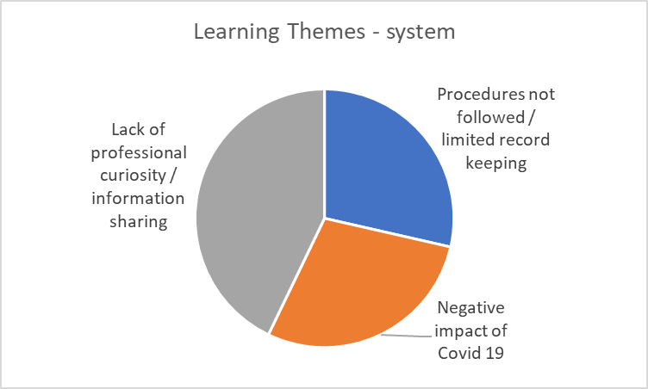
The five most commonly occurring learning themes in Rapid Reviews and Local Child Safeguarding Practice reviews are:
- Poor or unmanaged parental mental health
- Poor or unmanaged child mental health
- Fatal and non-fatal non-accidental fractures and head trauma injuries in under 2 year olds
- The cumulative risk of domestic violence
- Inadequate professional curiosity and information sharing between agencies

6.2 Quality Assurance Audits
The QA subgroup held four audits during 2022/23: a Pan Sussex audit on safeguarding children who were electively home educated; an audit on multi-agency response to the identification of initial need and risk, using the Joint Targeted Area Inspection criteria; a ‘deep dive’ audit of two cases of Harmful Sexual Behaviours (HSB) which occurred in school settings; and an ‘appreciative inquiry’ style audit into engagement of fathers and male carers in safeguarding practice.
Learning from the audits is shared at the ESSP Steering Group and one page learning briefings are shared with the wider ESSCP network and on the ESSCP website Quality Assurance Group - ESSCP. QA audit reports and one page learning summaries are now routinely shared at the Learning & Development Subgroup to ensure that learning arising from audit activity is more efficiently and effectively embedded into local training and learning activity.
Key learning included:
- The vital work schools do to safeguard children.
- The need for clear communication between the Police and key professionals when there are investigations following incidences of HSB in schools. This will allow schools to better understand and manage these complex situations.
- Training and support are crucial elements when dealing with HSB. Working collaboratively, sharing challenges, expertise and resources is incredibly beneficial when managing risk and safeguarding children.
- The importance for SWIFT and SARC involvement when a case involves HSB, so they consult and share resources with professionals.
- Professionals to challenge if not all statutory agencies are present at a Strategy Discussion.
- Challenging the myth that male workers are needed to engage fathers/male carers.
- Challenging unconscious bias around labelling father/male carers as a risk or perpetrators, and the impact this has on relationship building with the adults and outcomes for the child.
Further details on the ESSCP QA audits in 2022/23 can be found in the assurance section of this report. Following are examples of actions taken in response to learning arising from audits:
- The Pan Sussex audit of safeguarding children who are electively home educated highlighted to a range of professionals and agencies how safeguarding EHE children is everyone’s responsibility, and the difficulties that services sometimes face when safeguarding EHE children. In most cases, education settings act as a protective factor in children’s lives. Being in school increases the visibility of children and enables professionals with expertise in safeguarding to refer to other agencies as needed. Children who do not attend school often become hidden and the risks to their welfare are harder to observe. As a result, the Independent Chair and scrutineer of the Sussex Safeguarding Children Partnerships wrote to the National Safeguarding Panel and Secretary of State for Education, to share the learning from the review. The letter highlighted the lead safeguarding partner’s concerns that the Government indicated that they will not be progressing the ‘Schools Bill’, which proposed the requirement for a statutory register of children who are EHE.
- The audit of the ‘front door’ highlighted the need to review the referral pathway for ensuring timely cSARC (child sexual assault referral centre) engagement in cases where sexual abuse is suspected or known. In collaboration between SARC, East Sussex MASH and the ICB Designated Nurse for Safeguarding, it was agreed that for new referrals the MASH Health lead will provide the initial liaison with SARC. In cases where SARC do not feel there is a further role for them they will provide advice to MASH Health, which will be shared at the strategy meeting and added to the assessment plan.
- Learning arising from the Harmful Sexual Behaviours audit and the HSB Task & Finish group was promoted at the ‘super’ Designated Safeguarding Lead network for schools. This was presented in collaboration with the education safeguarding team, SWIFT and Sussex Police. This was attended by over 100 schools and colleges.

6.3 ESSCP Learning & Improvement Framework
The ESSCP Learning and & Improvement Framework was refreshed in 2021/22, with additional chapters on how the partnership uses ‘Independent Scrutiny’ and the ‘Voice of the Child’ to learn and improve local practice. The refreshed framework includes a stronger focus on how learning will be disseminated and how partners will review and evaluate the impact learning has on practice. Following on from the framework, during 2022/23 the ESSCP has:
- Produced a public response to the two published LCSPRs (Child AA and Thematic Review), in order to achieve better transparency about how the partnership is responding to and learning from reviews.
- Delivered four lunchtime briefing sessions on learning from reviews. In total, over 200 staff across the workforce have attended these presentations on key themes and learning from LCSPRs.
- Delivered two ‘evidencing impact’ events with front-line practitioners and managers, including those involved in the original case, on the ‘Child T’ Serious Case Review (published in 2019) and a themed event on Infant Injury, which included the Child W and Child V SCRs. The events considered how the review impacted on practice and outcomes for children and families. More details can be found in the ‘evidence’ section of this report.
- Developed a Scrutiny Plan, which is monitored and steered by the ESSCP Planning Group, to ensure that the partnership is appropriately responding to national, and reoccurring local, safeguarding learning.

6.4 ESSCP Learning Strategy
The work of the ESSCP Learning and Development sub group is to ensure that East Sussex workforce and volunteers working with children, young people and/or adults who are parents/carers are provided with appropriate and effective multi-agency training to meet their needs, and that practice is underpinned with appropriate policies and procedures. The L&D Subgroup operated and discharged its functions in line with the ESSCP Learning Strategy (2020), which ensures that the ESSCP has a clear and shared vision as to the priorities for safeguarding learning and training and how this will be achieved. The Strategy aims are to:
  - Ensure that safeguarding training/learning activities are based on local necessity and enable practitioners to recognise and respond to need and risk.
  - Measure the impact of safeguarding training on practice and improving outcomes for children and young people.
  - Ensure that learning from Local Child Safeguarding Practice Reviews, Audits, the Child Death Overview Process (CDOP) and the Voice of the Child is embedded into practice and ensures continuous learning and improvement.
  - Ensure key safeguarding messages (local, pan-Sussex and national) are communicated.

6.5 ESSCP Training Programme
The ESSCP Learning and Development (L&D) Subgroup resumed several classroom-based training courses for Safeguarding Children Partnership partners in April 2022. As interest in the virtual sessions continues to be positive and, for shorter courses more cost effective, the future training programme will include virtual as well as classroom-based courses.
In September 2022 the East Sussex Learning Portal (ESLP) reverted to a temporary ‘manual’ system, due to the company who provided the existing Learning Portal going into liquidation. Consequently, the number of training courses offered during 2022/2023 (42) is lower than those offered during 2021/22 (63). The County Council Workforce Development Team worked incredibly hard to get a new booking system quickly into place to minimise the impact on the training programme.
Between 1st April 2022 and 31st March 2023, 42 training courses ran with 552 participants from a range of agencies attended, which equates to 68% attendance rate. A large majority of participants continue to rate courses as either Excellent (66%) or Good (33%).
New ESSCP courses were introduced from June 2022 onwards: DASH, MARAC, and Safety Planning; Professional Curiosity and Professional Challenge within a Safeguarding Context and Working with Parents Effectively: Enabling Staff to deal with Difficult or Evasive Behaviour. The latter two being areas highlighted in recommendations in both local and national Safeguarding Practice Reviews. Contextual Safeguarding in East Sussex – the Local Context and Trauma-Informed approaches to working with Families in a Multi-Professional Context have also been introduced during 2022/23. The latter benefits from input from ‘Experts by Experience’ and this is reflected in positive evaluation comments.
From April 2023 onwards new courses planned include Equalities, Diversity and Inclusive Practice, Unaccompanied Asylum Seeking Young People and a relaunch of the revised Neglect Toolkit and Neglect Matrix, and associated training.
7. Impact of Partnership Activity

This section aims to convey the impact of multi-agency and partnership activity on practice and outcomes for children and families.
Child AA LCSPR recommendations gave 3 areas of delivery focus.
- Disruption – quarterly highlight reports from the Serious Organised Crime Unit are now shared at MACE strategic. At a MACE operational level, the Police single agency escalation meeting was reviewed to ensure appropriate information sharing with partners at a client level.
- Education - embedded Education Review Meetings (ERMs) and development of the new Inclusion Partnerships (IPs) to discuss children of concern.
- Transition – a new Head of Service for LD and transitions has been appointed and holds the lead on this agenda. The Under 25’s SMS is now receiving referrals for young people who use substances and are involved in criminal exploitation.

Following the Child X LCSPR, the tertiary hospital made significant changes to the trust wide safeguarding policy for documenting safeguarding concerns to coroners, introduced safeguarding supervision for the bereavement team and weekly meetings with the legal and safeguarding teams to ensure the cross referencing of cases.
The Child W LCSPR raised concerns regarding the collection of Kennedy Samples at an out of county hospital site.
As a result, a new Standard Operating Procedure (SOP) for Child Death Process in the Event of Unexpected Death Before 18th Birthday was developed across the entire acute hospital Trust.

Evidencing Impact Event – Child T SCR (2018) Child T died in hospital, at the age of 18, due to complications caused by his Type 1 diabetes. Practice change identified since the review:
- Improved knowledge and understanding (especially in schools) about life-limiting health conditions, and in particular how neglect of these conditions is a safeguarding issue.
- Improved identification and assessment of medical neglect safeguarding concerns, including clearer recurrent ‘did not attend/was not brought’ pathways.
- Development of transitions pathways and lead practitioners in health agencies.
- A greater focus across ‘the system’ on relationship based and trauma informed practice.

Evidencing Impact Event – Infant Injury: Event incorporated Child V and Child W SCRs (2019) and three Rapid Reviews (2020), all involving non-accidental injuries to babies. Practice change identified since the review:
- Improved information sharing across Health landscape, in particular between midwifery and health visiting.
- Increased professional knowledge and understanding of the vulnerability of infants, including increased awareness of ICON, safer sleeping messages, and indicators of non-accidental injuries.
- Improved engagement of fathers and other male carers, recognising there is still more to do.
- Improved culture of professional challenge.
- Embedded culture of ‘corporate grandparenting’.
- Introduction of ‘health’ to MASH arrangements.

Safeguarding in Education priority impact:
Two preventative curriculum and Theatre In Education projects developed and delivered in partnership with Public Health.
Revised HSB Protocol, new screening tool and intervention packages shared with all education settings.
Pan-Sussex Unexpected Death toolkit and suicide awareness training rolled out for schools and colleges.

Safeguarding under 5s priority impact:
Improving practice and practice knowledge – the ESSCP has introduced ‘light bite’ sessions on safeguarding under ones, with the aim of increasing the number and range of professionals with safeguarding knowledge in this area. The sessions focus on increasing awareness and understanding of ICON, safer sleeping advice, and risk of injury and abuse of infants, including indicators to look out for. The course has been such a success it is planned to be implemented across Sussex.
Multi-Agency Child Exploitation priority impact:
Disruption and Education - The introduction of Education Review Meetings has resulted in education improvements for 22/23 MACE cases, and it is envisaged that the opportunity for schools to refer their concerns at a lower threshold of risk via the new Inclusion Partnership meetings will result in more timely intervention for pupils and avoid the non-attendance or exclusion profiles identified within this cohort during previous case audits.
Voice of the child – Direct and indirect activity undertaken by the partnership includes:
- Each Board/Steering report is asked to consider how work is informed by the voice of child.
- Children involved in recruitment of Chair and Lay Members.
- Agency challenge and participation of care experienced young people in Section 11 scrutiny process.
- Childs view (and family) sought as part of case review process.
- Oversight of agency activity capturing children’s views, such as Public Health My health My School survey.
What Children and Young People want from services:
Practitioners who are consistent, open, honest and genuine. Encouragement to express their views and not asking to repeat their story. To advocate on their behalf. Better help with mental health. Smoother transition between services.

Collaboration Against Child Exploitation (CACE) project is a service offer developed in partnership with parents who have ‘lived experience’ of exploitation. CACE includes an open access six week educational programme and monthly parent led self-support groups. There are ongoing service consultations with parents accessing CACE to ensure that delivery remains focused and targeted.
“I was so scared to come along to the course & felt I would be judged. How wrong was I!!! I never spoke to anyone outside the home … but at the group after a week I felt totally comfortable to speak out as I did not feel alone. The MACE workers are so approachable & never once did I feel judged”.
“That we are not alone with our experiences and there are people we can speak to with advice or share experiences. Everyone was so lovely and supportive”.
8. Assurance
One of the roles of the ESSCP is to ensure the effectiveness of safeguarding practice, which it does through evidence-based auditing, performance management, and self-analysis. The SCP ensures that there is continual evaluation of the quality of services being provided, as well as effective communication and joint working between all SCP partner agencies.
The Quality Assurance (QA) Subgroup has the lead role, on behalf of the Partnership, for monitoring and evaluating the effectiveness of the work carried out by partners. It does this through regular scrutiny of multi-agency performance data and inspection reports, and through an annual programme of thematic and regular case file audits. This subgroup is chaired by the Detective Chief Inspector of the Safeguarding Investigation Unit in Sussex Police.
Examples of assurance undertaken by the ESSCP during 2022/23 include:
- The ESSCP has an Independent Chair whose function is to provide challenge and scrutiny of the effectiveness of the lead partners and other relevant agencies, via the Board and Steering Group meetings, and to also work with the lead partners to ensure the effectiveness of the safeguarding work carried out by partners. The approach of the Chair is to act as a constructive critical friend to promote reflection and continuous improvement and to provide support to that improvement. This included:
  - Reviewing and endorsing the recommendation to conduct one Local Child Safeguarding Practice Reviews (LCSPRs) arising from three serious safeguarding incidents;
  - Requesting assurance from the lead safeguarding partners that appropriate processes are in place, as highlighted in the National Child Safeguarding Panel review of the murders of Arthur Labinjo-Hughes and Star Hobson.
  - Raising concerns with agencies regarding participation in Child Protection Conferences and requesting agencies consider their responsibilities.
  - Overseeing the development of a partnership ‘Scrutiny Plan’ providing an overview for lead partners on key areas of challenge to multi-agency working and progress with responding to national learning.

- In addition to the Independent Chair, three Lay Members play a critical role in the partnership. The Lay Members act as further independent insight, on behalf of the public, into the work of agencies and of the partnership. As well as acting as critical friends at Board meetings, providing additional challenge and scrutiny, one Lay Member is a standing member of the SCP Case Review Group (CRG), and Lay Members are involved in the panel meetings for all LCSPRs. Their role has been critical at CRG, via the rapid review process and subsequent LCSPR process, in advocating the voice of the child. In 2022/23 the ESSCP recruited two new Lay Members (as two left the role in Summer 2022).

“I have now been a lay member of the East Sussex Safeguarding Children Partnership for five years. During that time I have learned much and been consistently impressed by the dedication of staff from all agencies and organisations involved, particularly given the difficult circumstances of the last few years. There is excellent collaboration and no sign of a destructive cycle of defensiveness. People challenge and take challenge with respect and openness while remaining focused on children and their families.
One of the key functions of the Partnership is to provide training and to disseminate learning, both from reviews and more generally. Training is very well received, and the learning briefings are clear and widely distributed. However, I have been most impressed by the focus on the impact of these activities. Information and training are of no use unless they influence behaviour and change practice in such a way that the outcomes for children and their families are improved. The Partnership continues to strive to find ways of assessing impact and using this understanding to do things differently and so contribute to reducing the chance of children and young people coming to harm. This is also true in terms of how the Partnership supports improvements in safeguarding within organisations. They are not content with a tick box approach but look for ways to encourage reflective thinking and mutual challenge. None of this is easy but the Partnership shows no sign of giving up and I expect it to continue to make progress next year” Harriet Martin

"Although I have only been a Lay Member of the ESSCP for a short time, during this time I have witnessed some great examples of partnership working and found all partners to be truly dedicated to safeguarding children. Although much progress has been made, it is disappointing that "Safeguarding Under 5s" was not retained as a priority for the Partnership, as evidence shows the continued vulnerability of this age group. I have found the breadth and scope of the partnership training to be excellent". Nick Porter

“I joined the ESSCP as a lay member because I wanted to make a contribution to safeguarding children across the county. What I have found is a partnership full of highly specialised, committed professionals from a range of backgrounds who collaborate with care to promote good practice in safeguarding children against a very difficult backdrop.
There is a great deal of high level training to support the partnership and the communication is detailed and sensitive. What has struck me about the partnership is the high level of commitment and collaboration between professionals driven by shared goals and values who bring a great deal of safeguarding experience to a range of projects which have a real impact on children and their families across the county.” Anne Moynihan

- The QA Subgroup reviews the ‘ESSCP Performance Dashboard’ on a quarterly basis. The dashboard includes 60 performance indicators which are presented by: impact of multi-agency practice; children supported by statutory services; children with family related vulnerabilities; children with health-related vulnerabilities; and children whose actions place them at risk. Indicators are reviewed by the QA subgroup and escalated to the Steering Group if required. During 2022/23, performance indicators escalated by QA included:
- Indicator 25/26 (penetrative and non-penetrative sexual offences against children): was escalated at Steering to consider the sustained increase in sexual offences recorded against children. Further investigation by the East Sussex Safeguarding Investigation Unit (Sussex Police) suggested that the increase in offences was, in part, due to an increase in awareness and reporting. The Steering Group noted that the Police are dealing with more non-penetrative offences that have occurred in schools which are now referred to the Police, where previously schools may have dealt with these in house. Subsequently, the QA subgroup held a deep dive audit on ‘harmful sexual behaviour’, on two cases that occurred in school settings, to better understand multi-agency working in this context.
- Indicator 45/46 (CAMHS completed within target timescales) was escalated to Steering as the proportion of assessments within 4 weeks continued to be low over recent quarterly monitoring. The Service Manager for CAMHS explained that reporting on wait times had changed in 2022 - if a young person does not attend a planned appointment, this does not stop the waiting time clock (as it did previously). The robust SPFT 'Child Not Brought' (CNB) policy, to address potential safeguarding concerns around a young person not being brought to appointments, means that CAMHS will offer further appointments and proactive contact attempts, until the service has had direct contact with a young person and family for assessment. This means that some young people offered an initial appointment within 4 weeks may be waiting more than 5 months in total. The Service Manager noted that the CNB rate can be as high as 40% at initial appointment, resulting in high re-booking levels, delays in assessment and inefficiency costs. A project to reduce missed initial appointments was in place.

- The QA subgroup held four audits during 2022/23:
Safeguarding children who are electively home educated was chosen as a Pan Sussex audit theme given the significant increase in numbers, since the COVID-19 pandemic, across all areas of Sussex. The purpose of the audit was to understand how individual agencies respond to need and risk of vulnerable EHE children, and how agencies work together, including with local authority EHE teams, to safeguard children who are EHE. The audit was a useful tool to highlight, to a range of professionals and agencies, how safeguarding EHE children is everyone’s responsibility and the difficulties that services sometimes face when safeguarding EHE children.
A key theme arising from the audit was the effectiveness of all Sussex EHE teams in terms of multi-agency communication, joint working, and participation in multi-agency safeguarding meetings. While there was some good evidence of direct work with the child/family, the challenge of seeing the child alone, or at all, meant that the child's voice, and understanding of their lived experience, was missing in too many of the audited cases, this was compounded by the constraints of EHE legislation that does not require parents to engage with services around EHE. The audit also highlighted there were examples of professional’s variable understanding of when a safeguarding referral should be made in respect of educational neglect and/or educational neglect was not given sufficient weight within assessments and decision making.
Following the publication of the National Review into the murders of Arthur Labinjo-Hughes and Star Hobson, partners agreed to hold an audit on the ‘front door’ in September 2022. The objective of the audit was to get a view on the system and evaluate how effectively individual agencies identify and respond to need and risk, how timely and effective the multi-agency response is, and the impact of responses to safeguard children and in improving outcomes for the child.
The key theme emerging from the audit was the impact of capacity issues, across all agencies, on the timeliness of response to referrals. Whilst the most acute cases received a timely response through the front door, some cases presenting with lower risk were delayed in being allocated. Information sharing at the front door appeared strong, with roles, responsibilities, and thresholds well understood and embedded. Several cases also identified issues around the strategy discussion process, around either the initial identification of strategy discussion threshold being met, or quoracy and multi-agency representation at the meeting itself.
This multi-agency audit provided a valuable opportunity to take stock of areas of strength and areas of development requiring focus. It was evident through the process that there is an embedded understanding across the agencies of thresholds, importance of information sharing, timely referrals and focus on the child’s experience. Recommendations in response to the audit learning have been taken forward, including:
- The appointment to the newly established post, Strategic Lead for MASH, Assessment and Safeguarding offers additional management and leadership capacity to oversee and develop further the effectiveness of the ‘front door’.
- Ensuring quoracy at strategy discussions, and continued promotion of the ‘Statement of Professional Differences’ procedure in strategy discussions to support multi-agency challenge.
- Multi-agency MASH practice development sessions commenced in January 2023, involving health, social care and Police, focussing on front door actions and threshold decision.
- Continuing drive to ensure MASH resource meets demand: the MASH has seen a continued increase in demand over the past few years with a 21% increase in contacts coming into MASH in 2023/23 compared to 2020/21. MASH capacity is a regular item on the ESSCP Risk Register, which is owned by the three safeguarding lead partners. To mitigate the pressure on MASH;
  - Additional Saturday MASH sessions have been implemented when demand requires additional capacity.
  - Revised guidance has been launched to improve efficiency in MASH with regards to case recording, through succinct summarising of history, checks and decision making.
  - Additional Practice Manager capacity has been added to the East MASH and DAT. There has been successful recruitment of experienced social workers into recently vacated posts. Additional Practice Manager capacity in the West MASH is being recruited to.
  - Both MASH Teams continue to benefit from having dedicated Health representatives (in post in the Teams since June 2022). This is considered essential to the MASH approach and significantly strengthens partnership approach to safeguarding.
  - Police have increased their capacity by 0.6 FTE and are working towards continuous and consistent office presence across both MASH’s.
- Continuing recruitment drive for health visitors and continuing focus on staffing within the Duty and Assessment Teams to address issues of timeliness in completion of assessments. Assessment timescales have significantly improved across 2023 to date.
- Ensuring the unallocated work protocol to maintain management oversight on unallocated cases in the MASH and Duty and Assessment Teams is robustly applied. Subsequent audits have evidenced the unallocated work protocol to be embedded.
- To maintain a view on the system and evaluate the effectiveness of the front door, there is a programme of twice yearly auditing of the front door, led by social care and including MASH Health. The last audit was completed in March 2023, which evidenced an overall improvement in the response to MASH referrals through the processing of MIGs, the allocation and completion of timely Family Assessments, and strategy discussions being convened promptly. An additional quality assurance mechanism involves weekly audits of MASH episodes exceeding timescales.
The QA subgroup held a ‘deep dive’ audit of two cases of Harmful Sexual Behaviour. The purpose of the audit was to better understand multi-agency working in response to allegations of harmful sexual behaviour (HSB), which have occurred in a school setting, and to test the impact of work resulting from the ESSCP Task & Finish Group on HSB. It was agreed that a ‘deep dive’ audit approach would work well, where two cases were looked at in detail with front-line professionals and managers. One case occurred in a secondary school setting and the second case occurred in a primary school setting.
The common theme of the audit was the challenge schools face between managing risk and safeguarding of children, and this impact this has on the wider school community. All agencies attending felt they had a better understanding of how these types of incidences can impact on a community and how they can support schools to provide timely information to manage the situation. There was some excellent good practice identified in terms of school safety planning and multi-agency working.
The findings of the audit were shared at the schools DSL supernetwork meeting in January 2023, noting how seriously this issue is viewed across the partnership and recognition of the difficulties for schools in managing these types of situations.
QA subgroup held an appreciative style audit on the theme of ‘Unseen Men’, which focused on the engagement of fathers and other male carers in safeguarding work. Unseen men has been an ongoing area of focus for the partnership, given the learning both locally and nationally on how male partners and carers often go ‘unseen’ by services engaged with children. This includes learning from a number of local children safeguarding practice reviews and audit findings (engagement of fathers, partners and other male carers is a standard component of all ESSCP QA audits).
The QA group agreed that a powerful way to capture and audit work in this area would be to hold an ‘appreciative’ style audit, where ten safeguarding cases were selected, where there was good engagement of males: either where they posed a risk to the child and successful engagement by services reduced that risk and/or they were successfully engaged to ensure the child was protected/nurtured. The approach was positively received by front-line practitioners and managers and provides a basis for sharing learning on ‘what works’ rather than what isn’t working.
The key theme arising from the session was that the skills to engage fathers/male carers are the same skills used to engage mothers, and challenging the myth that only male workers can engage fathers/male carers successfully. Learning also included giving due regard to significant males in all assessment and planning, especially when they have parental responsibility; challenging unconscious bias around labelling fathers/male carers as a risk or perpetrators, and the impact this has on relationship building with the adult and outcomes for the child; and tailoring the support which is on offer when what’s offered doesn’t ‘fit’.

- The Partnership has a key role in evaluating the effectiveness of support for looked after children and care leavers – it does this via the annual scrutiny of the ESCC Annual Looked After Child & Care Leaver Report, the Annual Independent Reviewing Officer (IRO) report, regular monitoring of key performance information in the ESSCPs quarterly dashboard, and via the Section 11 process. In particular, the Steering Group have scrutinised the management of the increased number of unaccompanied asylum-seeking children placed in the county.

- The Partnership has a key role in evaluating the effectiveness of early help services – it does this via the regular monitoring of key performance information in the ESSCPs quarterly dashboard.

- In 2022/23 the ESSCP, along with Brighton & Hove SCP and West Sussex SCP, held its seventh bi-annual ‘section 11’ audit. All organisations represented on the ESSCP were requested to complete a self-assessment and provide evidence of how they comply with s11, of the Children Act 2004, when carrying out their day-to-day business. The audit provides an indication of how well organisations are working to keep children safe. The 2022 section 11 audit was framed more as an ‘improvement’ tool, rather than simply demonstrating compliance with the standards, with agencies encouraged to rate themselves as amber where improvement could be identified. Peer Challenge events are organised for summer 2023, include a Pan Sussex peer challenge event in June, a challenge event in July for ESCC teams, and a further peer challenge event for the district and borough councils. An action plan has been developed for the top ten lowest rated standards which is overseen by the Learning & Development Subgroup.

- The Annual Schools Safeguarding Audit Report (s175) was presented to the ESSCP Board for scrutiny and challenge in October 2022. All schools (including maintained, independent, academies, free schools, and colleges) in East Sussex are requested to complete the safeguarding audit toolkit on an annual basis, assessing their practice in line with statutory guidance and local good practice. Engagement with the process is strong with 100% of state funded schools returning their audit. A bespoke audit tool for independent schools, which aligns with the Independent School Inspection Framework, has been developed to increase engagement with the audit process from the independent sector. The audit provides all schools with a robust framework against which they can evaluate their practice and identify areas for development as necessary and the data gathered by SLES Safeguarding, through having the audits returned to them, informs the ongoing development of guidance, training and support to schools. For the current academic year SLES Safeguarding have developed a tool for school governors to use, which will support their scrutiny and challenge of safeguarding practice and will facilitate some deeper thinking around practice. This in turn will strengthen the integrity of the self-assessment process.

- Other examples of assurance work undertaken include:
- Health Visitor numbers and service capacity has been a regular item at the ESSCP Steering, Planning and Board during 2022/23. Over the past year, the service continues to experience high vacancy rates with implications on the capacity of the service to identify safeguarding concerns with the families on their caseloads and provide support to prevent concerns escalating. Lead Safeguarding Partners have closely monitored the situation, ensuring all relevant agencies are aware of the impact of the situation, and agreeing strategies to reduce and mitigate safeguarding risks. In January 2023 the lead partners agreed to establish a multi-agency Task & Finish Group to review the ability of health visiting services to deliver antenatal review and attend statutory meetings in the long term.
- (Oct 22) Scrutiny at Board of the report from the Manager at Lansdowne Secure Children’s Home, highlighting safeguarding and behaviour management practice at the unit over the past year. Annual presentation of this report to the ESSCP is a regulatory requirement given the significant vulnerability of young people in secure establishments. The Board noted the unit’s approaches to managing behaviour, episodes of single separation and use of restraint. The effective relationships between staff and the children and young people were evident, with staff able to use support strategies in response to incidents, resulting in positive interventions and a further decline in physical interventions over the course of the year. The homes relationship-based trauma informed care has led to the stabilisation of children’s behaviours, and in most cases, this has led to the successful development and positive progress of children. The home was inspected by Ofsted in December 2022 and received a ‘Good’ judgement. From February 2023 the unit was temporarily closed due to ongoing challenges regarding staff recruitment, resulting in only being able to utilise a small proportion of the places in the unit. The unit is undergoing a review and redesign of the staffing structure and developing an enhanced recruitment strategy to allow a resilient and sustainable service in the future. The unit is due to re-open in November 2023.

9. Appendices

9.A Safeguarding Context

Impact of multi-agency working
Family contacts (to SPOA and other excluding MASH) | ↑ | The total number of contacts is up 5% on last year (17,798 compared to 17,011) however the increase is not as steep as the previous year (29%).
Information gatherings by Multi-agency Safeguarding Hub (MASH) | ↑ | The number of multi-agency information gathering (MIG's) also increased by 8% (21,181 compared the 19,572 in the previous year).
Referrals to statutory social care | ↓ | In 2022/23 the number of referrals to statutory social care was 6% down from last year (4018 compared to 4,169) but still higher than 2020/21.
Privately Fostered children | ↓ | Following a peak at 80 in summer 2022, the number of Privately Fostered children fell to 35 at the end of 2022/23. This is lower than the number at the end 2021/22.
Children supported by statutory services
Children with a child protection plan | ↑ | The number of CP plans has continued to rise throughout 2022/23 to a peak of 691 at the end of March 2023. This is 29% higher than in March 2022 (536).
Looked After Children | ↑ | The number of looked after children has increased (6%) to 664 at the end of March 2023, compared to 628 at the end of March 2022. This is partly driven by the increase in Unaccompanied Asylum Seeking Children.
Unaccompanied asylum-seeking children | ↑ | There were 73 unaccompanied asylum-seeking children in East Sussex at the end of March 2023, higher than at the same in March 2022 (57).
Young people at high risk of child exploitation | ↑ | There were 22 children within the SAFER cohort at the end of March 2023: 12 at high risk and a further 8 at amber level of risk. This is higher than the March 2022 figure of 18 active cases.
Sexual offences against children | ↑ | The number of sexual offences (penetrative and non-penetrative) has increased over the past year, from a total of 542 in 2021/22 to 570 in 2021/22. This continues the trend seen over the past few years.
Children with family related vulnerabilities
Children living with domestic violence (MARAC) | ↑ | There were 128 cases reviewed by MARAC at the of March 2023 compared to 83 at the end of March 2022. There was a total of 206 children in households of cases held by MARAC at the end of March 2023.
Vulnerable young carers | ↓ | There were 328 children’s social care assessments completed in 2022/23 where a young carer was identified as a factor, this is a decrease compared to 371 in the previous year.
Children educated at home | ↑ | 1514 children were recorded as being electively home educated at the end of March 2023, compared to 1358 at the same point in 2021.
Children with health related vulnerabilities
Children with disabilities with a Child Protection Plan | ↑ | At the end of March 2022 there were 22 children with disabilities with a child protection plan. This represents an average of 3% of all CP plans compared to 4% at the end of 2021/22.
Children attending A&E due to self-harm | ↑ | 692 children in 2022/23 attended A&E in East Sussex hospitals due to deliberate self-harm, an increase from 612 the previous year.
Referrals to child mental health services | ↔ | A total of 3607 new CAMHS referrals were received in 2022/23, slightly lower than the previous year, but still continuing the significant upward trend seen since 2021.
Children whose actions place them at risk
Missing episodes | ↑ | There were a total of 2083 missing episodes in 2022/23, a 48% increase on the previous 2021/22 figure of 1404.
Births to under-18 year olds | ↑ | Awaiting Qtr. 3 & 4 data. There were 11 live births in East Sussex hospitals to children under the age of 18 in the first half of 2022/23.
Young people entering the youth justice system | ↓ | 62 young people entered the youth justice system for the first time in 2022/23 compared to 100 in 2021/22.
Young people held overnight in Police custody | ↔ | There were only 11 occasions of young people being held overnight in Police custody in 2022/23, the same as in 2021/22

9.B: Board Membership – up to March 2023

NAME | TITLE, ORGANISATION
Chris Robson (Chair) | Independent East Sussex SCP Chair
Louise MacQuire-Plows | Manager, East Sussex SCP
Victoria Jones | Manager, East Sussex SCP
Harriet Martin | Lay Member, East Sussex SCP
Anne Moynihan | Lay Member, East Sussex SCP
Jacqueline Muntzer | Lay Member, East Sussex SCP (to July .22)
Nick Pointer | Lay Member, East Sussex SCP
Maxine Nankervis | Partnership Support Officer, East Sussex SCP

Domenica Basini | Asst. Dir. for Safeguarding & Quality, NHS England (to April .22)
Gail Gowland | Head of Safeguarding (Adults and Children), East Sussex Healthcare Trust
Gareth Knowles | SECAmb Trust Safeguarding Lead, Clinical Supervisor
Jackie Dyer  (Job Share, LT) | NHS England and NHS Improvement – South
Jayne Bruce | Deputy Chief Nurse, Sussex Partnership Foundation Trust (SPFT)
Jo Tomlinson | Assistant Head of Safeguarding Children/Designated Nurse, NHS Sussex
Judith Sakala | Named GP for Child Safeguarding, NHS Sussex
Lynne Torpey  (Job Share, JD) | NHS England and NHS Improvement – South
Martin Ryan | Named Nurse/Associate Director Safeguarding Children
Michael Brown | Head of Safeguarding and Looked After Children, NHS Sussex
Naomi Ellis | Director of Safeguarding & Clinical Standards, NHS Sussex
Sergio Lopez-Gutierrez | Designated Nurse Safeguarding Children for NHS Sussex
Tracey Ward  (Deputy Chair) | Designated Doctor Safeguarding Children, NHS Sussex
Vikki Carruth | Director of Nursing, ESHT

Andrea Holtham | Service Manager, Sussex CAFCASS (to July .22)
Dave Springett | Detective Superintendent, Public Protection, Sussex Police
David Kemp | Head of Community Safety, East Sussex Fire & Rescue Service
Debbie Knight | Head of East Sussex Probation Delivery Unit
James Collis | Chief Superintendent, Sussex Police
Jon Hull | D/Sup Sussex Police (to July .22)
Kate Kirwan | Service Mngr, Sussex Children & Family Court Advisory Support Service CAFCASS

Annabel Hodge | Dir. Of Safeguarding, Bede’s Senior School
Kate Bishop | Rotherfield Primary (to Jan.23)
Richard Green | Deputy Head Teacher, Chailey Heritage School
Richard Preece | Executive Head teacher, Torfield & Saxon Mount Federation

Alison Jeffery | Director of Children’s Services
Amanda Glover | Operations Manager, ESCC
Ben Brown | Consultant, Public Health, ESCC
Bob Bowdler, Cllr | Lead Member for Children and Families
Catherine Dooley | Senior Manager, Standards and Learning Effectiveness (5-19), Children’s Services
Douglas Sinclair | Head of Safeguarding and Quality Assurance, Children’s Services
Fraser Cooper | Head of Safeguarding Adults
Justine Armstrong | Safer Communities Manager, ESCC
Kathy Marriott | Assistant Director (Early Help & Social Care), Children’s Services
Lucy Spencer | Safeguarding Adults Board Development Manager
Rachel Doran | Legal & Coroner Services Manager, ESCC
Vicky Finnemore | Head of Specialist Services, Children’s Services

Charlotte O’Callaghan | Senior Policy Officer, Wealden District Council (Maternity Leave)
David Plank | Director, Child + Adult Safeguarding, Wealdon District Council
Jeremy Leach | Principal Policy Adviser, Wealden District Council (to Oct.22)
Malcolm Johnston | Executive Director for Resources, Rother District Council (to March .23)
Peter Hill | Policy Officer, Wealden District Council, Wealdon District Council
Seanne Sweaney | Strategy and Corporate Projects Officer, Lewes DC and Eastbourne BC
Verna Connolly | Head of Personnel & Organisational Development, Hastings Borough Council

Kate Lawrence | Chief Executive Home-Start East Sussex

9.C ESSCP Budget
ESSCP – Actual Income and Expenditure 2022/23:
Income 2022/23 |  | Area of Spend | Confirmed Expenditure
Sussex Police | £35,000 | Independent Chair | £23,500
NHS Sussex | £53,400 | Business Manager(s) & Administrator | £115,327
East Sussex County Council | £124,500 | Administration | £1,535
Training Income | £5,508 | Learning & Development Consultant | £59,268
ESSCP brought forward from 2021/22 | £23,855 | Training Programme and Conferences | £6,933
 |  | Projects (QA and Data support) | £16,533
 |  | Pan Sussex Procedures | £7,031
 |  | IT Software & Hardware | £1,368
 |  | Safeguarding Practice Reviews | £7,717
 |  | cfwd (balancing fig) | £3,051*
Total | £242,263 |  | £242,263
*The £3,051 carry forward is due to ongoing review author activity initiated in 2022/23, therefore this amount is already allocated to known safeguarding review expenditure.

Projected Expenditure for 2023/24:
EXPENDITURE CATEGORIES | Details | Forecast
Independent Chair | Based on 26 days | £26,269
Business Managers | Inc. travel allowance, not inc. 23/24 pay award | £94,366
Administrator | Not inc. 23/24 pay award | £24,001
Administration | Includes; TASP membership, Mobile phones/laptop cards, Board/Steering/QA deep dive venue cost once a year, ESSCP website and Misc. Admin costs | £5,229
Learning & Development Consultant | Inc. travel allowance, not inc. 23/24 pay award | £59,886
Training Programme and Conferences | Multi-agency Training Programme external training delivery and venue costs | £13,197
QA & Data Support | QA Dashboard and Quality Assurance support (£12,500) | £16,500
Pan Sussex Procedures | PSP Co-ordinator role and website contribution | £7,310
IT Software & Hardware | Misc. IT costs | £250
Safeguarding Practice Reviews | Includes activity already undertaken on current reviews, 1 x LCSPR and 1 x Evidencing Impact event | £10,050

9.D Links to other documents

CDOP annual reports - Sussex Health and Care (ics.nhs.uk)
The 2021/22 Annual Report from the Sussex Child Death Overview Panel (CDOP) was presented at the ESSCP Board in October 2022. Through the process of reviewing child deaths, CDOP identified several matters of concern affecting the safety and welfare of children in the area as well as wider public health or safety concerns arising from a particular death or from a pattern of deaths in the area. Key learning and recommendations from the reviews completed during 2021/22 included:
- Extensive thematic suicide panel learning
- Deaths from road collisions overseas
- Medical management of SEN children who are unable to describe their symptoms
- Senior clinical oversight providing safe effective care and ensuring that parental concerns are listened to and given appropriate weight
- Smoking cessation support offered to all in the households of pregnant mothers
- Importance of eliciting from mother the amount and frequency of alcohol being consumed during pregnancy
- Importance of sharing information between professionals, particularly where separate record systems do not support the effective sharing of information

East Sussex Health and Wellbeing Strategy
This strategy is a framework for the commissioning of health and wellbeing services in the County. The Health and Wellbeing Board will consider relevant commissioning strategies to ensure that they have taken into account the priorities and approaches set out in the Health and Wellbeing Strategy.
The main priority is to protect and improve health and wellbeing and reduce health inequalities in East Sussex. To enable us to do this over the next three years the strategy will focus on: Accountable care; Improving access to services; Bringing together health and social care; Improving emergency and urgent care; Improving health and wellbeing; Improving mental health care; Improving primary care; Better use of medicines; Better community services.
East Sussex Children and Young Peoples Plan
The Children and Young People’s Plan (the CYP Plan) is the ten-year ambition for partners in the Children and Young People’s Trust.
The CYP Plan shows how partners in the Children and Young People’s Trust work together to improve outcomes for children and young people. It focuses on those who are vulnerable to poor outcomes.

Sussex Police and Crime Commissioner – Police and Crime Plan 2021-24
The Commissioner has identified the following four policing and crime objectives:
- Strengthen local policing
- Work with local communities and partners to keep Sussex safe
- Protect our vulnerable and help victims cope and recover from crime and abuse
- Improve access to justice for victims and witnesses

East Sussex Safer Communities Partnerships' Business Plan 2020-23
The East Sussex Safer Communities Partnership undertakes a strategic assessment of community safety every three years with an annual refresh in order to select work streams and plan activity for the year ahead.
Colleagues from the ESSCP and ESCC Children’s Services work closely with the Safer Communities Partnership to respond to the broader threat of exploitation. Sustaining existing work within the partnership and developing new and existing relationships with partners is of particular importance to ensure that we are supporting vulnerable individuals within the community and helping them feel safe and confident in their everyday lives.
East Sussex Safeguarding Adult Board Strategic Plan 2021-24
The ESSCP works closely with the SAB on the overlapping themes of Modern Slavery, Domestic Abuse, and Cuckooing. The two boards are also collaborating on a needs analysis for the cohort of 18 to 25 year olds who may be at risk of exploitation to identify any current gaps in service provision.
East Sussex Youth Cabinet

The Youth Cabinet members are young people aged 11 to 18 years old. They are elected to represent the views of young people in East Sussex. Members of the Youth Cabinet gather the views of young people through:
- surveys
- workshops
- events
- creative consultation

9.E Acronyms
ABE | Achieving Best Evidence
AMH | Adult Mental Health
CAFCASS | Children and Family Court Advisory and Support Service
CAMHS | Child and Adolescent Mental Health Service
CCG | Clinical Commissioning Groups
CDOP | Child Death Overview Panel
CQC | Care Quality Commission
CRG | Case Review Subgroup
CSARC | Children’s Sexual Assault Referral Centre
CSP | Community Safety Partnership
CYPT | Children and Young People Trust
DAT | Duty and Assessment Team
DfE | Department for Education
EET | Education, Employment, or Training
EHE | Electively Home Educated
ESFRS | East Sussex Fire & Rescue Service
ESHT | East Sussex Health Trust
JTAI | Joint Targeted Area Inspection
LAC | Looked After Children
LADO | Local Authority Designated Officer
LCSPR | Local Child Safeguarding Practice Review
LSCLG | Local Safeguarding Children Liaison Groups
MACE | Multi-Agency Child Exploitation Group
MASH | Multi-Agency Safeguarding Hub
NPS | National Probation Service
SAB | Safeguarding Adults Board
SCARF | Single Combined Agency Report Form
SCP | Safeguarding Children Partnership
SCR | Serious Case Reviews
SECAmb | South East Coast Ambulance
SLES | Standards and Learning Effectiveness Service
SPFT | Sussex Partnership Foundation Trust
SPOA | Single Point of Advice
STP | Sustainability and Transformation Plan
SUDI | Sudden Unexpected Death in Infancy
SWIFT | Specialist Family Services
YOT | Youth Offending Team

